Supporting document 3

Scientific information for the assessment of raw milk products – Cheeses (at Approval) – Proposal P1022

Primary Production & Processing Requirements for Raw Milk Products

Executive summary

Standard 4.2.4 of the Food Standards Code contains requirements for the production of raw milk products where it can be demonstrated that processing ensures that pathogenic microorganisms that may be present in the raw milk are reduced to safe levels. The food safety outcomes can be achieved through:

- Controls on production, collection and transport that ensure the initial level of an identified hazard in the raw milk at the start of processing will not impact on the safety of the final product; and
- The intrinsic physico-chemical characteristics of the raw milk product do not support growth; and
- Controls during processing that result in no net increase in hazard levels during manufacture.

Food safety outcome 1 deals with the production, collection and transportation of raw milk and is addressed in the document Guide to the requirements for raw milk products in Standard 4.2.4 -– Primary Production and Processing Standard for Dairy Products.

This document examines the range of scientific information that may be required to demonstrate food safety outcomes 2 and 3. Raw milk can be contaminated by a wide range of pathogens including Listeria monocytogenes, enterohaemorrhagic Escherichia coli, Salmonella spp., Staphylococcus aureus and Campylobacter spp. The models and challenge studies presented in this document are not exhaustive and do not cover all possible pathogens or cheese types. Examples of the application of existing tools such as default criteria and predictive equations are presented to aid decision making. The focus is on the type of pathogen challenge studies available to meet the food safety outcomes. This includes demonstrating that the physico-chemical characteristics of the cheese do not support the growth of pathogens through to determining the time required for no net increase in pathogen concentration. The document is to be considered in conjunction with the Guide to the validation of raw milk products (Supporting Document 2).

Demonstration of the food safety outcome 2 requires evidence that the physico-chemical characteristics of the cheese (e.g. pH, moisture, salt, water activity, lactic acid etc.) do not support the growth of pathogens. Methods available to assess the likelihood of pathogen growth in cheeses can include default physico-chemical parameters, predictive equations using growth rates or probability of growth, and cheese challenge studies.
Predictive equations were evaluated to determine their utility for determining the growth rate or probability of growth based on a limited number of characteristics (pH, salt and moisture) against published cheese challenge studies for Listeria monocytogenes.

The probability of growth equation developed by Augustin et al. (2005) was selected as an appropriate screening tool given the limited number of physico-chemical characteristics reported in published cheese challenge studies. This equation was found to accurately predict (greater than 90% probability of growth) those cheeses where growth was found to occur in challenge studies. However, predictions where growth was not observed in challenge study cheeses were less clear. This finding was consistent with Augustin et al. (2005) where the correct prediction of growth or no growth for cheeses was poor compared with liquid dairy products and meat or seafood products. This may suggest that predictive models based on liquid microbiological media or simple foods cannot handle matrix effects such as cheese structure or physico-chemical characteristics not include in the model forms. Use of predictive equations such as Augustin et al. (2005) could allow cheese makers to consider changes in the manufacturing processes, selection of starter/adjunct cultures or ingredients (such as salt) to re-formulate cheeses which are less likely to support the growth of pathogens. Pilot scale production of raw milk cheeses could be used to determine the variability in the characteristics of raw milk cheese.

Demonstration of the food safety outcome 3 requires evidence of no net increase in pathogen concentration through the entire cheese making process. This is likely to require evidence from cheese challenge studies, where pathogens are deliberately added to milk and their concentration measured over time (at key stages of the cheesemaking process).

The growth rate of pathogens during the early stages of cheese making (e.g. milk warming prior to addition of starter cultures) is much faster than the inactivation rate during maturation. This highlights the importance of rapid acidification at the start of the cheese making process to limit the growth of pathogens during this stage in an effort to minimise the time required to achieve no net increase (taking account reductions during ripening/maturation). Quantitative analysis of milk challenge studies, where pathogens are grown with lactic acid bacteria showed that there was a strong negative correlation between the maximum rate of acidification and the total amount of growth of pathogens; faster acidification rates results in less growth.

The applicability of published challenge studies in the scientific literature was analysed. The cheese making process involves many different processing steps, temperatures and times, ingredients (salt, coagulating agents) etc. Challenge studies are almost exclusively observational and based on recipes rather than replicating commercial practice. Subtle variations between a published challenge study and a proposed process may lead to different outcomes. This is especially true as very few published challenge studies are conducted using raw milk as a starting ingredient. For the purposes of demonstrating no net growth, it is likely that challenge studies will need to be conducted using the same processes, starter cultures and ingredients as proposed for the commercially produced product.

Table of Contents
Executive summary i
List of Figures iv
List of Tables vi
1 Background 7
2 Establishing no growth in cheese 9
2.1 Cheese classification 9
2.2 Cheese physico-chemical characteristics 11
2.4 Available tools to establish no growth 14
2.4.1 Default criteria 14
2.4.2 Predictive equations 15
2.5 Validation of tools to establish no growth 17
2.6 Discussion 22
3 Establishing no net increase 24
3.1 Cheese production steps 24
3.2 Starter culture behaviour 25
3.3 Milk challenge studies 26
3.3.1 Effect of starter cultures on pathogen growth 26
3.3.2 Variability in pathogen response to a starter culture 30
3.4 Cheese challenge studies 31
3.4.1 Cheese formation 33
3.4.2 Maturation and ripening 35
3.5 Establishing no net increase 37
3.6 Demonstrating through challenge studies 42
3.7 Discussion 43
4 Conclusion 44
5 References 45
Appendix 1 – Starter and adjunct cultures used in pathogen challenge study cheeses 49
Appendix 2 – Summary of physico-chemical tests performed in cheese challenge studies 51
Appendix 3 – Prediction of water activity for challenge study cheeses 55
References 59
Appendix 4 – Quantifying acidification kinetics 61

List of Figures
Figure 1: Flow diagram illustrating the determination of no growth and no net increase criteria. 8
Figure 2: Classification of cheese into super-families (modified from Fox et al., 2004) 10
Figure 3: Moisture, pH, salt in moisture phase and water activity of retail cheeses Data from Fernandez-Salguero et al. (1986), Marcos et al. (1981), Marcos and Esteban (1982), Marcos et al. (1990) and Rüegg and Blanc (1977). F – Fresh; IBR – Internal bacterially ripened; IM – Internal mould; SM – Surface mould and SR – Surface ripened. Bold black lines within the box are the median times, bottom and top of the boxes represent the 25th and 75th percentiles, while the open circles represent outliers. 12
Figure 4: Retail cheese pH and water activity by cheese superfamily. Data from Fernandez-Salguero et al. (1986), Marcos et al. (1981), Marcos and Esteban (1982), Marcos et al. (1990) and Rüegg and Blanc (1977). 13
Figure 5: pH and water activity limits for conditions deemed not to support the growth of Listeria monocytogenes by Codex (2007) 15
Figure 6: Challenge study cheese characteristics (pH and salt-in-moisture phase, %) that support the growth of L. monocytogenes by cheese superfamily group. Conditions that don't support growth are open symbols and conditions that do support growth are closed symbols. 18
Figure 7: Challenge study cheese characteristics (pH and predicted water activity) against the Codex (2007) default criteria for the growth of L. monocytogenes. Conditions that don't support growth are open symbols and conditions that do support growth are closed symbols. 19
Figure 8: Challenge study cheese characteristics (pH and predicted water activity) with the Augustin et al. (2005) 10% probability of growth line at 10°C. Conditions that do not support growth are open symbols and conditions that do support growth are closed symbols. 21
Figure 9: Predictions of the probability of growth by the Augustin et al. (2005) equation by temperature for Internal mould, Surface mould, Heat coagulated (whey) and Internal bacterially ripened cheeses. 22
Figure 10: Overview of major steps in the manufacture of cheese 24
Figure 11: Growth of Salmonella Typhimurium in skim milk without a starter culture (Control) and co-cultured with the starter culture Streptococcus lactis C6 27
Figure 12: Co-culture of starter culture Streptococcus lactis C6 (0.25% inoculum) and Salmonella Typhimurium in skim milk at 32°C. 27
Figure 13: Change in Salmonella Typhimurium concentration (log₁₀ cfu/ml) when grown in co-culture with different lactic acid starter cultures (numbered 1 – 10). Starter culture “0” is the control where no starter culture was added to the skim milk. Starter culture 9 did not inhibit the growth of S. Typhimurium during the experiment. The dot represents the observed growth to 18 hours. The arrow indicates the potential growth had the experiment continued. 28
Figure 14: Change in Salmonella Typhimurium concentration (log₁₀ cfu/ml) vs the maximum acidification rate (V_{m}, pH units/h) for different lactic acid starter cultures. The value at V_{m} = 0 is the control experiment for reference. The solid line is a linear regression for V_{m} > 0. 29
Figure 15: Response of enteropathogenic (A-1, A-4, H-1 and B2C) and non-pathogenic (K-12 and B) E. coli strains when co-cultured in skim milk with a commercial mixed strain homofermentative starter culture at two temperatures (21 and 32°C) and inoculum levels (0.25% and 2%). Data from Frank and Marth (1977). 31
Figure 16: Temperature profiles for challenge study cheeses for four superfamily groups up to three days from the start of cheesemaking: High salt, Internal mould, Surface mould and Surface ripened. 33
Figure 17: pH profiles for challenge study cheese for four superfamily groups up to three days from the start of cheesemaking: High salt, Internal mould, Surface mould and Surface ripened 34
Figure 18: Changes in L. monocytogenes concentration through the first three days of each challenge study for High salt, Internal mould, Surface mould and Surface ripened cheese types. The dashed line indicates 1 log₁₀ increase in L. monocytogenes 35
Figure 19: pH profiles for challenge study cheese for four superfamily groups through to the end of the respective trial: High salt, Internal mould, Surface mould and surface ripened. Closed circles (●) represent the pH on the surface/crust and open circles (○) represent the pH in internal/core samples. Closed squares are used where slices or portions were sampled. 36
Figure 20: Changes in L. monocytogenes concentration throughout to the end of the respective trial for High salt, Internal mould, Surface mould and Surface ripened cheese types. 37
Figure 21: Changes in concentration of L. monocytogenes California and Scott A strains during the production and maturation of Feta cheese (Papageorgiou and Marth, 1989a). 38
Figure 22: Effect of temperature on the rate of inactivation for L. monocytogenes in for IBR cheeses. Line represents prediction using Ross et al. (2008) equation. 39
Figure 23: Illustrating the impact of a ‘shoulder’ on the calculation of the time required to achieve no net increase for L. monocytogenes in a Feta cheese (Papageorgiou and Marth, 1989a) 40
Figure 24: Maturation time required to achieve no net increase for challenge study cheeses that did not support the growth of L. monocytogenes 41
Figure 25: Measured water activity, a_{w} and salt-in-moisture phase (%) concentration for Fresh, Internal bacterially ripened, Internal mould, Surface mould and Surface ripened cheeses. The solid line is the predicted water activity calculated using the Pitzer equation. Data sources: Fernandez-Salguero et al. (1986) ; Marcos et al. 1981 ○; Marcos and Esteban (1982) ; Marcos et al. (1990) ; Rüegg and Blanc (1977) . 57
Figure 26: Water activity suppression due to salt (NaCl) only (left) and the predicted water activity from all other cheese solutes (right) calculated using the Ross (1975) equation 58
Figure 27: Prediction of water activity for challenge study cheeses due to salt alone (left) and salt plus superfamily adjustment due to other solutes (right) against the Codex (2007) default criteria. 59
Figure 28: Growth of Streptococcus lactis C6 and pH against time in skim milk with an inoculum size of 0.25% at a temperature of 30°C (Park and Marth, 1972). Growth curve fitted using the Baranyi equation and pH using the Torrestiana et al. (1994) equation. 61
Figure 29: Changes in pH and acidification rates during milk fermentation: (a) changes in pH with time; (b) change in acidification rate with time; (c) change in acidification rate with pH. (after Spinnler and Corrieu, 1989) 63
Figure 30: Effect of temperature on the acidification of laboratory milk (9.5% Total solids, temperature profile) using Chr. Hansen culture FD-DVS R-704 at 22, 30, 37 and 42 °C 64
Figure 31: Effect of temperature on pH kinetic parameters: (a) maximum acidification rate, V_{m}; (b) time to reach maximum acidification rate, T_{m} determined using the Torrestiana equation (Torrestiana et al., 1994) for Chr. Hansen FD-DVS R-704 starter culture. 65

List of Tables

Table 1: Principal categories of cheese (FSANZ, 2009) 11
Table 2: Parameter values for the Augustin et al. (2005) model #8bis 16
Table 3: Summary of the final product physico-chemical characteristics for L. monocytogenes cheese challenge studies 20
Table 4: Examples of important combinations of starter cultures for cheese production (Willman and Willman, 1999) 25
Table 5:Summary information for the production of challenge study cheeses from four superfamilies: High salt, Internal mould, Surface mould and Surface ripened 32
Table 6: Median values of measured a_{w}, a_{w} due to salt only, a_{w} due to other solutes and the difference between the measured and salt only a_{w} 58

Background
The Food Standards Australia New Zealand Risk assessment for raw milk cheeses (FSANZ, 2009) in Proposal P1007 highlighted a number of microbiological hazards associated with milk products including Listeria monocytogenes, enterohaemorrhagic Escherichia coli, Salmonella spp., Staphylococcus aureus and Campylobacter spp. The risk assessment considered the risk associated with a small number of cheese types/varieties including Extra Hard, Swiss-type, Cheddar, Blue, Feta and Camembert.

The Extra Hard and selected Swiss-type cheese were determined to present a low to negligible risk to public health and safety due to high curd cooking temperature. Other types of cheese types (Cheddar, Feta and Camembert) were considered a high risk due to growth and/or survival of pathogens during cheesemaking. No risk level was determined for Blue cheese due to a lack of data.

The risk assessment identified factors during cheesemaking which have the greatest impact on the safety of raw milk cheeses:

- microbiological quality of raw milk
- acidification step
- temperature and time of curd cooking
- temperature and time of maturation

The ability of pathogens to survive and/or grow in cheese is also dependent on the physico-chemical characteristics of the cheese (pH, salt content, water activity and the concentration of organic acids, primarily lactic acid).

The FSANZ Proposal P1007 identified three categories for raw milk products based on consideration of processing conditions or the potential for growth of pathogens. These categories are defined in terms of the effect processing factors and intrinsic characteristics of the final product have on pathogen survival and growth. The subsequent Proposal P1022 considered those raw milk products for which the physico-chemical properties and/or processing factors may allow survival of pathogens that may have been present in the raw milk but do not support the growth of these pathogens. Additional on-farm and processing risk management controls to achieve the required food safety outcome were:

- Controls on production, collection and transport that ensure the initial level of an identified hazard in the raw milk at the start of processing will not impact on the safety of the final product.
- The intrinsic physico-chemical characteristics of the raw milk product do not support growth.
- Controls during processing that result in no net increase in hazard levels during manufacture.

Food safety outcome 1 deals with the production, collection and transportation of raw milk and is addressed in the document Guide to the requirements for raw milk products in Standard 4.2.4 -– Primary Production and Processing Standard for Dairy Products.

The objectives of this document are to highlight the scientific information which may be used to develop the evidence to support the production of a raw milk cheese to achieve food safety outcomes 2 and 3:

- physico-chemical characteristics of retail cheeses
- the utility of predictive equations to determine the likelihood of pathogen growth
- milk and cheese challenge studies to determine the behaviour of pathogens during production and maturation
- information required to demonstrate no net increase in pathogen levels.

Section 2 of this report analyses the considerations and scientific evidence relating to establishing no growth of pathogens in cheese products. Section 3 of the report analyses the available scientific evidence for assessing the probability of no net increase in pathogen concentration during production of cheese products. The outcomes of these two analyses are summarised in Figure 1.

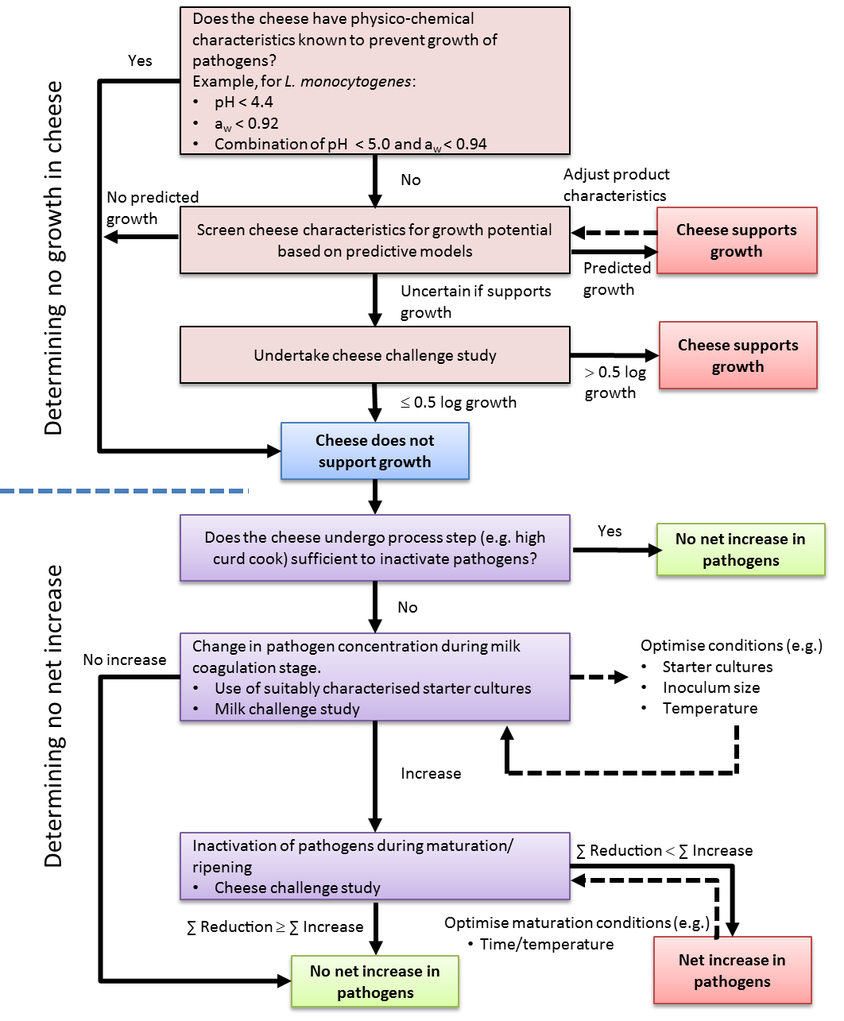
Figure 1: Flow diagram illustrating the determination of no growth and no net increase criteria.

Establishing no growth in cheese
This section considers the scientific evidence relating to establishing no growth of pathogens in cheese products. The physico-chemical characteristics which affect the growth of pathogens in cheese products are considered together with the utility of tools available of predict pathogen growth.

Tools available to assess the rate or likelihood of pathogen growth in cheeses can include default physico-chemical parameters, predictive equations using growth rates or probability of growth and cheese challenge studies. Cheese challenge studies can take two forms: inoculation of milk prior to cheese making or inoculation of a cheese surface or matrix. The first approach will include the impact of acidification, salting and maturation on pathogen response, while the second approach provides information on the growth of pathogens based solely on the physico-chemical properties of the cheese.

2.1 Cheese classification
Classification systems that have been developed are primarily based on characteristics of the cheese including:

- Texture, which is dependent mainly on moisture content
- Method of coagulation as the primary criterion, coupled with other criteria
- Ripening indices

Codex (1978) classifies cheeses primarily based on the method of ripening and firmness. Ripening categories include: ripened, mould ripened, cheese in brine and unripened cheese. Firmness is based on percentage moisture on a fat free basis (MFFB % = % moisture/(100-% fat)) and includes: soft (>67%), firm/semi-hard (54 - 69%), hard (49 - 56%) and extra hard (<51%). Definitions are also provided for ripened, mould ripened and unripened cheese. Country specific classification schemes for cheeses also exist based on the MFFB. For example the Canadian Dairy Products Regulations (Canadian Government, 2012) defines soft white cheese (>= 80%), soft (>67 to <80%), semi-soft (>62 to <= 67%), firm (>50 to <= 62%) and hard (<50%).

While particularly useful in trade, the Codex classification of cheese does not adequately categorise cheeses based on the wide range intrinsic and extrinsic properties that influence the potential growth, inactivation and/or survival of pathogenic microorganisms.

For the purposes of this report, the classification scheme of Fox et al. (2004) has been used, where the rennet coagulated cheeses are further subdivided into groups based on characteristic ripening agents or manufacturing technology (Figure 2). Fox et al. (2004) classifies natural cheese into Internal bacterially ripened (IBR) cheese, Mould ripened and Surface ripened cheese superfamilies.

The IBR group is the most diverse of rennet coagulated cheeses and it is then further subdivided based on moisture (extra hard, hard and semi-hard), the presence of eyes, or a characteristic technology such as cooking/stretching or ripening under brine. IBR cheese with eyes is further subdivided into hard varieties e.g. Swiss type (lactate metabolism) or semi-hard e.g. Dutch type (citrate metabolism) types.

Soft cheese varieties are usually not included in the group of IBR cheeses because they have a characteristic secondary microflora which has a major effect on the characteristics of the cheese (Fox et al., 2004). Mould ripened cheeses are subdivided into Surface mould e.g. Brie and Camembert, and Internal mould e.g. Roquefort and Stilton.
Fresh cheeses for this report are a combination of Acid-coagulated and Heat/Acid coagulated type of cheese varieties (Table 1). These cheeses are ready for consumption immediately after production and are not ripened.

Further description of these major cheese categories is provided in Table 1. As with any classification system there will be cheeses which may have attributes of more than one superfamily. One example is “blue brie” of which Cambozola is an example. This type of cheese is produced using a combination of Penicillium camemberti but with the inclusion of the blue mould Penicillium roqueforti. The result is a cheese which has characteristics of both Surface mould and Internal mould superfamily groups.

Processed cheese
Most varieties of cheese may be processed
Acid Coagulated
Cottage / Cream
Concentration/ Crystallisation

Heat / Acid coagulation
Ricotta

Ricotta

R
Enzyme—Modified
Cheese
Cheese Analogues
Cheese with eyes
Swiss type
(lactate metabolism by Propionibacterium spp.)
Emmentaler
Gruyère
Maasdam
Dutch type
(eyes caused by citrate metabolism)
Edam
Gouda
High-salt varieties
Domiati
Feta
Pasta filata varieties
Mozzarella
Kashkaval
Provolone
Surface ripened
Havarti
Limburger
Münster
Port du Salut
Trappist
Taleggio
Tilsit

Caerphilly
Mahon
Monterey Jack
Cheddar
Cheshire
Graviera
Ras
Grana Padano
Parmesan
Asiago
Sbrinz
Semi hard
Extra hard
Mould ripened
Internal bacterially ripened
Natural cheese
Rennet Coagulated
Dried cheeses

Cheese
Internal mould
(P. roqueforti)
Roquefort
Danablu
Stilton
Surface mould
(usually P. camemberti)
Brie
Camembert
Hard
Figure 2: Classification of cheese into super-families (modified from Fox et al., 2004)

Table 1: Principal categories of cheese (FSANZ, 2009)
Internal bacterially ripened
Extra hard varieties | Extra hard cheeses are characterised by a hard granular texture following ripening for a long period (usually 6 - 24 months). Examples are the Italian “Grana” types, Asiago and “Pecorino” cheeses.
Hard varieties | Hard cheeses are typically milled with dry salting of the curd. Cheddar cheese, originating in England, is one of the most important cheese varieties made worldwide. Other British Territorial hard cheese varieties include Cheshire, Derby, Gloucester and Leicester.
Semi-hard varieties | The description of a cheese as semi-hard is arbitrary and distinction between this and other groups (e.g. hard, smear-ripened and pasta-filata) may not be clear. Semi-hard varieties include Colby and Monterey, Lancashire and Bryndza.  Stirring Cheddar-type cheese curd inhibits the development of curd structure and results in a cheese with higher moisture content and a softer texture.
Cheese with eyes (Swiss type) | Semi-hard cheeses with propionic acid fermentation include Maasdamer, Emmentaler and Jarlsberg. The propionic acid fermentation produces numerous large openings called “eyes”. Characteristics of this category include: formation of eyes and ripening at elevated temperatures.
Cheese with eyes (Dutch type) | Unlike the eye formation using propionic acid formation, Gouda and related type cheese eye formation is through the metabolism of citrate.
Pasta-filata cheeses | These cheeses are semi-hard varieties, also known as kneaded or plastic curd cheeses and include Mozzarella, Provolone and Kasseri. These cheeses are heated to a high temperature, kneaded and stretched.
Cheeses ripened under brine | Feta, Domiati and related species are also referred to as pickled cheeses as they are ripened under brine.
Other cheese varieties
Surface mould ripened varieties | Soft cheeses characterised by the growth of Penicillium camemberti on the cheese surface are usually high moisture and have relatively short maturation and shelf-life.
Internal mould ripened varieties | Characterised by a network of blue and green veins caused by the growth of Penicillium roqueforti. Examples include Cabrales, Gorgonzola, Stilton and Roquefort.
Surface smear ripened varieties | Smear cheeses are characterised by the growth of complex Gram-positive microflora on the surface during ripening. Although most varieties in this group are soft or semi-hard, a surface flora may also develop on hard cheeses such as Gruyère.
Acid-curd cheese | Acid-coagulated cheese is made by acidifying milk to a pH of 4.6 resulting in coagulation. These cheeses are characteristically high in moisture and consumed fresh, however, they may be ripened. Cottage and Quarg varieties are acid-curd cheeses.
Heat/Acid cheese | These cheeses are produced from rennet cheese whey, with a small amount of milk added, as well as the addition of an acidifying agent and exposure to heat (85 - 90°C). The coagulant is then pressed into moulds, packed in ice and allowed to drain. The most common variety is Ricotta.

2.2 Cheese physico-chemical characteristics
To illustrate the differences in the physico-chemical characteristics between, and within, cheese superfamilies, data was compiled from surveys of retail cheeses reported in the scientific literature: Fernandez-Salguero et al. (1986), Marcos et al. (1981), Marcos and Esteban (1982), Marcos et al. (1990) and Rüegg and Blanc (1977). Each cheese in the surveys was placed into one of five superfamily groups: Fresh, IBR, Internal mould, Surface mould and Surface ripened (Figure 2) and summary plots of measured characteristics: moisture, pH, salt-in-moisture phase and water activity are provided in Figure 3.

Fresh cheeses generally high moisture and high water activity (low salt in moisture) and low pH compared with other cheese families. By comparison, internal mould ripened cheeses tended to have lower moisture and water activity (higher salt in moisture), and also higher pH. The higher pH in surface ripened cheese is a result of proteolysis by the moulds during ripening, producing basic amines and ammonia.

Figure 4 illustrates the combined pH and water activity for the five superfamily groups. Examination of this plot reveals that retail cheeses of each superfamily show a degree of clustering. The majority of Internal mould cheeses have water activity values between 0.9 and 0.94 and a pH range of 5 to 6.25. Individual cheese samples lie outside of these ranges e.g. a single cheese has very low water activity of 0.86 and two cheese have pH values close to 7. Surface mould cheeses have water activities between 0.96 and 0.98 and pH value of 5 to 7.5. Fresh cheeses have the lowest pH and amongst the highest water activities.

Summary data on the physico-chemical properties of cheese from surveys as presented in
Figure 4 cover a broad range of cheeses within a superfamily. Within each superfamily group there may be important differences in physico-chemical characteristics which may be considered. For example the addition of cream (double or triple cream) will increase the amount of fat in a cheese and results in a decrease in the moisture content by compensation. For internal mould cheeses the choice of Penicillium moulds can influence the pH since those that produce less ammonia have a lower pH.
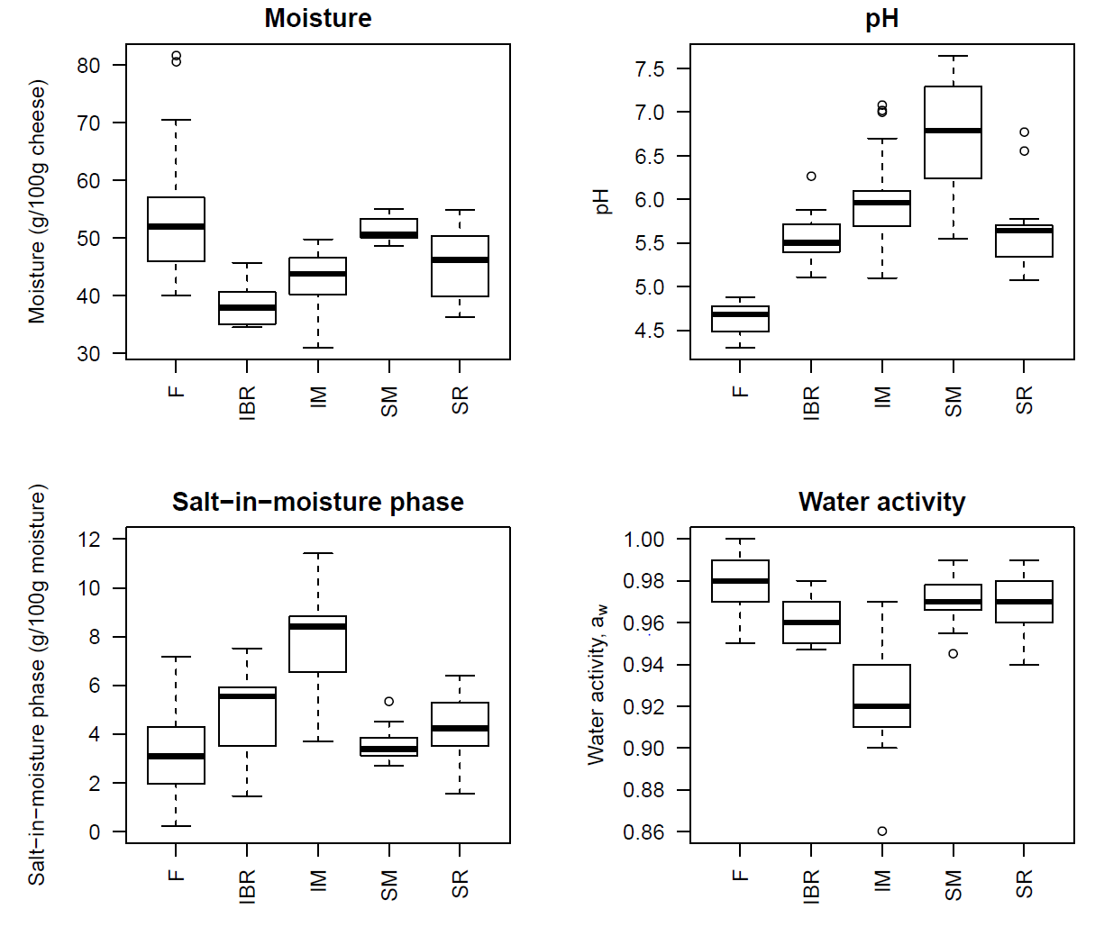
Figure 3: Moisture, pH, salt in moisture phase and water activity of retail cheeses Data from Fernandez-Salguero et al. (1986), Marcos et al. (1981), Marcos and Esteban (1982), Marcos et al. (1990) and Rüegg and Blanc (1977). F – Fresh; IBR – Internal bacterially ripened; IM – Internal mould; SM – Surface mould and SR – Surface ripened. Bold black lines within the box are the median times, bottom and top of the boxes represent the 25th and 75th percentiles, while the open circles represent outliers.
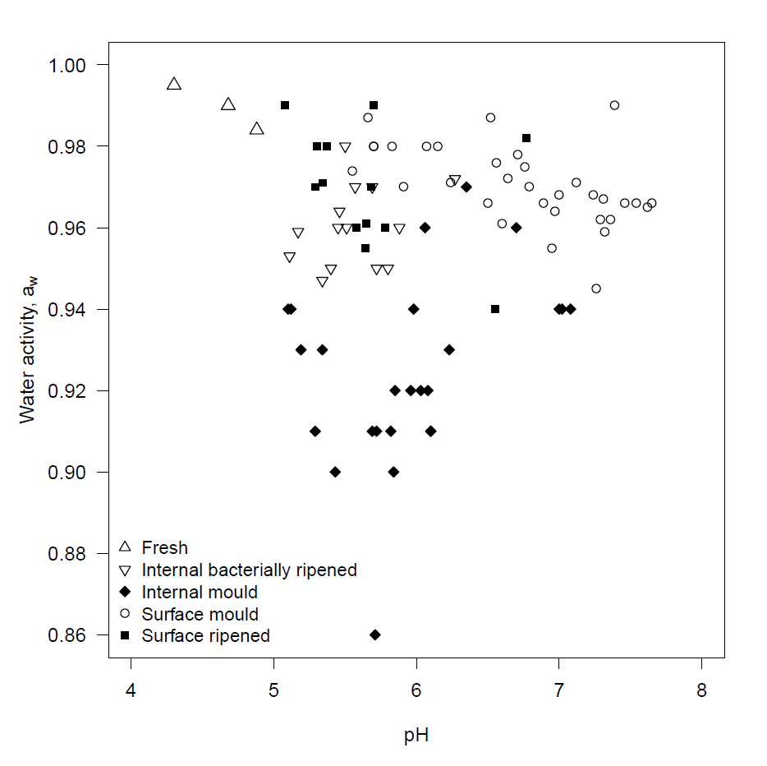
Figure 4: Retail cheese pH and water activity by cheese superfamily. Data from Fernandez-Salguero et al. (1986), Marcos et al. (1981), Marcos and Esteban (1982), Marcos et al. (1990) and Rüegg and Blanc (1977).

When considering the physico-chemical characteristics of cheeses it is important to understand that one characteristic may influence another. Guinee et al (2008) sampled six brands of mature/vintage full-fat cheddar cheeses from retail stores in Ireland and the UK over a six month period. The cheeses were analysed for a range of compositional, proteolysis, lipolysis and sensory characteristics. The study showed that significant inter-brand differences were found for salt-in-moisture concentration, MFFB, fat-in-dry matter (FDM) and total lactate (lactic acid) concentration. Intra-brand variation was also observed for salt-in-moisture and total lactate concentration.

Possible explanations for the inter- and intra-brand differences included milk composition (eg casein levels or protein-to-fat ratio), the activity of starter cultures and/or manufacturing conditions (including factors such as gelation conditions, cut firmness, pH during production stages, salt content etc).

Guinee et al (2008) presented figures showing that Total lactate and salt-in-moisture phase concentration were negatively correlated (ie Total lactate decreased with increasing salt-in-moisture phase concentration), while pH was positively correlation with salt-in-moisture phase concentration (ie pH increased with increasing salt-in-moisture phase concentration). One explanation for these findings is that higher salt addition to the curd slows the rate of acid formation by the starter cultures.
As a result, cheeses with higher salt contents would also have higher pH. Although not shown in the paper, Total lactate concentrations were negatively correlated with pH; cheeses with less Total lactate had higher pH values.

2.4 Available tools to establish no growth
Tools to aid cheese makers to determine whether the physico-chemical properties of a cheese will support the growth of pathogens will be divided into two categories: default criteria and predictive equations.

Default criteria are based on scientific information describing the limits of the growth of pathogens e.g. minimum pH or water activity. In the case of L. monocytogenes, Codex has developed default criteria for pH and water activity for growth. For other pathogens, standard food microbiology texts or the FSANZ Agents of foodborne illness series (FSANZ 2013) provide summary information on the minimum temperature, pH and water activity for growth of pathogens such as Salmonella spp. and enterohaemorrhagic Escherichia coli (EHEC).

Predictive equations which use the physico-chemical properties of a food to predict the growth rate or the probability of growth have been developed from many pathogens including L. monocytogenes, Salmonella spp. and E. coli. Summary information for these models can be found in the scientific literature or books such as McKellar and Lu (2004).

As described in Section 2.2, the physico-chemical characteristics of cheeses will only vary within a limited range and groups of characteristics (salt-in-moisture, pH and lactic acid) may be correlated. This may be different to other foods such as preserved fish or meat where specific recipes of brines which incorporate salts (sodium chloride, sodium nitrite etc) and other components (lactic acid, diacetate) are used. Individual brine components can be adjusted to produce a brine recipe so that the food will not support the growth of pathogens. The reformulated foods can then undergo challenge testing to validate the predictive models.

As the majority of cheese pathogen challenge studies have been performed using
L. monocytogenes, this pathogen will be the focus for illustrating the use of tools.

2.4.1 Default criteria
Default criteria to control the growth of L. monocytogenes in ready-to-eat foods have been developed internationally (Codex, 2007). Physico-chemical characteristics such as pH and water activity can limit the growth of L. monocytogenes, alone or in combination:

- pH < 4.4, regardless of water activity
- a_{w} < 0.92, regardless of pH and
- combination of pH and a_{w} (e.g. pH < 5.0 and a_{w} < 0.94)

Foods that meet these criteria are expected to not support the growth of L. monocytogenes. A graphical summary of the Codex default criteria is presented in Figure 5. Each of the three criteria is presented individually and then combined (bottom right panel) to provide the region where growth may potentially occur and validation would be required.
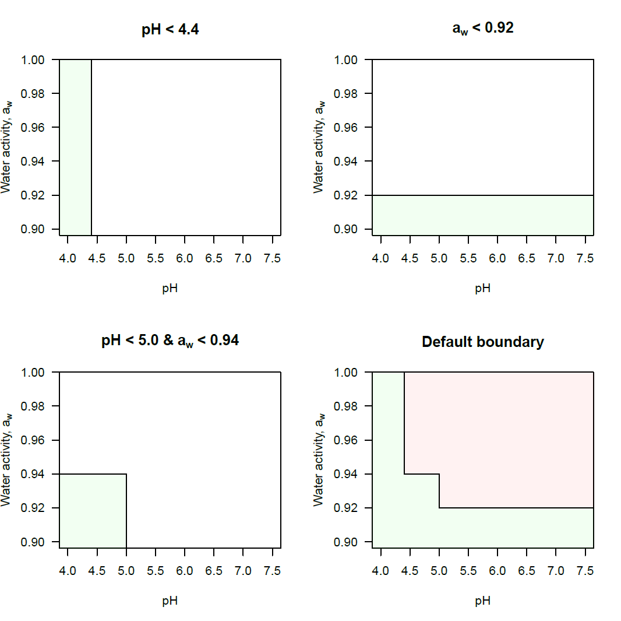
Figure 5: pH and water activity limits for conditions deemed not to support the growth of Listeria monocytogenes by Codex (2007)

2.4.2 Predictive equations
Three predictive equations were selected to illustrate the use for predicting the growth of L. monocytogenes in cheeses: Schvartzman et al. (2011), Augustin et al. (2005) and Mejlholm and Dalgaard (2009).

Schvartzman et al. (2011) reports on the development of an equation to predict the probability of growth of L. monocytogenes at the beginning of cheesemaking to establish safety limits for manufacturing cheese. The experiments were performed at 30°C using a semi-soft laboratory scale cheese system with five levels of pH (5.6 to 6.5), four water activity levels (0.938 to 0.96) and two L. monocytogenes concentrations (1 to 20 cfu/ml and 500 to 1000 cfu/ml). Each experimental combination was replicated six times with resulting growth/no growth data fitted using a logistic regression model. The model predicts the probability of L. monocytogenes growth occurring after 8 hours. The approach used in this paper fails to account for the dynamic changes in pH during the initial acidification phase or that the water activity of fresh cheeses is often close to 1 until salting. The time taken to complete salting of a cheese may take weeks not hours to complete. The lowest experimental water activity of 0.944 would not be reached within 8 hours. As a result this model was not considered further.

Mejlholm and Dalgaard (2009) developed a growth rate and growth boundary model for
L. monocytogenes in RTE shrimp.
The model includes 12 factors and their interactive effects of relevance to the prediction of the probability of growth in cheeses: temperature, salt, pH, six acids (acetic acid, benzoic acid, citric acid, diacetate, lactic acid and sorbic acid), smoke components (phenol), CO₂ in head space gas at equilibrium and nitrite. A paper describing a validation study in 2010 which included this model (Mejlholm et al, 2010) included meat products, seafood products, poultry products and non-fermented dairy foods (e.g. milk, cream and ice cream) only.

Augustin et al. (2005) evaluated the performance of eight growth rate and probability of growth/no growth models using a combination of temperature, pH, and the main acid present in the medium, water activity, nitrite, phenol and the proportion of CO₂ in the modified atmosphere as factors. Of the eight models considered in the paper, model #8bis, a probability of growth (P) model was chosen for evaluation due to availability of physico-chemical characteristics:
$$P=\frac{1}{1+exp\left[a\left(b-θ\right)\right]}$$

with $θ=1-\sum_{i}{{\left(\frac{X_{i,opt}-X_{i}}{X_{i,opt}-X_{i,min}}\right)}^{3}}$where $X_{i,opt}$ is the optimum value of the ith environmental factor based on the maximum specific growth rate, $X_{i,min}$ is the minimum value of the ith environmental factor and $X_{i}$ is the ith environmental factor: temperature, pH and a_{w}. Substituting the factors gives the following equation for $θ$:

$$θ=1-\left\{{\left(\frac{T_{opt}-T}{T_{opt}-T_{min}}\right)}^{3}+{\left(\frac{a_{w,opt}-a_{w}}{a_{w,opt}-a_{w,min}}\right)}^{3}+{\left(\frac{{pH}_{opt}-pH}{{pH}_{opt}-{pH}_{min}}\right)}^{3}\right\}$$

Table 2: Parameter values for the Augustin et al. (2005) model #8bis

Parameter | Value
a | 10.2
b | 0.037
T_{opt} | 37°C
T_{min} | -1.72°C
pH_{opt} | 7.1
pH_{min} (lactic acid) | 4.71
a_{w,opt} | 0.997
a_{w,min} | 0.913

The Augustin model #8bis parameter values using temperature, pH and water activity as model factors together with lactic acid as the main acidulant are presented in Table 2. pH_{min} is adjusted depending on the main acidulant in the food and takes the value of 4.71 for lactic acid.

The θ parameter takes values in the range of -2 to +1. When each of the environmental factors T, pH and a_{w} are optimal the value of θ is 1 and P = 1. By contrast θ = -2 when each of the environmental factors are at the minimum values with P = 0.

As the outcome of this equation is probabilities of growth, two decision rules were suggested by Augustin et al. (2005): (1) growth was predicted when the probability of growth was above 0.9 and (2) no growth was predicted when the probability was below 0.1. This leads to three possibilities based on the environmental factors included in the equation: a reliable no-growth domain (p < 0.1), a reliable growth domain (p > 0.9) and an uncertain domain (0.1 ≤ p ≤ 0.9). The model was validated with a range of foods including dairy products, meat and seafood products and a limited number of cheeses.
The validation demonstrated that the predictive performance was found to be poor in cheese, but that the model could be used for no-growth prediction.

2.5 Validation of tools to establish no growth
A review of cheese challenge studies (see Appendix 2) was undertaken to collect data on physico-chemical characteristics that may be used to evaluate the predictive performance of the Codex default criteria and the two predictive equations, Mejlholm and Dalgaard (2009) and Augustin et al. (2005).

A total of 35 challenge studies were identified between 1971 and 2008; all but two studies considered only a single pathogen. The majority of challenge studies were for L. monocytogenes (n=23) followed by E. coli (generic and pathogenic strains) (n=11). Only one or two challenge studies were identified that considered Salmonella spp., Staphylococcus aureus or Campylobacter spp.

Two broad groups of challenge studies were identified. The first group of studies inoculated milk prior to the addition of lactic acid starter cultures, while the second group inoculated commercial cheeses (as a surface inoculation for solid cheeses or direct inoculation into soft cheeses). The milk inoculation studies provide an insight into the dynamics of pathogens during curd formation and ripening/maturation. The cheese inoculation studies may be used to investigate the intrinsic characteristics of cheeses that inhibit growth of pathogenic bacteria.

Analysis of the cheese challenge studies found that relevant physico-chemical characteristics information was often limited. The cheese pH was the most commonly reported characteristic (32/35) followed by salt concentration (23/35) and moisture (22/35). Other relevant factors such as titratable acidity (6/34), water activity (2/35) and organic acid concentration (2/35) were not commonly measured. There was also a lack of consistency between studies regarding the stage at which the measurements were taken. Some studies reported measurements at the start of ripening/maturation while others provided information throughout the shelf life of the cheese. A summary of the challenge study data is in Appendix 2.

Of the available information only pH, salt and moisture levels could be extracted in order to attempt to make predictions about the growth of L. monocytogenes in the challenge study cheeses. The studies in Table 3 were selected based on the consistency of analytical methodology and reporting. As lactic acid and acetic acid concentration data was not available for these challenge studies, the Mejlholm and Dalgaard (2009) equation was not considered further.

A limitation with using published challenge studies is the absence of data for the water activity of cheese. While salt and moisture are generally reported, other properties influence water activity such as ash and nonprotein nitrogen (see Appendix 3). Calculating water activity using salt alone will lead to the prediction of water activity values higher (closer to 1) than if measured directly. To adjust for superfamily specific differences in water activity the Ross (1975) equation is used with two components: a_{w,salt} and a_{w,other}, where a_{w,other} represents the water activity reduction due to all non-salt components such as ash, nitrogen fractions (e.g. nonprotein) etc. Details on the conversion of salt concentration to water activity for challenge study cheeses are outlined in Appendix 3.

‘Growth’ was defined as a period of sustained increase in L. monocytogenes concentration. The intrinsic characteristics (pH, salt and moisture) at the end of ripening/maturation and whether growth had occurred were recorded for each of the challenge studies in Table 3.
In order to aid in visualising the findings, salt and moisture were combined as salt-in-moisture (%). This value represents the amount of salt present in the aqueous phase of the cheese.

A summary plot of the results for four superfamily groups is presented in Figure 6. Of the challenge studies investigated only two superfamilies supported growth: Surface mould and Heat Coagulated cheeses. None of the Internal mould ripened or IBR cheeses supported growth. The cheeses that supported growth of L. monocytogenes had pH > 5.5 and less than 5.5% salt-in-moisture phase (Figure 6).

Comparison of the challenge study data (Table 3) with the Codex default values for the growth of L. monocytogenes is presented in Figure 7. Results for only two challenge studies where growth was not observed were correctly predicted: High salt (Papageorgiou and Marth, 1989a), and the Internal mould (Papageorgiou and Marth, 1989b). The feta study falls into the no growth area due to a low pH of 4.3 while the Internal mould study due to the high salt-in-moisture phase concentration of 10-12% and low predicted water activity. The Roquefort and all other IBR studies where growth was not observed fall into the growth region. All cheeses where growth was observed are inside the growth region.
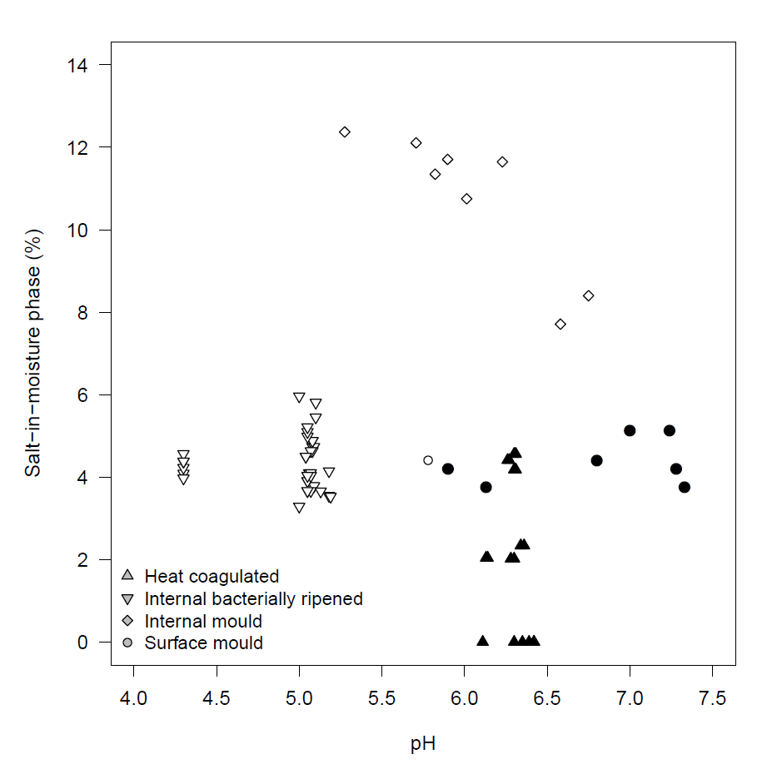
Figure 6: Challenge study cheese characteristics (pH and salt-in-moisture phase, %) that support the growth of L. monocytogenes by cheese superfamily group. Conditions that don't support growth are open symbols and conditions that do support growth are closed symbols.
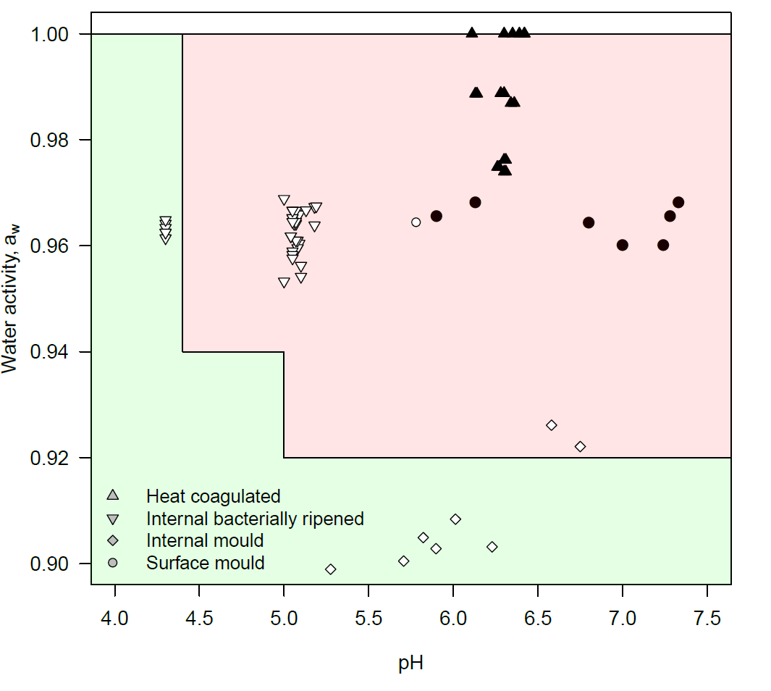
Figure 7: Challenge study cheese characteristics (pH and predicted water activity) against the Codex (2007) default criteria for the growth of L. monocytogenes. Conditions that don't support growth are open symbols and conditions that do support growth are closed symbols.

Table 3: Summary of the final product physico-chemical characteristics for L. monocytogenes cheese challenge studies
Superfamily | Sub-family | Name | Salt-in-moisture phase (%)  mean (range) | pH  mean (range) | Predicted a_{w}  mean (range) | Temperature  (°C) | Reference
Heat Coagulated |  | Anthotyros | 2.1 (2.0 – 2.3) | 6.26 (6.13 – 6.36) | 0.988 (0.987 – 0.989) | 5, 12, 22 | Papageorgiou, Bori and Mantis (1996) J. Food Protect. 59:1193-1199
Heat Coagulated |  | Manouri | 4.4 (4.2 – 4.6) | 6.29 (6.26 – 6.31) | 0.975 (0.974 – 0.976) | 5, 12, 22 | Papageorgiou, Bori and Mantis (1996) J. Food Protect. 59:1193-1199
Heat Coagulated |  | Myzithra | 0 (-) | 6.33 (6.11 – 6.42) | 1 (-) | 5, 12, 22 | Papageorgiou, Bori and Mantis (1996) J. Food Protect. 59:1193-1199
Mould-ripened | Internal mould | Blue | 11.7 (10.8 – 12.4) | 5.82 (5.28 – 6.23) | 0.903 (0.899 – 0.908) | 10.5 | Papageorgiou and Marth (1989b) J. Food Protect. 52:459-465
Mould-ripened | Internal mould | Roquefort | 8.1 (7.7 – 8.4) | 6.67 (6.58 – 6.75) | 0.924 (0.922 – 0.926) | 8 (typical) | The Pasteur Institute of Lille (2001)
Mould-ripened | Surface mould | Camembert | 4.4 (3.8 – 5.1) | 6.68 (5.78 – 7.33) | 0.965 (0.960 – 0.968) | 10 | Ryser and Marth (1987b) J. Food Protect. 50:372-378
IBR | Hard | Cheddar | 4.2 (3.6 - 4.9) | 5.07 (5.04 - 5.09) | 0.963 (0.960 – 0.967) | 6, 13 | Ryser and Marth (1987a) J. Food Protect. 50:7-13
IBR | Hard | Colby | 3.6 (3.3 – 4.1) | 5.12 (5 – 5.19) | 0.967 (0.964 – 0.969) | 4 | Yousef and Marth, (1988) J. Food Protect. 51:12-15
IBR | Extra Hard | Parmesan | 5.4 (5.0 – 6.0) | 5.06 (5.0 – 5.1) | 0.956 (0.953 – 0.959) | 12.8 | Yousef and Marth (1990) J. Dairy Sci. 73:3351-3356
IBR | High salt | Feta | 4.3 (4.0 – 4.6) | 4.3 (-) | 0.963 (0.961 – 0.965) | 4 | Papageorgiou and Marth (1989a) J. Food Protect. 52:82-87

Comparison between the challenge study results and the Augustin et al. (2005) equation is presented in Figure 8. The solid line represents the combinations of pH and water activity at a temperature of 10°C where the probability of growth is predicted to be 10%. Similarities between Figure 7 and Figure 8 are evident as the same two studies fall below the no-growth probability of 10%. As challenge studies were performed at different temperatures the predicted line in Figure 8 is only indicative and the actual probabilities for each cheese in a challenge study needs to be examined to evaluate the growth/no-growth domain.

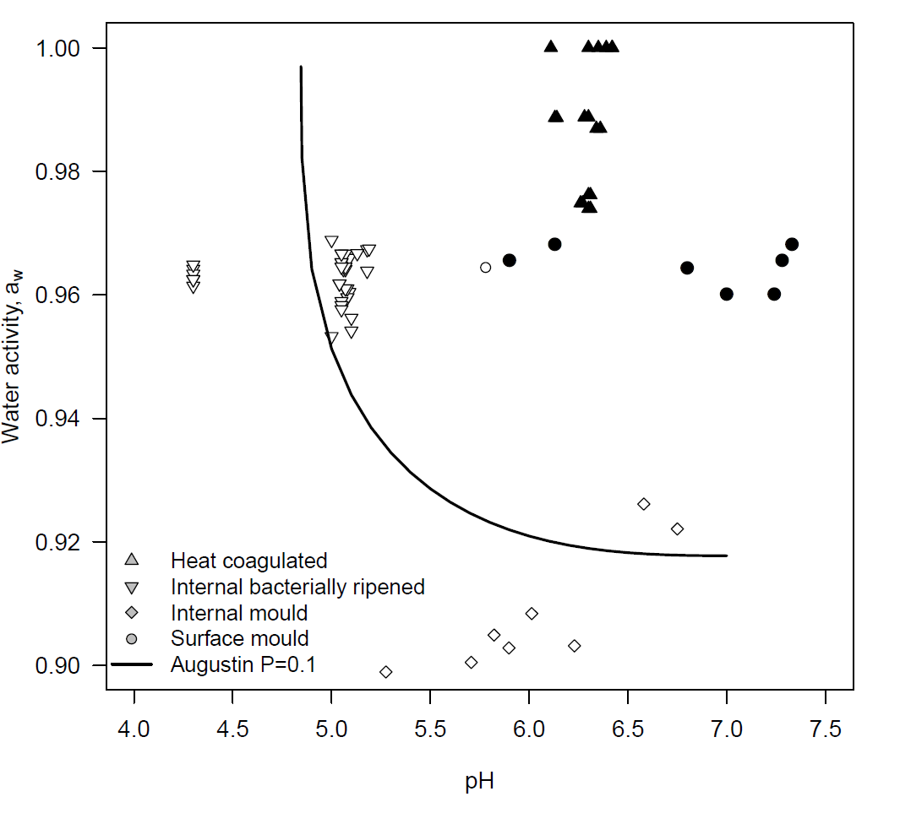
Figure 8: Challenge study cheese characteristics (pH and predicted water activity) with the Augustin et al. (2005) 10% probability of growth line at 10°C. Conditions that do not support growth are open symbols and conditions that do support growth are closed symbols.

The predicted probability of growth for each cheese by superfamily and experimental storage temperature is presented in Figure 9. For the Surface mould and Heat coagulated cheeses the probability of growth is close to 1, indicating a high probability of growth. This result is supported by the challenge study results where growth was observed at all temperatures.

The High salt (Papageorgiou and Marth, 1989a) and Internal mould (Papageorgiou and Marth, 1989b) cheeses had a probability of growth close to zero, while the Roquefort predictions were 0.16 and 0.36. These probabilities lie in the uncertain growth domain and challenge study evidence would be required to demonstrate that the cheese did not support growth of L. monocytogenes.
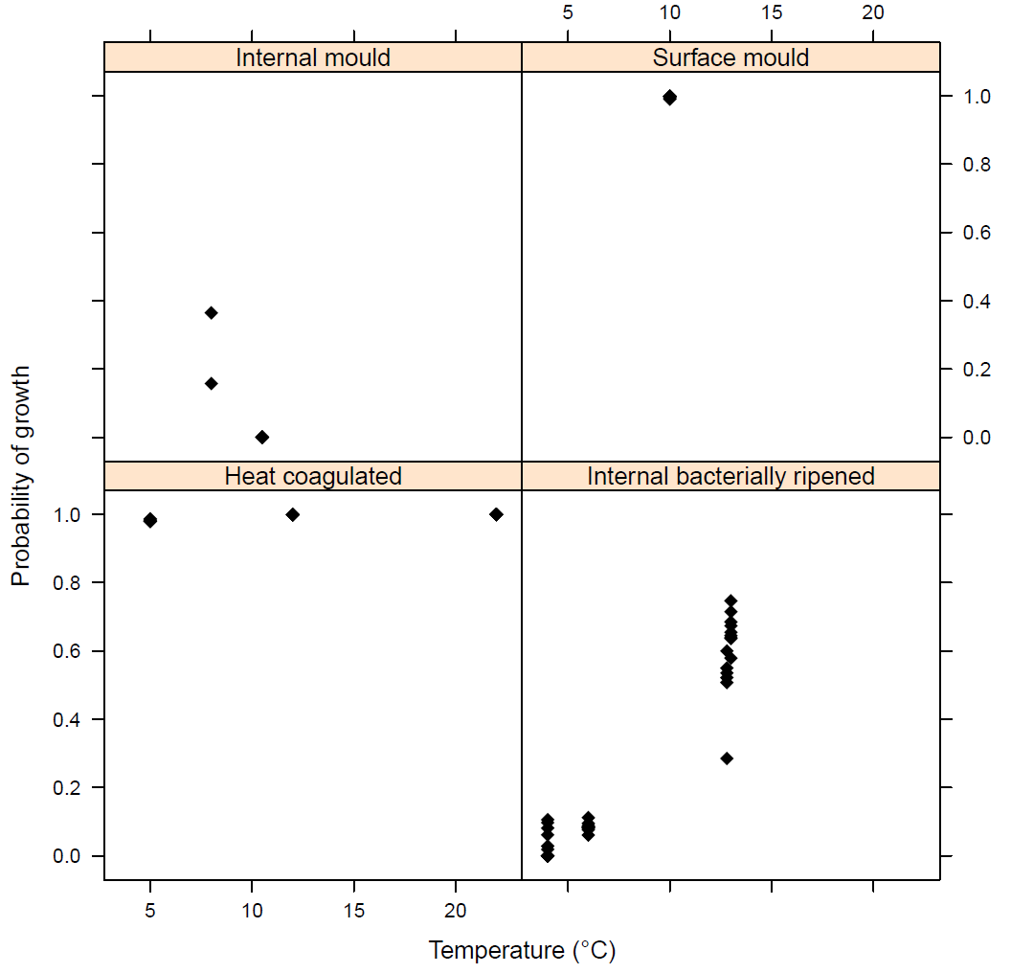
Figure 9: Predictions of the probability of growth by the Augustin et al. (2005) equation by temperature for Internal mould, Surface mould, Heat coagulated (whey) and Internal bacterially ripened cheeses.

The average probability of growth at temperatures below 10°C for the IBR group was 0.055 (range: 0 to 0.11). The predictions mostly fall within the no-growth domain and are supported by the challenge study results. However, at 12 or 13°C the mean probability of growth increases to around 0.6 (range: 0.29 to 0.75). Despite the higher predicted probability of growth none of the challenge study cheeses were found to support the growth of L. monocytogenes.

2.6 Discussion
In this section two types of tools: default criteria and predictive equations using pH and water activity were considered to illustrate the likelihood of the growth of L. monocytogenes in matured/ripened challenge study cheeses.

A key limitation in this assessment is the paucity of physico-chemical characteristics in published pathogen challenge studies beyond pH, moisture and salt concentration.
Key intrinsic characteristics such as water activity and organic acids, especially lactic acid are lacking.

The calculation of water activity based on the food moisture and salt concentrations as used by Augustin et al. (2005) does not perform adequately for most cheese superfamily groups except for the Fresh cheese e.g. acid-curd and heat/acid cheeses. Cheese specific factors such as proteolysis results in water activity values below that predicted using salt alone. Not considering the additional water activity suppression due to the products of proteolysis will lead to conservative outcomes i.e. a false positive result where growth is predicted in a cheeses but no growth observed (Appendix 3).

To address the lack of water activity information from the cheese challenge studies the Ross (1975) equation was used. This equation assumes that the water activity due to individual solutes is multiplicative. The use of the median water activity due to non-salt solutes does not account from the variability in results for individual cheeses (Figure 25 and Figure 26). To avoid these issues, cheesemakers assessing the growth of pathogens on cheeses should measure moisture, salt and water activity.

The Codex default criteria based on pH and water activity are conservative and not relevant to the majority of cheeses for predicting cheese that do not support growth. Cheeses with pH < 4.4, such as some High salt varieties may met this criterion.

Of the many available predictive equations, the Augustin et al. (2005) equation was evaluated against challenge study cheeses to assess its predictive performance. The equation correctly predicted growth (P≫0.9) for challenge study cheeses were growth was observed. The result for challenge study cheeses where L. monocytogenes growth was not observed was poor. The majority of these cheeses fell into the uncertain domain defined by Augustin et al. (2005) as probabilities of growth in the range of 0.1 to 0.9. Higher maturation temperatures were associated with higher probabilities of growth. For IBR cheeses the probability of growth at 13°C almost reached 0.8. No growth was observed for any of the cheeses in this group.

A consideration in assessing the performance of the Augustin et al. (2005) equation it is important to consider the information and data used in its development. The optimum conditions of T_{opt}, pH_{opt} and a_{w,opt} were arbitrarily set to 37°C, 7.1 and 0.997, respectively (Augustin and Carlier 2000). Growth data obtained in liquid microbiological media were used to estimate the minimal temperature (T_{min}), the minimal pH for lactic acid (pH_{min,lactic}), the minimal water activity (aw,min). Finally, the relationship between θ and the probability of growth, P was also obtained using liquid microbiological media.

Cheese is of course solid and is more complex than liquid microbiological media. As a result there may well be food matrix effects such as competitive microflora, cheese structure or other physico-chemical characteristics which cannot be accounted for in models such as Augustin et al. (2005).

Despite this there is still value in the Augustin et al. (2005) and similar equations such as the Mejlholm and Dalgaard (2009) equation as they may provide tools to screen the physico-chemical characteristics from initial production trials for raw milk cheeses. Probabilities of growth close to 1.0 appear to be supported from the (limited) experimental evidence. Further validation would strengthen the conclusion from this preliminary analysis.

Additional L. monocytogenes challenge studies for cheeses with water activities in the range 0.93 to 0.96 and pH > 5.0 would clarify the uncertainty about the location of the growth/no-growth boundary between the Internal mould cheeses where growth was not observed and the Surface mould cheeses were growth was observed. In this region a small decrease in salt concentration may result in conditions supportive to growth as the pH becomes less limiting. Inoculation of retail cheese samples by Tan et al. (2008) demonstrated that growth by L. monocytogenes was possible in Internal mould cheeses at 4, 16 and 22°C.

In conclusion, a knowledge and understanding about the physico-chemical characteristics of cheese products is a necessary pre-requisite to predicting the probability and/or rate of pathogen growth. If predictive equations are used for screening of the probability of growth, then the necessary variables need to be measured. These factors may include but are not limited to pH, salt, water activity, lactic acid, and acetic acids. Other cheese-specific data may also need to be measured and evaluated.

Establishing no net increase

3.1 Cheese production steps
The key steps for cheese productions can generally be described as: warming, addition of starter cultures and/or rennet, warming/ripening, curd cutting, removal of whey, hooping, pressing, salting, maturation/ripening (see Figure 10). The production steps involved for the manufacture of specific cheeses vary widely.

Figure 10: Overview of major steps in the manufacture of cheese
Raw milk receival
Additions:
Starter culture
Calcium chloride
Rennet
Acidification and coagulation
Cutting of curd
Drainage of whey
Distribution/retail/consumer
Packaging
Primary production of milk
Ripening/maturation
Milling/Hooping/Pressing
Stirring/cooking
Dry/Brine salting
Drainage of whey
Acid coagulated fresh cheese
Other treatments:
Surface treatments
Needling
Waxing
Oiling

3.2 Starter culture behaviour
A large range of commercial starter and ripening cultures are used in the cheese making process, each with different metabolic characteristics and optimum growth and acid production temperatures. These can broadly be grouped into primary (mesophilic and thermophilic) and secondary cultures.

Primary starter cultures are used in cheesemaking for their ability to convert the milk lactose (a disaccharide sugar composed of glucose and galactose) to lactic acid, with a resulting pH drop in the milk. Not all lactic acid bacteria have the same ability to ferment lactose and are broadly grouped into homo- and hetero-fermentative bacteria. The difference between the two groups is due to the fermentation end-products. Homo-fermentative lactic acid bacteria species produce lactic acid as the primary product with an overall stoichiometry:

1 glucose 2 lactate + 2 ATP

where ATP is Adenosine-5'-triphosphate and is part of the energy cycle within cells.

Hetero-fermentative species produce lactic acid plus other products such as ethanol, carbon dioxide, diacetate etc. For example the overall stoichiometry for Leuconostoc spp. sugar metabolism includes lactate, ethanol and carbon dioxide as products (Cogan and Jordan, 1997):

1 glucose 1 lactate + 1 ethanol + 1 CO₂ + 1 ATP

As less lactate is produced by hetero-fermentative lactic acid bacteria, the rate and extent of pH drop is less than for homofermentative, acid-producing species. Hetero-fermentative lactic acid bacteria may be included as adjuncts in starter culture mixtures to improve the flavour profile of cheeses.

Commercial starter cultures may contain a single species (e.g. Starter code E), mixtures of homofermentative species (e.g. Starter Code A and C) or mixtures homo- and heterofermentative species (e.g. Starter code B) (Table 4). The choice of starter culture will depend on the type of cheese.
Table 4: Examples of important combinations of starter cultures for cheese production (Willman and Willman, 1999)
Starter code | Species | Comments
A | Lactococcus lactis subspecies cremoris and  Lactococcus lactis subspecies lactis | Acid producers  Mesophilic cultures: optimum 30°C. Growth at lower temperatures possible to delay setting.  Starter preparation: 22 – 30°C until milk curdles (12-20 hours)  Cheese types: Cheddar, Fetta, Camembert, Blue vein, Cottage cheese and Quarg
B | Lactococcus lactis subspecies cremoris,  Lactococcus lactis subspecies lactis,  Lactococcus lactis  subspecies lactis biovar diacetylactis  and with or without one  or more Leuconostoc species | Acid, flavour and gas producers  Mesophilic cultures  Starter preparation: incubate at 22 – 30°C until milk curdles (12-20 hours)  Cheese types: Edam, Gouda, Camembert, Havarti, Tilsit
C | Streptococcus thermophilus and either  Lactobacillus delbreuckii subspecies bulgaricus or Lactobacillus helveticus | Acid and flavour producers  Thermophilic cultures  Starter preparation: incubate at 37°C until the milk curdles (6-8 hours)  Cheese types: many Italian varieties  Also thermophilic yoghurt cultures
E | Streptococcus thermophilus | Thermophilic, acid-sensitive cultures  Starter preparation: incubate at 37°C until the milk curdles (6-8 hours)  Cheese types: modern Camembert

3.3 Milk challenge studies
The fermentation and acidification of milk is one of the key hurdles in limiting the growth of pathogens during raw milk cheese production. As milk is warmed, starter cultures begin to metabolise sugars (e.g. lactose) to lactic acid and other compounds. The rate at which lactose is converted to lactic acid is dependent on many factors including the strain of the starter culture, temperature, inoculum size and metabolic pathways (e.g. homo- or heterofermentative). Starter cultures or combination of starter cultures (see Table 4) must be selected to achieve the necessary technological function to produce both the type of cheese and also limit the growth of pathogens during milk warming.

One experimental approach to assess these requirements is to inoculate milk samples with starter cultures and pathogens and then monitor changes in concentration and pH with time. Starter cultures strains that produce more lactic acid and reduce pH faster are more likely to inhibit the growth of pathogens earlier in the cheese making process. Published milk challenge studies are typically performed using defined single or mixed strains at constant temperature and do not include additions such as rennet, calcium chloride which may have an impact of pathogen behaviour. Nevertheless these types of studies may be a relatively simple approach to screen potential starter culture strain(s) for inhibition of pathogens.

3.3.1 Effect of starter cultures on pathogen growth
Park and Marth (1972) inoculated skim milk with Salmonella Typhimurium (approximately 10³ cfu/ml) together with a range of mesophilic homo- and hetero-fermentative strains of starter cultures. The concentrations of the starter culture, Salmonella Typhimurium and pH were measured for 18 hours at 30°C.

The effect on the growth of Salmonella Typhimurium with and without the lactic acid bacteria can be seen in Figure 11. When Salmonella Typhimurium is grown without the starter culture (Control) the concentration increases rapidly to greater than 8-log₁₀ cfu/ml. By contrast, when the Salmonella is co-cultured with Streptococcus lactis C6 the growth rate is immediately reduced and the maximum concentration is 4 log₁₀ cfu/ml lower after 18 hours.

Figure 12 combines the starter culture concentration and pH results from Figure 28 and the co-culture Salmonella Typhimurium concentration data from Figure 11. For this experiment growth of Streptococcus lactis C6 and Salmonella Typhimurium both cease at around seven hours. This time corresponds to the period at which the maximum acidification rate occurs highlighting the strong effect that starter culture activity has on pathogen growth.
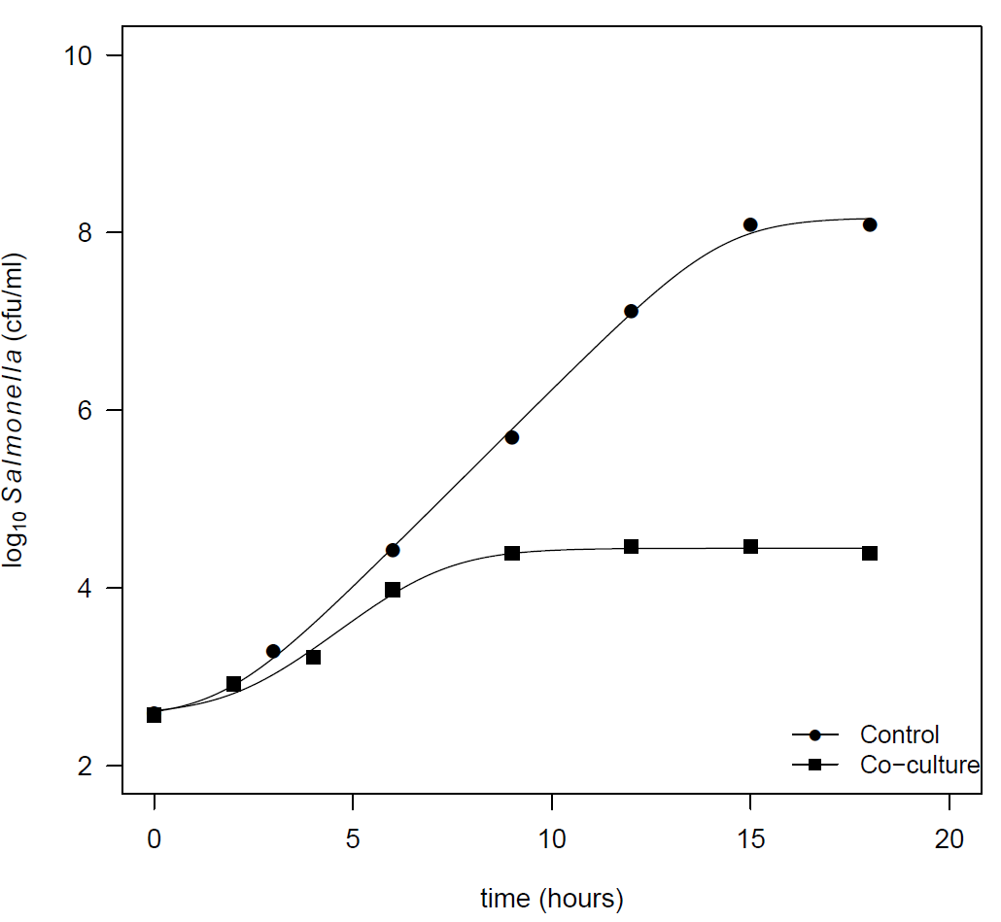
Figure 11: Growth of Salmonella Typhimurium in skim milk without a starter culture (Control) and co-cultured with the starter culture Streptococcus lactis C6

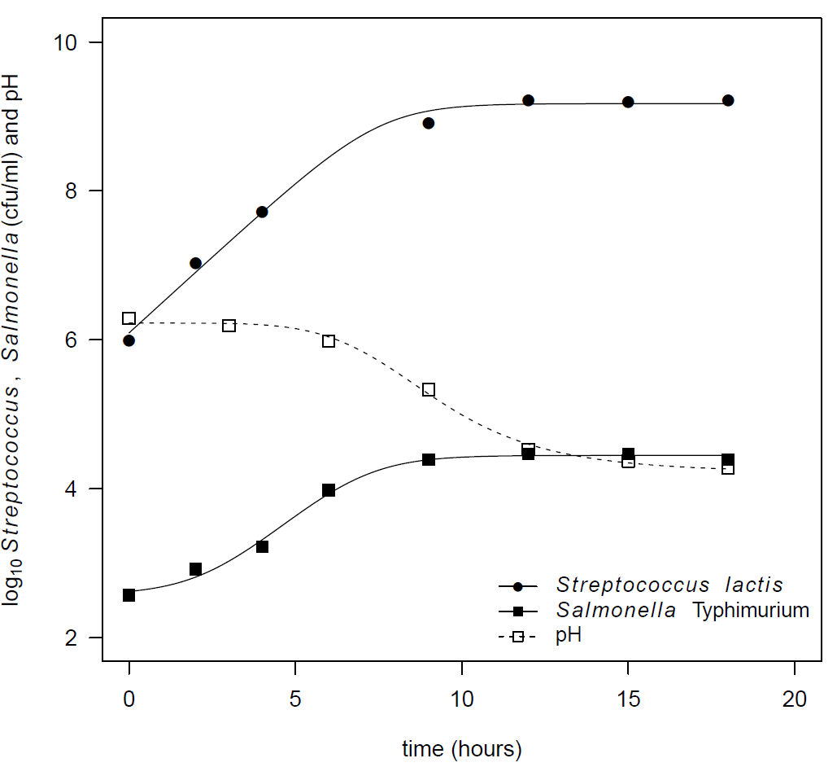
Figure 12: Co-culture of starter culture Streptococcus lactis C6 (0.25% inoculum) and Salmonella Typhimurium in skim milk at 32°C.
The data in Figure 12 represents the behaviour of a single starter culture on Salmonella Typhimurium. Park and Marth (1972) repeated the milk challenge experiment for different lactic acid starter cultures to investigate the differences in the inhibition of growth of Salmonella Typhimurium.

An example of an alternative analysis of the Park and Marth (1972) is presented in Figure 13, where starter culture “0” is the control experiment where no starter was added. In the control experiment a total increase in Salmonella concentration of 5.56 log₁₀ cfu/ml was found. The greatest co-culture growth was 4.87 log₁₀ cfu/ml for a Leuconostoc species strain and the least growth was for Streptococcus cremoris US3 at 1.47 log₁₀ cfu/ml. Starter culture 9 did not inhibit the growth of Salmonella Typhimurium within the 18 hours of the experiment and the actual growth is represented by an arrow to indicate the maximum growth if the experiment had been extended. This study illustrates that different lactic acid starters (homo- and heterofermentative) inhibit the growth of Salmonella Typhimurium to different extents. This type of analysis is observational and provides no predictive capacity to identify other starters which may inhibit pathogens more than those already tested. A quantitative approach is necessary to achieve this outcome.
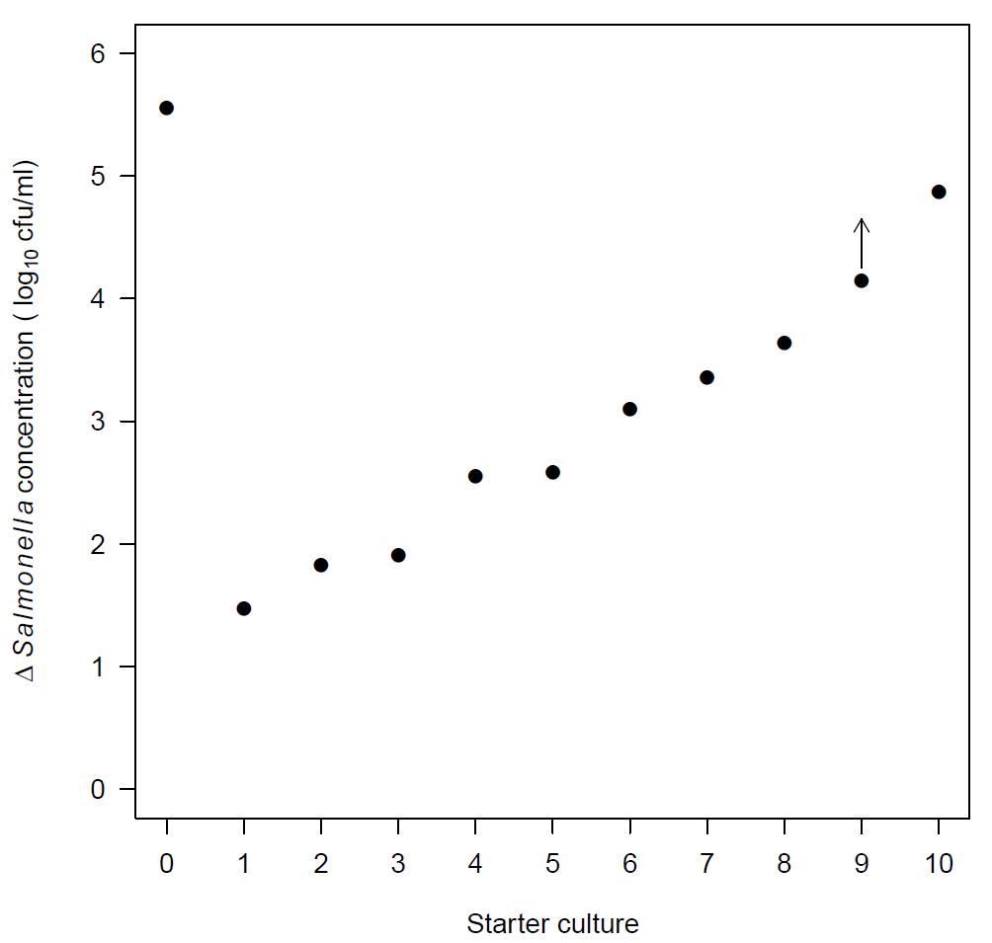
Figure 13: Change in Salmonella Typhimurium concentration (log₁₀ cfu/ml) when grown in co-culture with different lactic acid starter cultures (numbered 1 – 10). Starter culture “0” is the control where no starter culture was added to the skim milk. Starter culture 9 did not inhibit the growth of S. Typhimurium during the experiment. The dot represents the observed growth to 18 hours. The arrow indicates the potential growth had the experiment continued.
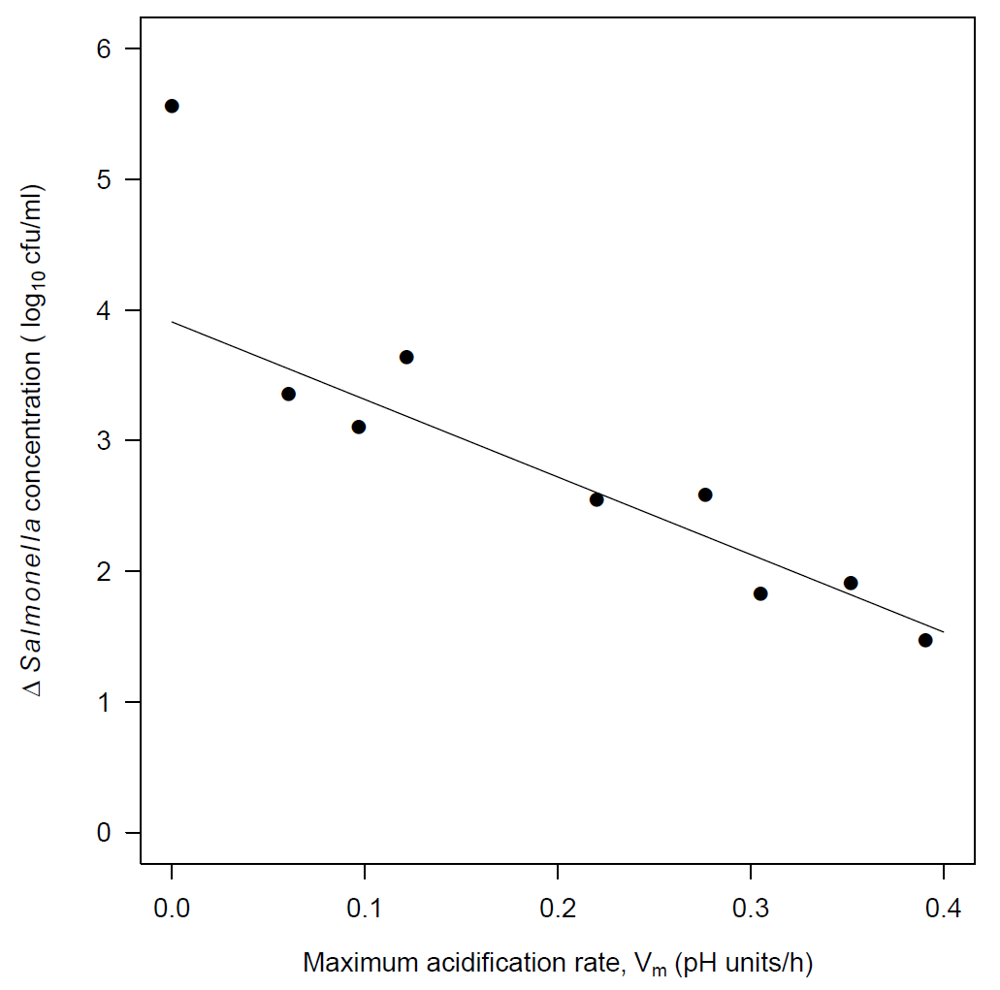
Figure 14: Change in Salmonella Typhimurium concentration (log₁₀ cfu/ml) vs the maximum acidification rate (V_{m}, pH units/h) for different lactic acid starter cultures. The value at V_{m} = 0 is the control experiment for reference. The solid line is a linear regression for V_{m} > 0.
The Torrestiana et al. (1994) equation was fitted to the pH-time data from Park and Marth (1972) using nonlinear regression to estimate the four equation parameters and the kinetic parameters calculated. Details on the modelling of acidification kinetics and Torrestiana et al. (1994) equation can be found in Appendix 4.

An example of the usefulness of this quantitative approach is that the change in Salmonella concentration is linearly related to the maximum rate of pH change, V_{m} for the co-culture experiments (Figure 14). The solid line is a linear regression fit to the data where V_{m} > 0. If V_{m} is less than 0.1 pH units/hour, then a greater than 3 log₁₀ increase in Salmonella Typhimurium concentration may be expected for this study in skim milk. As the maximum acidification rate changes to 0.4 pH units/hour the amount of growth reduces to 1 to 1.5 log₁₀ cfu/ml.

The quantitative analysis of the Park and Marth (1972) paper highlighted important difference between strains of lactic acid bacteria which are acid-producers (homofermentative) and flavour and/or gas producers (heterofermentative). Those strains that only produced acid were able to reduce the skim milk pH more rapidly with greater inhibition of the growth of Salmonella Typhimurium. The finding that the amount of growth of Salmonella Typhimurium was strongly correlated with the maximum acidification rate (Figure 14) is informative for selection starter cultures for making cheese from raw milk.

Establishing a growth-V_{m} relationship for pathogens in raw milk would increase the number of starter cultures that could be assessed for the ability to inhibit pathogens in raw milk during the milk warming portion of the cheese making process. It should also be noted that for raw milk the V_{m} value for the control will likely not have the value of zero. This is due to the presence of lactic acid metabolising bacteria in the natural flora of raw milk. The function of these bacteria will also play a role in the inhibition of pathogens. However, the magnitude of this effect would need to be established and considered in the determination of the inoculum size of starter culture added to the raw milk to make cheese.

3.3.2 Variability in pathogen response to a starter culture
The analysis of the milk challenge studies by Park and Marth (1972) highlighted that the maximum rate of acidification of starter cultures influenced the amount of Salmonella Typhimurium growth. Another factor to consider is strain variability in the response to the growth of pathogens with starter cultures.

Frank and Marth (1977) used a commercial mixed strain homofermentative starter culture to investigate the effect of both temperature (21 and 32°C) and inoculum size (0.25% and 2%) on six enteropathogenic and non-pathogenic strains of E. coli. A graphical summary of the study results is presented in Figure 15 for each combination of temperature and inoculum size. As the growth response of the E. coli strains is complex, smoothing splines were used to highlight the individual curves.

The results in Figure 15 highlight the variability between strains of E. coli grown with the same commercial starter culture. For example at 32°C and 0.25% inoculum there is a 2 log₁₀ difference in the growth of E. coli strains after nine hours and 3 log₁₀ differences at the end of the experiment (15 hours). A 3 log₁₀ difference represents a 1000-fold increase in the concentration of one strain over another.

More E. coli growth is observed when a smaller inoculum size is used at both 21 and 32°C. This is likely due to the delay in acidification (e.g. longer T_{m}, see Appendix 4) as the starter culture takes longer to reach the maximum population size from smaller initial concentration. E. coli growth is greater at 32°C than 21°C for the same inoculum size. A close inspection of the response of each individual E. coli strain suggests a degree of consistency of results between experimental combinations. For example the non-pathogenic E. coli K-12 strain had the greatest growth, while enteropathogenic strains A-4 and H-1 performed poorly in all experiments.

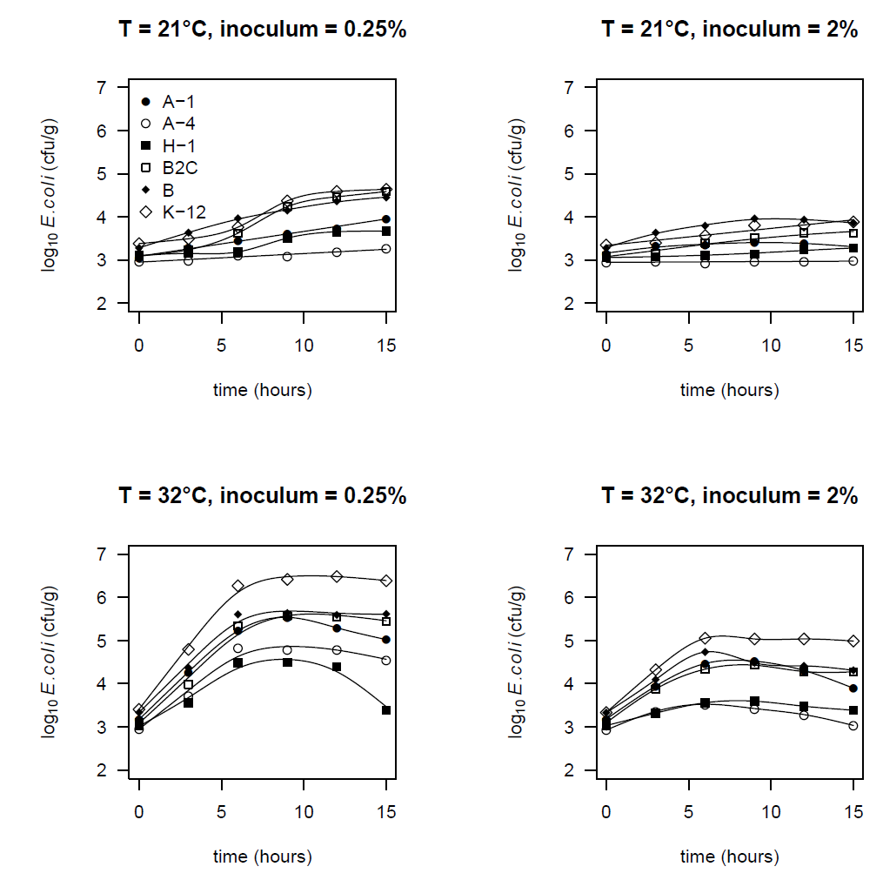
Figure 15: Response of enteropathogenic (A-1, A-4, H-1 and B2C) and non-pathogenic (K-12 and B) E. coli strains when co-cultured in skim milk with a commercial mixed strain homofermentative starter culture at two temperatures (21 and 32°C) and inoculum levels (0.25% and 2%). Data from Frank and Marth (1977).

3.4 Cheese challenge studies
The milk challenge studies in Section 3.3 were performed under constant temperature conditions, while cheesemaking processes require changes in temperature e.g. curd cooking to achieve the desired cheese characteristics.

To illustrate the dynamic changes in physico-chemical properties during challenge cheese studies and consequential effect of L. monocytogenes concentration data from four challenge cheeses are presented, namely: High salt (Papageorgiou and Marth, 1989a), Internal mould (The Pasteur Institute of Lille, 2001), Surface mould (Maisnier-Patin et al., 1992) and Surface ripened (Ryser and Marth, 1989b). These examples were chosen to highlight differences in production methods and the influence of changes in physico-chemical characteristics during maturation/ripening which may lead to the growth of L. monocytogenes. A brief summary of information relating to the conduct of the challenge studies is provided in Table 5.
The High salt cheese uses a combination thermophilic starters (Streptococcus thermophilus and Lactobacillus bulgaricus) while the other three cheeses are made with mesophilic starter cultures. This is reflected in the higher milk ripening temperature used for the thermophilic starters (35-37°C) compared with the mesophilic starters (30 – 34°C). Adjunct/smear cultures are used for the Internal mould (Penicillium roqueforti), Surface mould (Penicillium camemberti) and Surface ripened (Brevibacterium linens) to develop the characteristic properties of the cheese types.

Each of the cheeses was rennetted to aid coagulation and curd formation. The differences in the curd cooking temperatures were quite wide with the Surface ripened cheese having the highest temperature, higher even that the High salt cheese made with thermophilic starter culture. The Surface ripened cheese had an additional manufacturing step when warm water was added to wash the curd after the cooking step. This washing will result in a loss of lactose and other soluble curd components.

Salting was performed by brining, dry salting or a combination of both methods. The High salt cheese was stored under brine at 4°C for up to 90 days, with the other three cheeses stored under controlled temperature and humidity conditions.

Table 5:Summary information for the production of challenge study cheeses from four superfamilies: High salt, Internal mould, Surface mould and Surface ripened
 | High salt | Internal mould | Surface mould | Surface ripened
Starter and adjunct cultures | Streptococcus thermophilus and Lactobacillus bulgaricus | Typically mesophilic starters  Penicillium roqueforti | Lactococcus lactis subsp lactis (2 nisin negative strains)  Penicillium camemberti. | Streptococcus cremoris CC6  Brevibacterium  linens
Inoculum preparation | 37°C for 14-16h in skim milk | Not reported | skim milk | 21°C for 16-18 hours in reconstituted non-fat dry milk
Inoculum size | 1% v/v | Not reported | 2%  Penicillium camemberti spores added to milk | 0.25% w/w
Milk type | Pasteurised whole cow milk | Raw ewe milk | Pasteurised skim milk | Pasteurised whole cow milk
Rennet | Yes | Yes | Yes | Yes
Other additions | Calcium chloride
Milk ripening conditions | 35-37°C for 45 minutes | 30°C | 31-34°C | 31.1°C
Curd cooking conditions | 35-37°C | 18°C | 28.4-31°C | 38.9°C
Additional process steps |  |  |  | Curd washing  Smearing
Hooping
Salting method | Brine | Dry | Dry | Brine + dry
Salting conditions | 12% salt brine for 24 h at 22°C followed by  6% brine for 4 days at 22°C | 12 °C |  | 22% salt brine at 10°C for 24 hours followed by dry salting
Maturation conditions | 6% salt brine at 4°C up to 90 days | Natural caves  9 to 10°C  90 days (minimum) | 11°C  85-95% humidity | 15.5°C  95% relative humidity
Cheese size | Block 8.7x6.5x7.0 cm |  | 12 cm diameter | 6.35x6.5x6.5 cm

3.4.1 Cheese formation
Figure 16 to Figure 18 show the temporal changes in temperature, pH and L. monocytogenes concentration during the first three days of the respective challenge studies. This period covers all of the main aspects need to form the cheese ready for maturation/ripening: milk warming, acidification, curd formation and cooking, hooping, salting and the start of maturation (Figure 10).

Figure 16 is a graphical summary of the temperatures listed in Table 5 and indicates the time at which salting (dry or brining) occurs and the start of maturation. The Surface ripened cheese has an additional smearing step where the surface of the cheese is inoculated with Brevibacterium linens. The Internal and Surface mould cheeses also have Penicillium species mould’s added either to the milk or at hooping. The difference in the brining temperature appears to have an impact on the pH of the High salt and Surface ripened cheeses.

The IBR-High Salt cheese is brined at 22°C until the pH reaches 4.3 while the Surface ripened cheese is brined at 10°C a temperature which would likely slow the acidification of the curd by the mesophilic starter. The combination of a low starter culture inoculum (0.25%), curd washing and low brining temperature resulted in a relatively high pH at smearing of 5.34. The pH for all other cheeses at the same time was below 5 (Figure 17). The pH response with time for these cheeses is generally similar to that observed in the milk challenge study data (Figure 11).
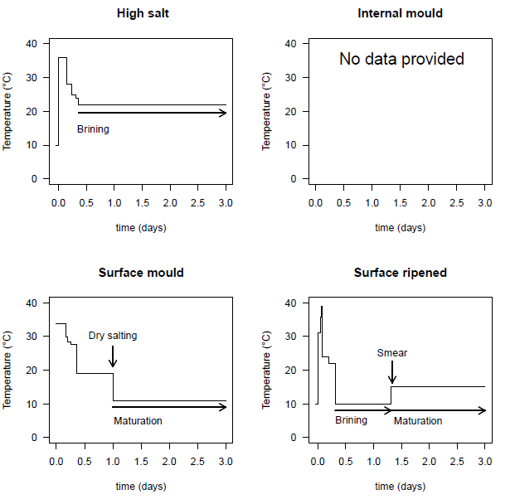
Figure 16: Temperature profiles for challenge study cheeses for four superfamily groups up to three days from the start of cheesemaking: High salt, Internal mould, Surface mould and Surface ripened.
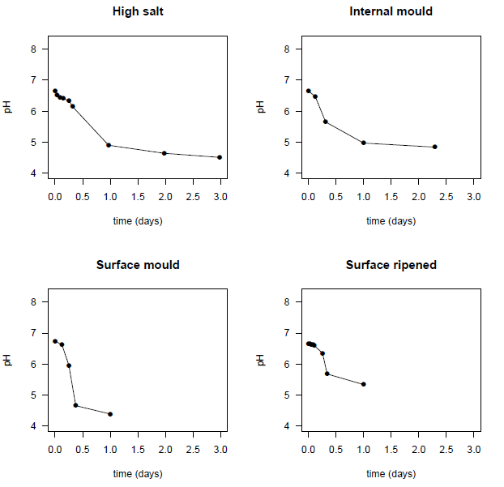
Figure 17: pH profiles for challenge study cheese for four superfamily groups up to three days from the start of cheesemaking: High salt, Internal mould, Surface mould and Surface ripened

Section 0 of this document highlighted the importance of the starter culture and acidification of the milk to limit the growth of pathogens. Figure 18 shows the dynamic changes in L. monocytogenes concentration for each of the challenge cheeses during the initial stages of cheese production. The dashed line in each panel represents the +1 log₁₀ increase from the initial inoculum level. This increase is due to the entrapment of pathogens during curd formation. Therefore concentrations above the dashed line are taken to represent actual growth during the early stages of cheesemaking.

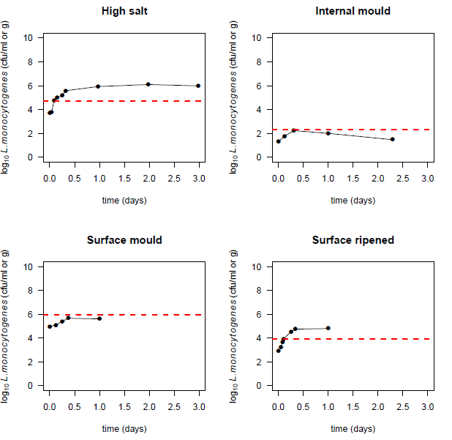
Figure 18: Changes in L. monocytogenes concentration through the first three days of each challenge study for High salt, Internal mould, Surface mould and Surface ripened cheese types. The dashed line indicates 1 log₁₀ increase in L. monocytogenes

Two of the challenge studies did not show evidence of growth during the initial fermentation of the milk: Internal mould and Surface mould, while two studies did: High salt and Surface ripened. For the High salt cheese the mean increase in concentration in the curd was 0.92 log₁₀ while actual growth was 1.41 log₁₀, giving a total increase of 2.33 log₁₀ (Papageorgiou and Marth, 1989a). The results in Figure 18 highlight the limitations of using published challenge studies as they are observational. If another starter culture, a higher inoculum size or temperature profile was used then the actual growth could be different.

3.4.2 Maturation and ripening
Figure 19 and Figure 20 presents the pH and L. monocytogenes concentration through to the end of the respective challenge studies, including maturation/ripening. For the High salt cheese where no adjunct culture was used the pH remained stable to the end of the study (90 days). For each of the other three cheeses, the addition of the adjunct cultures: Penicillium roqueforti for Internal mould, Penicillium camemberti for Surface mould and Brevibacterium linens for Surface ripened resulted in increases in the cheese pH. The pH changes for the Surface mould cheese were much faster than the other cheeses.

For both the Surface mould and Surface ripened cheeses, the pH on the surface was consistently higher than in the interior/core.
In the case of the Surface ripened cheese, this difference was as large as 2 pH units after 25 days from the start of cheesemaking and nearly 1 unit different at the end of the challenge study. The relative difference in surface and interior pH for the Surface ripened cheese was not as great as for the Surface mould cheeses. The Internal mould cheese pH results were determined from a slice sample so surface to interior differences could not be assessed.

The response of L. monocytogenes to the changes in pH is presented in Figure 20. The high pH values of the Surface mould and Surface ripened cheeses lead to the growth of L. monocytogenes. For the Surface mould cheese, the surface concentration reached 10 log₁₀ cfu/g, while the interior concentration peaked at 8 log₁₀ cfu/g. A 2 log₁₀ reduction was observed at the start of ripening, probably due to the low pH. No initial reduction in L. monocytogenes concentration was observed for Surface ripened cheese, likely due to the higher pH at the start of ripening.

The concentration of L. monocytogenes in the Internal mould cheese increased by 1 log₁₀ during the initial stages of cheese production and then dropped by about 1 log₁₀ at the start of maturation and persisted throughout the challenge study up to 175 days. For the High salt cheese the L. monocytogenes concentration remained unchanged for a period of nearly 30 days before slowly declining.
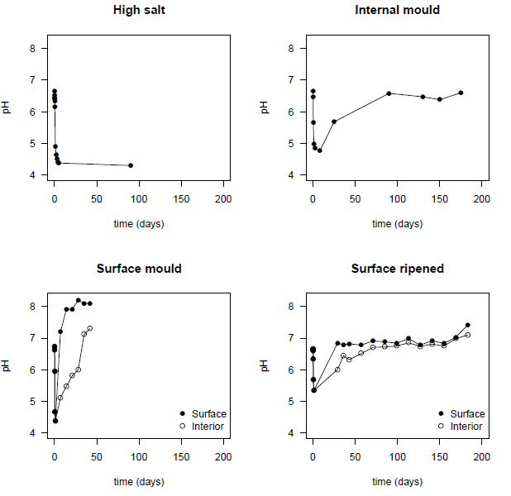
Figure 19: pH profiles for challenge study cheese for four superfamily groups through to the end of the respective trial: High salt, Internal mould, Surface mould and surface ripened. Closed circles (●) represent the pH on the surface/crust and open circles (○) represent the pH in internal/core samples. Closed squares are used where slices or portions were sampled.
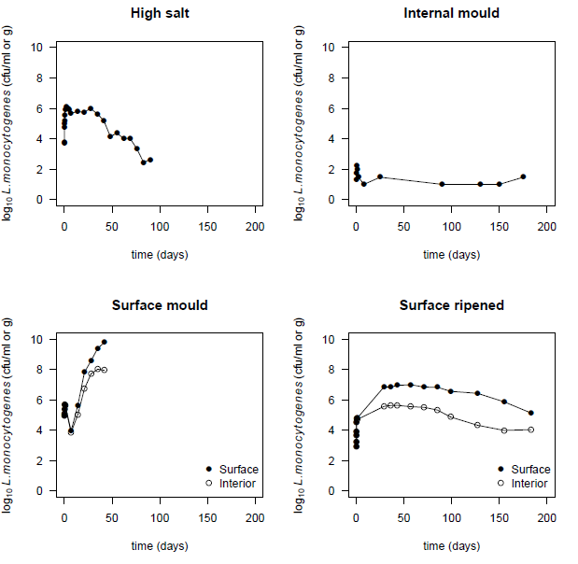
Figure 20: Changes in L. monocytogenes concentration throughout to the end of the respective trial for High salt, Internal mould, Surface mould and Surface ripened cheese types.
Dynamic changes in the physico-chemical characteristics due to the initial action of starter cultures and subsequently by adjunct cultures influence the response of pathogens such as L. monocytogenes. It is therefore important that decisions regarding the selection of starter and adjunct (and secondary) cultures influence the characteristics of the cheese and the response of pathogens. The design of a challenge study must adequately reflect the processes used to make the raw milk cheese, including consideration of variability.

3.5 Establishing no net increase
This section is to draw together the findings from Sections 2 and 3. The outcome is to establish a minimum maturation time to meet the no net increase requirement for raw milk cheeses. This determination process includes considering the changes in pathogen concentration during milk warming, acidification and curd formation together with the inactivation during cheese maturation.

Mathematically this may be stated as:

$$\sum{Increase}+\sum{Reduction≤0}$$

Σ Increase refers to the initial stages of cheese production, including the increase due to entrapment of pathogens in the curd and not growth in the maturing/ripening cheese. Σ Reduction may be due to specific processing steps (e.g. curd cooking) or the inactivation of the pathogens during the maturation/ripening of the cheese.

No equations are available to predict the inactivation rates of pathogens in cheeses. Ross et al. (2008) investigated the thermal and non-thermal inactivation of E. coli and
L. monocytogenes in uncooked meat products and broths. They found that in broth culture for non-thermal inactivation the Arrhenius activation energies were the same for both E. coli and L. monocytogenes. For L. monocytogenes, the Arrhenius equation the slope and intercepts were -10266 and 32.037 for broth cultures with growth preventing conditions of pH=3.5 and water activity = 0.90. These experimental conditions are well outside those observed for retail cheeses (
Figure 4).

In order to investigate the utility of the Ross et al. (2008) equation, challenge studies where growth was not observed were analysed and the first order inactivation rate calculated. The cheeses considered were all of the IBR superfamily. An example of the challenge study data in a Feta cheese is presented in Figure 21 for two strains of L. monocytogenes from milk inoculation to the end of the study (Papageorgiou and Marth, 1989a). The left panel in Figure 21 show the response of the California strain and the right panel the response of the Scott A strain. The response of L. monocytogenes in the Feta cheese is not consistent between individual experiments or strains. For the California strain trials, the concentration increases rapidly during cheesemaking and then steadily declines to the end of the 90 day experiment. By contrast, the Scott A strain also increases rapidly but then remains relatively constant for many weeks before declining (see Figure 20 and Figure 23 for individual trial results).
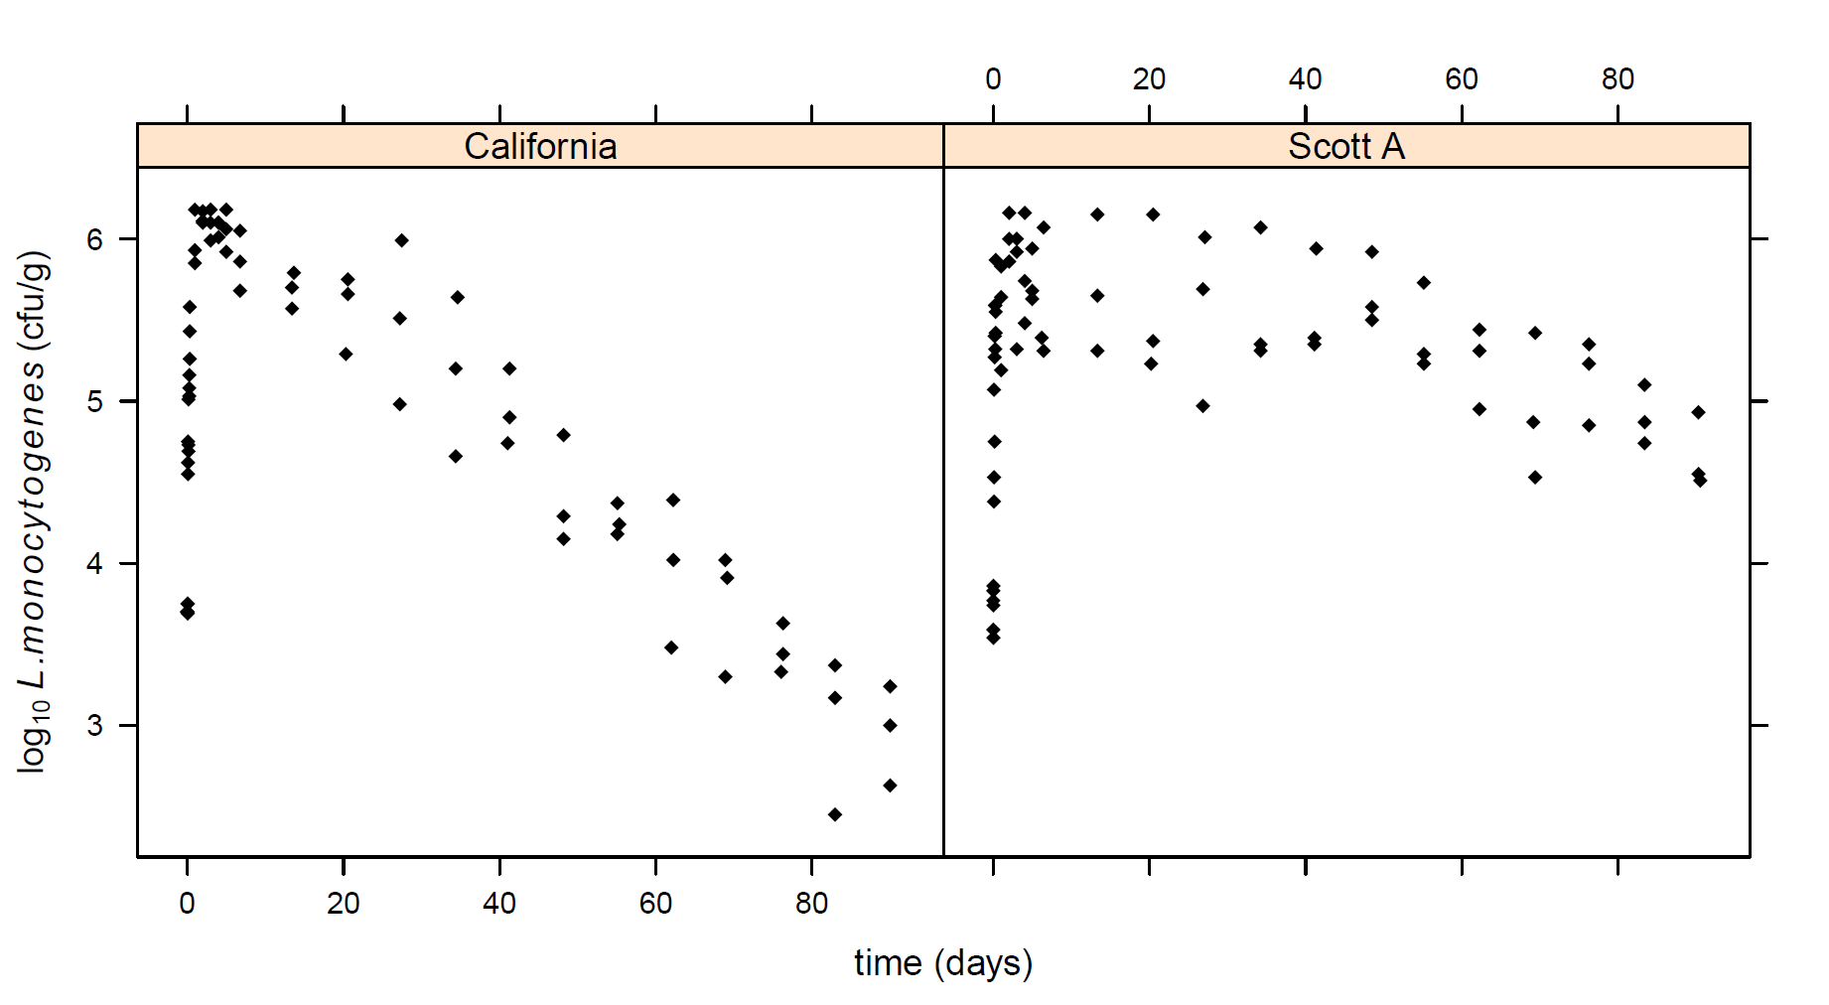
Figure 21: Changes in concentration of L. monocytogenes California and Scott A strains during the production and maturation of Feta cheese (Papageorgiou and Marth, 1989a).

Figure 22 is a summary of the inactivation rates for L. monocytogenes in the IBR cheeses: Cheddar (Ryser and Marth, 1987a), Colby (Yousef and Marth, 1988), Feta (Papageorgiou and Marth, 1989a) and Parmesan (Yousef and Marth 1990) is presented as an Arrhenius plot (natural logarithm of the inactivation rate vs the reciprocal of the absolute temperature in Kelvin) along with the Ross et al. (2008) equation. The Celsius scale is included for comparison.
The L. monocytogenes inactivation rates in cheese are well below the predicted rate using the Ross equation. For context, a 2.3 unit difference in the vertical scale represents a factor of 10 difference in the inactivation rates. At this highest temperature (left most data in Figure 22) the equation over estimates the observed rates by nearly a factor 10. The difference in the inactivation rates between experiments also varies by nearly a factor of 10. There was no evidence for a temperature effect on inactivation rates for these challenge studies.

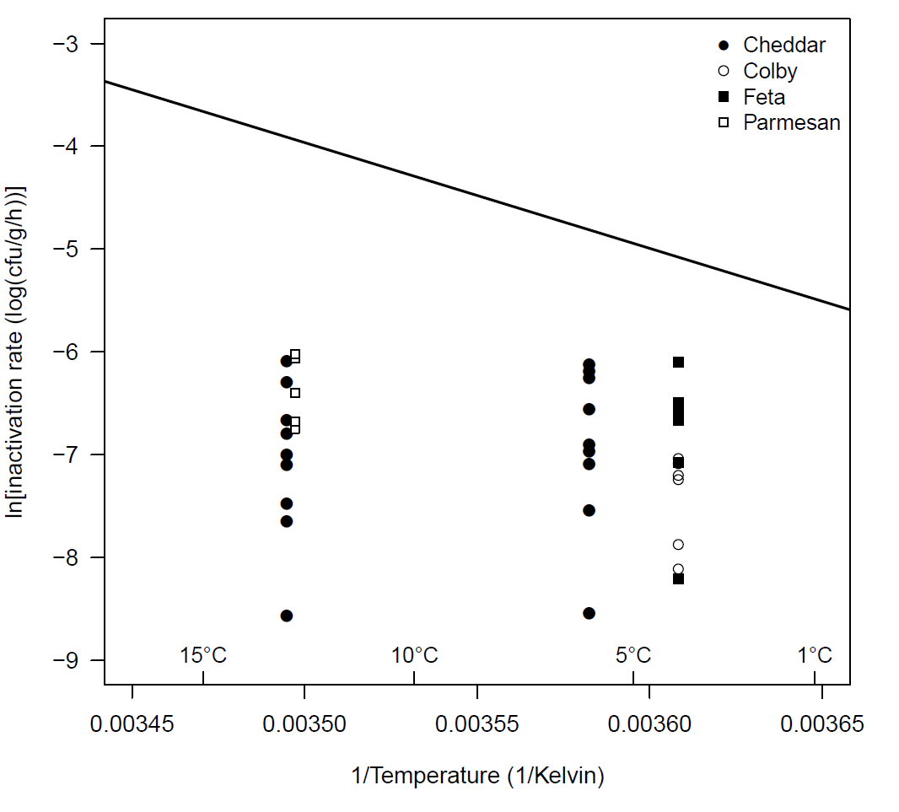
Figure 22: Effect of temperature on the rate of inactivation for L. monocytogenes in for IBR cheeses. Line represents prediction using Ross et al. (2008) equation.

The large amount of variability between challenge studies and strains of L. monocytogenes including the possible presence of shoulders (periods when inactivation does not occur) makes estimating a time to achieve no net increase difficult and must be carefully considered. The impact of a shoulder on the time required to reach no net increase is illustrated in Figure 23.

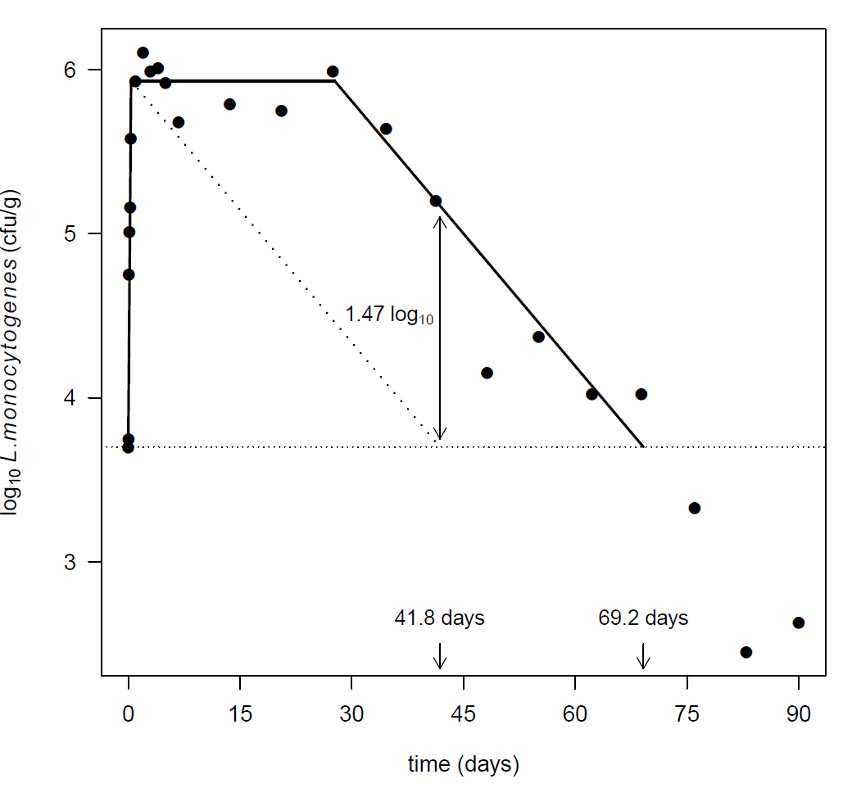
Figure 23: Illustrating the impact of a ‘shoulder’ on the calculation of the time required to achieve no net increase for L. monocytogenes in a Feta cheese (Papageorgiou and Marth, 1989a)

The initial total growth during cheesemaking is about 2.3 log₁₀, followed by a shoulder of around 27 days and then inactivation at a constant rate. If the shoulder was ignored and the same inactivation rate used to calculate the time to reach no net increase the result is 41.8 days. The actual time required for this experiment would be 69.2 days. The difference in concentration by not including the shoulder is +1.47 log₁₀.

Figure 23 also highlights the relative difference between growth rates during cheesemaking and the inactivation rates during maturation. Inactivation is a much slower process than growth and the increase in pathogen concentration due to entrapment during curd formation.

A box and whisker plot of the calculated time required to achieve no net increase for L. monocytogenes in IBR challenge study cheeses, including Swiss cheese (Buazzi et al, 1992) is presented in Figure 24. As shown by the horizontal dashed line in Figure 23, this is the time taken for the L. monocytogenes concentration to reach to initial inoculum level and includes curd concentration. Black dots are the median times, bottom and top of the boxes represent the 25th and 75th percentiles, open circles are outliers.

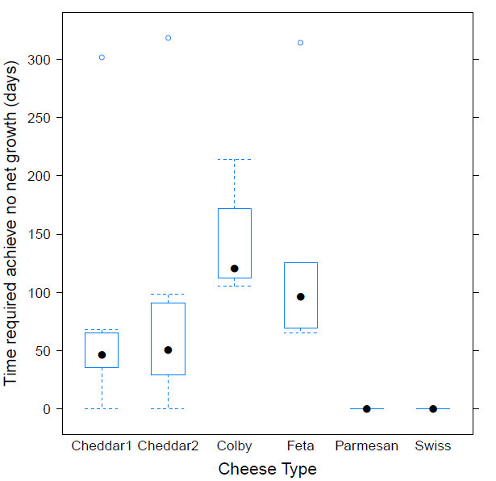
Figure 24: Maturation time required to achieve no net increase for challenge study cheeses that did not support the growth of L. monocytogenes

The Parmesan (curd cook of 51°C for 45 minutes) and Swiss (curd cook of 50°C for 30 to 40 minutes) both have times of zero (0) days due to the high curd cook temperature used during manufacture. No additional time is required to achieve no net increase as the curd cook achieves the required outcome. Maturation of the cheese will result in on-going inactivation of any pathogens such as L. monocytogenes, hence these types of cheeses would likely be permitted under the current approvals.

Cheddar1 and Cheddar2 are Cheddar cheeses which were stored at different temperatures, 6 and 13°C, respectively. The cheese pH (mean = 5.06) and times to achieve no net increase are similar (46.73 days and 50.95 days). This result is expected as there was no temperature effect on the rates of inactivation (Figure 22). In both cases, a single trial where the required maturation time was in excess of 300 days was reported. This highlights the variability in the response of pathogens during maturation. The physico-chemical properties reported in the papers did not explain the large difference between individual trials.

Colby is a washed curd cheese with a mean pH of 5.12 (range 5.00 to 5.18, n = 6) only slightly higher than Cheddar. The salt concentrations were found to be similar for both challenge cheeses. Despite the similarity in reported physico-chemical properties the median time required to achieve no net increase for Colby of 120.9 days is more than twice that for Cheddar cheese at either storage temperature. One contributing factor to this difference in times may be due to the washing of the curd and subsequent reduction in lactose and lactate concentration.

Feta cheese had a time required to achieve no net increase intermediate to Cheddar and Colby. Despite the low cheese pH (pH=4.3) the median time to achieve no net increase is 96.75 days. Unlike both Cheddar and Colby cheeses where no growth was observed during production, the Feta cheese exhibited a mean increase in L. monocytogenes concentration of 2.33 logs.
This increase was due to 0.92 log₁₀ due to curd concentration and 1.41 log₁₀ due to growth.

As a result the time taken to achieve no net increase was longer than might have been anticipated considering the physico-chemical properties and highlights the need to consider the entire production and ripening process. A single trial had a required time to achieve no net increase in excess of 300 days.

3.6 Demonstrating through challenge studies
The aim of a challenge study is to mimic as closely as possible the processes of contamination of the product, its processing, packaging, storage and distribution and end use, so as to evaluate the fate of pathogenic contaminants and consequent risk to public health.

Factors that can affect the fate (growth, inactivation, or survival) of the organism(s) of concern include (Ross, 2011):

- the physico-chemical properties of the food
- other micro-organisms in the food,
- the conditions (temperature, gaseous atmosphere, packaging type) under which the
- product is processed, distributed, stored and displayed and
- the properties of the organism(s) of concern (e.g. environmental limits to growth, responses to environmental conditions singly and in combination)

Material developed for the Ministry for Primary Industries, New Zealand titled Challenge testing of microbiological safety of raw milk cheeses: the challenge trial toolkit provides practical guidance on designing challenge studies (Ross, 2011). The key considerations when undertaking a challenge study include the following:

- the type of study (i.e. whether pathogen growth, or inactivation, or both are expected) so as to be able to correctly design the experiment to answer the specific question.
- the organism(s) of interest.
- factors related to the product of interest that will affect the fate of the challenge organism, including product preparation (process steps particularly Critical Control Points), variability in product and process characteristics, and types of packaging. The presence of competitive flora.
- the natural mode(s) of contamination of the product (e.g. stage of processing, how transferred), including:

  - levels of the organism(s) of interest that could be encountered in the food in “real world” situations
  - the physiological state of natural contaminants (e.g. whether stationary or exponential phase, spores or vegetative cells, etc.),

- storage duration and conditions (e.g. temperature, packaging type),
- variability (e.g. in pathogen response, in product or process characteristics, storage duration and conditions, etc. and including potential for product mishandling by others in the chain)
- number of samples and frequency of sampling.
- sampling method and analytical methods.

Details on each of these considerations are provided in the guidance document. Additional information on performing challenge studies for growth potential and durability studies can be found in Health Canada (2012), Beaufort (2011) and European Union Reference Laboratory (EU-RL) for Listeria monocytogenes (2009).

3.7 Discussion
Acidification of milk is a key step for limiting the growth of pathogens during the early stages of cheese making and it is therefore important to choose starter cultures suitable for the type of cheese. A summary of starter cultures used in challenge studies (Appendix 1) highlights the potentially wide variety of acid producers (homo-fermentative) or mixed type (homo- and hetero-fermentative) strains that can be used for the “same” type of cheese. Well characterised starter cultures assist in minimising pathogen growth.

Zanatta and Basso (1992) used a similar approach to classify strains of Streptococcus salivarius subsp thermophilus based on acidification kinetics in reconstituted dried skim milk. Statistical analysis of the acidification kinetic parameters revealed three distinct groups of strains corresponding to fast, medium and slow acidifications rates. A unique feature of this study was to simultaneously compare the acidification rates of strains from the fast and medium groups in a cheesemaking process. The slower rates of acidification during curd formation were observed for the medium strains compared to the fast strains. The results confirmed that the classification of starters when grown in skim milk were applicable to cheesemaking.

Park and Marth (1972) illustrated that different starter cultures can lead to dramatically different outcomes in terms of the growth of pathogens. The application of the Torrestiana equation to summarise pH changes with time provided insights into the effect of the maximum acidification rate on Salmonella Typhimurium growth. The finding that the amount of growth was linearly related to the maximum acidification rate, although expected, does provide guidance to starter selection.

Establishing that the cheese making process achieves the no net increase of pathogens requires an assessment of the entire cheese making process. As was shown in Section 3 the choice of starter culture and other variables such as inoculum size and temperature all influence the growth of pathogens during the early stages of cheese production.

For the four L. monocytogenes challenge study cheese considered here (Figure 18) there were clear differences in the amount of growth observed during the initial days from the start of production. In two cases (High salt and Surface ripened) the L. monocytogenes concentration exceeded the +1 log₁₀ increase in concentration due to entrapment in the forming curd. In the other two cases (Internal mould and Surface mould) the concentration didn’t reach the expected +1 log₁₀ increase. The addition of starter culture, acidification rates, pH, temperature and time appear to have combined to reduce the L. monocytogenes concentration in these studies. The analysis of the early stages of the cheese challenge studies are more complex than the simple milk challenge studies described in Section 0.

For the milk challenge studies, milk is inoculated with the starter cultures and then maintained at a constant temperature. Acidification parameters such the maximum rate of pH change and the time at which the maximum rate is reach can be readily determined. However, for cheese production, the addition of rennet and changes in temperature (e.g. milk warming, curd cooking etc.) make the interpretation of the experimental results more involved. An example is the blue cheese challenge studies by Papageorgiou and Marth (1989b). In this study salt was added to the vat after partial draining of the cooked curd. The effect was a change in the acidification rate which influenced the amount of growth observed for the inoculated L. monocytogenes strains.

Analysis of the kinetics of the inactivation of L. monocytogenes in four IBR cheeses (Figure 22) highlighted how slow inactivation of pathogens can be in cheeses and the large variability between challenge trials.
The slowest inactivation observed inactivation rates would require nearly a ten months for the concentration to decrease by a factor of ten. This finding highlights the importance of minimising the amount of growth of pathogens during the early stages of cheese making.

The calculation of the time to reach no net increase from the challenge studies was summarised in Figure 24. Two high curd cook cheeses (Extra Hard and Swiss) were included to illustrate the difference that temperatures capable of inactivating pathogens make to the required times. In both cases the time required was zero. However, the finding that the physico-chemical properties of the maturing cheese alone not sufficient to predict difference between cheeses within the same superfamily was informative. These results suggest that challenge studies which consider the entire cheese production and maturation process may be required to demonstrate the no net increase requirement.

Conclusion
The scientific evidence to meet the food safety objectives for the production of raw milk products that the intrinsic physico-chemical characteristics of the raw milk product do not support growth and that controls during processing that result in no net increase in hazard levels during manufacture has been presented. This evidence is summarised in Figure 1.

Demonstration that the intrinsic physico-chemical characteristics of the raw milk product do not support growth of pathogens requires evidence that the physico-chemical characteristics of the cheese (e.g. pH, moisture, salt, water activity, lactic acid etc.) do not support the growth of pathogens. The focus in this report has been on L. monocytogenes as most cheese challenge studies have focussed on this pathogen. Examining the available data it is apparent that the default criteria using pH and water activity developed by Codex (2007) are of limited use. Very few cheeses have the low pH or water activity required to meet these criteria. As an alternative predictive equations were considered. The focus was on a single probability of growth equation from the paper by Augustin et al. (2005). This paper considered a total of eight equations to predict either the growth rate or the probability of growth. Many new equations have been developed since 2005 which could also have been considered. The results point to the use of predictive equations to determing those cheeses where the physico-chemical properties support the growth of pathogens. The only clear group were those cheese where growth was found to occur and the probability of growth was very close to 1. Other challenge study cheeses where growth did not occur had probabilities of growth in the range of 0.1 to 0.9. Augustin suggests that validation studies should be performed on foods in this uncertain range. Where values of less than 0.1 were found it was for cheeses that had been stored at lower temperatures. The same results may not be found where the temperature was higher and the probability of growth increased. It is likely that challenge studies will be needed for most cheese types.

A default assumption when using predictive equations which include water activity is that it should be calculated from the salt concentration. Analysis of retail cheese samples has shown the water activity is for most superfamily groups less than that predicted by salt alone. To account for the difference in water activity, the multiplicative Ross (1975) equation was used to distinguish between water activity due to salt and all other solutes. No attempt was made to incorporate variability between cheeses within the same superfamily groups, rather the median value was used.

An implicit assumption in the application of the Augustin et al. (2005) equation is that the effect of salt on the growth of pathogens is the same as the other solutes. This may not be the case. However of the two choices: (1) other solutes have no effect of the probability of growth of pathogens and (2) other solutes have the same effect as salt on the probability of growth of pathogens; the second option seems more appropriate.
Demonstrating the food safety outcome that there is no net increase in pathogen concentration through the entire cheese making process requires a greater degree of evidence. Analysis of challenge studies highlights the difference between growth and inactivation rates; inactivation is much slower process than growth. This reinforces the importance of minimising the potential for growth of pathogens during the early stages of cheese making. One possibility considered is the choice of starter cultures capable of rapid acidification. Analysis of the growth response of Salmonella Typhimurium to different lactic acid bacteria (Park and Marth, 1972) demonstrated a linear relationship between the amount of growth and the maximum acidification rate. This type of finding can be exploited by cheesemakers.

Four types of challenge studies may inform the safety of a raw milk cheese:

- direct cheese challenge
- constant temperature milk challenge
- dynamic milk challenge
- cheesemaking process challenge

The direct cheese inoculation challenge study can be used to determine if the raw milk cheese supports the growth of pathogens. This is an essential first step in progressing through the flow diagram in Figure 1. The constant temperature milk challenge study as outlined in Section 0 and Appendix 4 may be used to screen starter cultures for both technological function (acid and flavour production) but also the ability to inhibit the growth of pathogens. This approach is especially relevant where defined starter cultures are not used e.g. milk or whey starters. The dynamic milk challenge study aims to replicate the initial stages of the cheesemaking process. As shown in Section 0 the analysis of challenge studies focussing on the first three days of the cheesemaking process provides important insights to the response of pathogens to the dynamic changes in temperature, pH and salt. The cheesemaking process challenge study is the ultimate study as it considers all of the processing steps from the raw milk through to the final cheese.

The amount and type of evidence required to demonstate the safety of cheeses may depend on the type of cheese. For example the evidence required for a High salt cheese with a low pH would be different to a Internal mould cheese with high pH and lower salt concentration. The closer to the growth boundary of the pathogens the greater the information requirements and ultimately process control.

5 References
Augustin, J.-C. and Carlier, V. (2000) Mathematical modelling of the growth rate and lag time for Listeria monocytogenes. International Journal of Food Microbiology 56:29–51
Augustin J-C, Zuliani V, Cornu M, Guillier L (2005) Growth rate and growth probability of Listeria monocytogenes in dairy, meat and seafood products in suboptimal conditions. Journal of Applied Microbiology 99:1019-1042
Baranyi J, Roberts TA and McClure PJ (1993) A non-autonomous differential equation to model bacterial growth. Food Microbiology 10:43-59
Beaufort A (2011) The determination of ready-to-eat foods into Listeria monocytogenes growth and no growth categories by challenge tests. Food Control 22:1498-1502
European Union Reference Laboratory (EU-RL) for Listeria monocytogenes (2009) Technical guidance document - On shelf-life studies for Listeria monocytogenes in ready-to-eat foods. Version 2 14/11/2008 correction 29/04/2009 http://www.ansespro.fr/eurl-listeria/Documents/LIS-Cr-200904G.pdf
Accessed 25 October 2013
Buazzi MM, Johnson ME, Marth EH (1992) Survival of Listeria monocytogenes during the manufacture and ripening of Swiss cheese. Journal of Dairy Science 75:380-386
Chirife J, Resnik (1984) Unsaturated solutions of sodium chloride as reference sources of water activity at various temperatures. Journal of Food Science 49:1486-1488
Codex (1978) Codex general standard for cheese. Codex Stan 283-1978 (amended 2008)
Codex (2007) Guidelines on the application of general principles of food hygiene to the control of Listeria monocytogenes in foods. CAC/GL 61 - 2007
Cogan TM (1978) Determination of growth rates of lactic starter cultures. Irish Journal of Food Science and Technology 2:105-115
Cogan TM, Barbosa M, Beuvier E, Bianchi-Salvadori B, Cocconcelli PS, Fernandes I, Gomez J, Gomez R, Kalantzopoulos G, Ledzda A, Medina M, Rea MC, Rodriguez E (1997) Characterization of the lactic acid bacteria in artisanal dairy products. Journal of Dairy Research 64:409-421
Fernandez-Salguero J, Alcala M, Marcos A, Esteban MA (1986) Measurement and calculation of water activity in Blue cheese. Journal of Dairy Research 53:639-644
Frank JF and Marth EH (1977) Inhibition of enteropathogenic Escherichia coli by homofermentative lactic acid bacteria in skimmilk I. Comparison of strains of Escherichia coli. Journal of Food Protection 40:749-753.
FSANZ (2009) Microbiological Risk Assessment of Raw Milk Cheese. http://www.foodstandards.gov.au/code/proposals/documents/P1007%20PPPS%20for%20raw%20milk%201AR%20SD3%20Cheese%20Risk%20Assessment.pdf
FSANZ (2013) Agents of foodborne illness. 2nd ed. Food Standards Australia New Zealand, Canberra, Australia
Fox PF, Guinee TP, Cogan TM, McSweeney PLH (2004) Fundamentals of Cheese Science. Aspen Publishers
Guinee TP, Kilcawley KN, Beresford TP (2008) How variable are retail vintage brands of cheddar cheese in composition and biochemistry? Australian Journal of Dairy Technology 63:50-60
Health Canada (2012) Listeria monocytogenes Challenge Testing of Refrigerated Ready-to-Eat Foods. http://www.hc-sc.gc.ca/fn-an/alt_formats/pdf/legislation/pol/listeria_monocytogenes-test-eng.pdf. Accessed 18 September 2014
Maisnier-Patin S, Deschamps N, Tatini SR, Richard J (1992) Inhibition of Listeria monocytogenes in Camembert cheese made with a nisin-producing starter. Lait 72:249-263
Marcos A, Alcalá M, León F, Fernández-Salguero J, Esteban MA (1981) Water activity and chemical composition of cheese. Journal of Dairy Science 64:622-626
Marcos A, Esteban MA (1982) Nomograph for predicting water activity of soft cheese. Journal of Dairy Science 65:1795-1797
Marcos A, Esteban MA, Alcala M (1990) Determination of water activity in Brie and Camembert cheese varieties by four different methods. Food Chemistry 38:189-199
Mejlholm O, Dalgaard P (2009) Development and validation of an extensive growth and growth boundary model for Listeria monocytogenes in lightly preserved and ready-to-eat shrimp. Journal of Food Protection 72:2132-2143
Mejlholm O, Gunvig A, Borggaard C, Blom-Hanssen J, Mellefont L, Ross T, Leroi F, Else T, Visser D, Dalgaard P (2010) Predicting growth rates and growth boundary of Listeria monocytogenes — An international validation study with focus on processed and ready-to-eat meat and seafood. International Journal of Food Microbiology 141:137-150
McKellar R and Lu X (eds) (2004) Modeling microbial responses in food. CRC Press. Boca Raton.
Papageorgiou DK, Bori M, Mantis A (1996) Growth of Listeria monocytogenes in the whey cheeses Myzithra, Anthotyros, and Manouri during storage at 5, 12, and 22°C. Journal of Food Protection 59:1193-1199
Papageorgiou DK, Marth EH (1989a) Fate of Listeria monocytogenes during the manufacture, ripening and storage of feta cheese. Journal of Food Protection 52:82-87
Papageorgiou DK, Marth EH (1989b) Fate of Listeria monocytogenes during the manufacture and ripening of Blue Cheese. Journal of Food Protection 52:459-465
Park HS, Marth EH (1972) Behaviour of Salmonella typhimurium in skimmilk during fermentation by lactic acid bacteria. Journal of Milk and Food Technology 35(8):482-488
The Pasteur Institute of Lille (2001) Study of the evolution of strains of Listeria monocytogenes and Salmonella enterica during the manufacture and storage of Roquefort cheese. 13 pages
Picque D, Perret B, Latrille E, Corrìeu G (1992) Caracterisation et classification de bacteries lactiques à partir de la mesure de leur cinetique d’acidification [Characterization and classification of lactic acid bacteria based on the acidification kinetic]. Lebensmittel-Wissenschaft und -Technologie 25:181-186. In French
Pitzer KS (1973) Thermodynamics of electrolytes. 1. Theoretical basis and general equations. Journal of Physical Chemistry 77:268-277
Resnik SL, Chirife J (1988) Proposed theoretical water activity values at various temperatures for selected solutions to be used as reference sources in the range of microbial growth. Journal of Food Protection 51:419–423
Ross KD (1975) Estimation of water activity in intermediate moisture foods. Food Technology 29:26, 28, 30, 32, 34
Ross T, Zhang D, McQuestin OJ (2008) Temperature governs the inactivation rate of vegetative bacteria under growth-preventing conditions. International Journal of Food Microbiology 128:129-135
Rüegg M, Blanc B (1977) Beziehungen zwischen wasseraktivität, wasser-sorptionsvermögen und zusammensetzung von käse [Relationships between water activity, water sorption capacity and cheese composition]. Milchwissenschaft 32:193-201. In German
Ryser ET, Marth EH (1987a) Behavior of Listeria monocytogenes during the manufacture and ripening of Cheddar cheese. Journal of Food Protection 50:7-13
Ryser ET, Marth EH (1987b) Fate of Listeria monocytogenes during manufacture and ripening of Camembert cheese. Journal of Food Protection 50:372-378
Ryser ET, Marth EH (1989) Behavior of Listeria monocytogenes during manufacture and ripening of brick cheese. Journal of Dairy Science 72:838-853
Schvartzman MS, Belessi X, Butler F, Skandamis P, Jordan K (2010) Comparison of growth limits of Listeria monocytogenes in milk, broth and cheese. Journal of Applied Microbiology 109:1790-1799

Spinnler HE, Corrieu G (1989) Automatic method to quantify starter activity based on pH measurement. Journal of Dairy Research 56:755-764

Tan A, Beaton S, Dimovski K, Hogg G, di Paola V, Haines H (2008) Pathogen survival in portioned
retail soft cheeses. The Australian Journal of Dairy Technology 63:39-44
Torrestiana B, Brito de la Fuente SE, Lacroix C, Choplin L (1994) Modelling the acidifying activity profile of Lactobacillus bulgaricus cultures. Applied Microbiology and Biotechnology 41:192-196
Willman N and Willman C (1999) Home cheesemaking. Neil and Carol Willman. Little River, Victoria. 2nd edition.
Withers H, Couper J (2012) Effect of microbial interactions on pathogen growth and survival during fermentation of raw milk − Final report. MPI Technical Paper No: 2012/13. New Zealand Ministry for Primary Industries. http://foodsafety.govt.nz/elibrary/industry/microbial-interactions-pathogen-raw-milk/microbial-interactions-pathogen-growth-technical%20paper.pdf Accessed 26 July 2012.
Yousef AE, Marth EH (1988) Behaviour of Listeria monocytogenes during the manufacture and storage of Colby cheese. Journal of Food Protection 51:12-15
Yousef AE, Marth EH (1990) Fate of Listeria monocytogenes during the manufacture and ripening of Parmesan cheese. Journal of Dairy Science 73:3351-3356
Zanatta P, Basso A (1992) A new approach to the characterization of Streptococcus salivarius subsp thermophilus based on acidification rates. Lait 72:285-295

Appendix 1 – Starter and adjunct cultures used in pathogen challenge study cheeses
Reference | Cheese name/Descriptor | Cultures added
Abdulla et al. (1993) JFP 56(10):841-846 | White pickled | Lactococcus lactis ssp. cremoris
Bachmann and Spahr (1995) JDS 78:476-483 | Swiss hard (Emmentaler-style) and semihard (Tilsiter-style) | Lactococcus delbrueckii spp. lactis  Streptococcus salivarius spp. thermophilus
Buazzi et al. (1992) JDS 75:380-386 | Swiss | Streptococcus salivarius ssp. thermophilus  Lactobacillus helveticus  Propionibacterium shermanii
D'Amico et al. (2008) JFP 71(8):1563-1571 | Soft cheese | Starter cultures  Lactococcus lactis subsp. lactis  L. lactis subsp. cremoris  L. lactis subsp. lactis biovar diacetylactis  Streptococcus salivarius subsp. thermophilus  Ripening cultures  Kluyveromyces lactis  Geotrichum candidum  Penicillium candidum
Dominguez et al. (1987) LAM 4:125-127 | Semi-hard | Streptococcus lactis  Strep. cremoris  Strep. diacetylactis  Leuconostoc cremoris
Erkmen (2000) JFE 46:127-131 | Turkish white (Feta) | Lactococcus lactis subsp. cremoris
Erkmen and Bozoğlu (1995) LWT 28:259-263 | Feta | Lactococcus lactis subsp. cremoris
Govaris et al. (2002) JFP 65(4):609-615 | Feta and Telemes | Contemporary method  Mixture of mesophilic starter culture strains:  Lactococcus lactis subsp. lactis  L. lactis subsp. cremoris  Traditional method  Thermophilic yoghurt-type starter strains:  L. delbrueckii subsp. bulgaricus  Streptococcus salivarius subsp. thermophilus
Kornacki and Marth (1982) JFP 45(4):310-316 | Colby-like | Streptococcus lactis
Kovincic et al. (1991) JFP 54(6):418-420 | Trappist | Streptococcus lactis subsp. lactis  S. lactis subsp. cremoris
Liu et al. (2008) IJFST 44(1):29-35 | Camembert | Lactococcus lactis subsp. lactis  Lactococcus lactis subsp. cremoris  Lactococcus lactis subsp. lactis biovar acetylactis  Leuconostoc mesenteroides subsp. cremoris  Penicillium candidum
Margolles et al. (1997) JFP 60(6):689-693 | Afuega'l Pitu | Lactococcus lactis subsp. lactis  Lactococcus lactis subsp. lactis biovar diacetylactis  Leuconostoc citreum
Papageorgiou and Marth (1989) JFP 52(7):459-465 | Blue | Streptococcus lactis  Strep. cremoris  Streptococcus lactis subsp. diacetylactis  Penicillium roqueforti
Papageorgiou and Marth (1989) JFP 52(2):82-87 | Feta | Streptococcus thermophilus  Lactobacillus bulgaricus
Ramsaran et al. (1998) JDS 81:1810-1817 | Soft cheese:  Camembert and Feta | Lactococcus lactis spp. lactis  Penicillium candidum
Reitsma and Henning (1996) JFP 59(5):460-464 | Cheddar | Mesophilic lactic starter REDI-SET #253
Ryser and Marth (1989) JDS 72:838-853 | Brick  - Mild  - Aged  - "Limburger-like" | Starter culture  Streptococcus cremoris CC6  Smear culture  Brevibacterium linens
Ryser and Marth (1987b) JFP 50(5):372-378 | Camembert | Streptococcus cremoris CC6  Penicillium camemberti
Ryser and Marth (1987a) JFP 50(1):7-13 | Cheddar | Streptococcus cremoris CC6
Ryser, Marth and Doyle (1985) JFP 48(9):746-750 | Cottage:  creamed and uncreamed | Streptococcus cremoris CC6 and OS
Schlesser et al. (2006) JFP 69(5):990-998 | Cheddar | Mesophilic lactic cultures R-703 or R-704 freeze-dried lactic culture for direct vat set
Spano et al. (2003) LAM 36:73-76 | Mozzarella | None
Tatini et al. (1971) JDS 54(6):815-825 | Cheddar  Colby | Streptococcus lactis
Villani et al. (1996) LAM 22:357-360 | Mozzarella | Natural whey culture
Yousef and Marth (1988) JFP 51(1):12-15 | Colby | Streptococcus cremoris CC6
Yousef and Marth (1990) JDS 73:3351-3356 | Parmesan | Streptococcus thermophilus  Lactobacillus bulgaricus
Journal titles: FM – Food Microbiology; IJFST – International Journal of Food Science and Technology;
JAM – Journal of Applied Microbiology; JDS – Journal of Dairy Science; JFE – Journal of Food Engineering;
JFP – Journal of Food Protection; LAM – Letters in Applied Microbiology;
LWT – Lebensmittel-Wissenschaft und -Technologie (Food Science and Technology)

Appendix 2 – Summary of physico-chemical tests performed in cheese challenge studies
Reference | Cheese name/ descriptor | Starting material | Pathogen(s)  (Inoculation) | pH | Titratable acidity | Salt | Moisture | Fat | Total solids | Protein | Ash | Organic acids | Other
Abdalla et al. (1993) JFP 56(10):841-846 | White pickled | Pasteurised milk | Lm  (milk) | Y | Y | Y | N | Y | Y | Y | Y | N | Proteolysis
Bachmann and Spahr (1995) JDS 78:476-483 | Swiss hard (Emmentaler-style) and semihard (Tilsiter-style) | Raw cow milk | Ec Lm ST  (milk) | Y | N | Y | Y | Y | N | Y | N | N
Buazzi et al. (1992) JDS 75:380-386 | Swiss | Pasteurised milk | Lm  (milk) | Y | N | Y | Y | Y | N | N | N | N
D'Amico et al. (2008) JFP 71(8):1563-1571 | Soft cheese | Raw and pasteurised milk | Lm  (cheese surface) | Y | Y | Y | Y | Y | Y | Y | N | N
Dominguez et al. (1987) LAM 4:125-127 | Semi-hard | Pasteurised milk  (15: 35: 50 of sheep, goat and cow) | Lm  (milk) | Y | N | N | N | N | N | N | N | N
Erkmen (2000) JFE 46:127-131 | Turkish white (Feta) | Pasteurised whole cow milk | Lm  (milk) | Y | N | N | N | N | N | N | N | N
Erkmen and Bozoğlu (1995) LWT 28:259-263 | Feta | Pasteurised cow milk | ST  (milk) | Y | N | N | N | N | N | N | N | N
Genigeorgis, Carniciu et al. (1991) JFP 54(9):662-668 | Queso Fresco  Queso Panela  Queso Ranchero  Ricotta  Teleme  Brie  Camembert  Cottage | Market cheeses | Lm  (cheese surface) | Y | N | Y | Y | N | N | N | N | N
Govaris et al. (2001) FM 18:565-570 | Myzithra, Anthotyros and Manouri whey cheeses | Ewe and goat milk  Cream | Ec  (cheese) | Y | N | Y | Y | Y | N | N | N | N
Govaris et al. (2002) JFP 65(4):609-615 | Feta and Telemes | Pasteurised whole cow milk  Pasteurised whole ewe milk | Ec  (milk) | Y | N | Y | Y | Y | Y | N | N | N
Hicks and Lund (1991) JAB 70:308-314 | Cottage cheese | Commercially manufactured product | Lm  (cheese) | Y | N | N | N | N | N | N | N | Y
Kornacki and Marth (1982) JFP 45(4):310-316 | Colby-like | Pasteurised milk | Ec  (milk) | Y | N | Y | Y | Y | N | N | N | N
Kovincic et al. (1991) JFP 54(6):418-420 | Trappist | Pasteurised milk | Lm  (milk) | Y | Y | Y | Y | N | N | N | N | N
Lekkas et al. (2006) FM 23:268-276 | Galotyri | Pasteurised ewe's milk | Ec  (cheese) | Y | N | Y | Y | Y | N | Y | N | Y
Lin et al. (2006) JFP 69(9):2151-2156 | Queso Fresco | Market cheeses | Lm  (cheese) | Y | N | N | N | N | N | N | N | N
Liu et al. (2008) IJFST 44(1):29-35 | Camembert | Pasteurised whole milk | Lm  (cheese) | Y | N | N | N | N | N | N | N | N
Maher et al. (2001) JAM 90:201-207 | Smear-ripened | Unpasteurised whole milk | Ec  (milk) | Y | N | Y | Y | N | N | N | N | N
Margolles et al. (1997) JFP 60(6):689-693 | Afuega'l Pitu | Pasteurised whole milk | Lm  (milk) | Y | N | Y | Y | N | N | N | N | N | Water activity
Papageorgiou, Bori and Mantis (1996) JFP 59(11): 1193-1199 | Whey cheeses  - Myzithra  - Anthotyros  - Manouri | Whey plus cream/NaCl | Lm (cheese) | Y | N | Y | Y | Y | N | N | N | N
Papageorgiou and Marth (1989) JFP 52(7):459-465 | Blue | Pasteurised cow milk | Lm  (milk) | Y | N | Y | Y | Y | N | N | N | N
Papageorgiou and Marth (1989) JFP 52(2):82-87 | Feta | Pasteurised whole cow milk | Lm  (milk) | Y | N | Y | Y | Y | N | N | N | N | Water activity (by calculation)
Piccinin and Shelef (1995) JFP 58(2):128-131 | Cottage | Retail cheeses | Lm  (cheese) | Y | N | N | N | N | N | N | N | N
Ramsaran et al. (1998) JDS 81:1810-1817 | Camembert and Feta | Raw and batch pasteurised | Ec  (milk) | Y | N | N | N | N | N | N | N | N
Reitsma and Henning (1996) JFP 59(5):460-464 | Cheddar | Pasteurised whole milk | Ec  (milk) | Y | N | Y | Y | Y | N | N | N | N
Ryser and Marth (1989) JDS 72:838-853 | Brick  - Mild  - Aged  - "Limburger-like" | Pasteurised whole milk | Lm  (milk) | Y | N | Y | Y | Y | N | N | N | N | Water activity (by calculation)
Ryser and Marth (1987b) JFP 50(5):372-378 | Camembert | Pasteurised whole milk | Lm  (milk) | Y | N | Y | Y | Y | N | N | N | N
Ryser and Marth (1987a) JFP 50(1):7-13 | Cheddar | Pasteurised whole milk | Lm  (milk) | Y | N | Y | Y | Y | N | N | N | N
Ryser, Marth and Doyle (1985) JFP 48(9):746-750 | Cottage:  creamed and uncreamed | Pasteurised skim milk | Lm  (milk) | Y | N | N | Y | Y | N | N | N | N
Schlesser et al. (2006) JFP 69(5):990-998 | Cheddar | Raw milk | Ec  (milk) | Y | Y | Y | Y | Y | N | N | N | N
Spano et al. (2003) LAM 36:73-76 | Mozzarella | Raw whole cow milk | Ec  (milk) | N | N | N | N | N | N | N | N | N
Tan et al. (2008) | Brie  Blue  Washed rind | Commercial cheeses | Ec Lm Sa  (cheese) | Y | N | N | N | N | N | N | N | N | Water activity  (by measurement)
Tatini et al. (1971) JDS 54(6): 815-825 | Cheddar  Colby | HTST whole milk | Sa  (milk) | Y | Y | Y | Y | N | N | N | N | N
Villani et al. (1996) LAM 22:357-360 | Mozzarella | Water-buffalo milk | Lm  (milk) | Y | Y | N | N | N | N | N | N | N
Yousef and Marth (1988) JFP 51(1):12-15 | Colby | Pasteurised whole milk | Lm  (milk) | Y | N | Y | Y | Y | N | N | N | N
Yousef and Marth (1990) JDS 73:3351-3356 | Parmesan | Pasteurised whole and skim milk | Lm  (milk) | Y | N | Y | Y | Y | N | N | N | N
Total 'YES' |  |  |  | 32/35 | 6/35 | 23/35 | 22/35 | 18/35 | 3/35 | 4/35 | 1/35 | 2/35
Challenge microorganisms: Ah – Aeromonas hydrophila; Cj – Campylobacter jejuni; Ec – Escherichia coli; Li – Listeria innocua; Lm – Listeria monocytogenes;
Pa – Pseudomonas aeruginosa; ST – Salmonella Typhimurium; Sa – Staphylococcus aureus; Ye – Yersinia enterocolitica
Abbreviations: ERH – Equilibrium relative humidity; Fat in dry matter – FDM; IDF – International Dairy Federation; RH – Relative humidity
Journal titles: FM – Food Microbiology; IJFST – International Journal of Food Science and Technology; JAM – Journal of Applied Microbiology; JDS – Journal of Dairy Science;
JFE – Journal of Food Engineering; JFP – Journal of Food Protection; LAM – Letters in Applied Microbiology; LWT – Lebensmittel-Wissenschaft und -Technologie (Food Science and Technology

Appendix 3 – Prediction of water activity for challenge study cheeses
In order to determine whether a pathogen will grow in a raw milk cheese it is necessary to know the physico-chemical characteristics of the cheese. This may be default criteria such as pH and water activity or other values such as lactic acid concentration.

The range of physico-chemical characteristics measured in challenge study cheeses is often limited to moisture, salt and pH (see Appendix 2). Other properties used in the development of equations to predict the water activities of cheeses, such as ash and nonprotein nitrogen are not commonly measured. Calculating water activity using salt alone will lead to the prediction of water activity values higher (closer to 1) than if measured directly.

To adjust for cheese superfamily specific differences in water activity the Ross (1975) equation is used with two components: a_{w,salt} and a_{w,other}, where a_{w,other} represents the water activity reduction due to all non-salt components such as ash, nitrogen fractions (e.g. nonprotein) etc.

Equations using salt only

Marcos et al. (1981) found that the water activity of cheese with greater than 40% moisture could be predicted with reasonable accuracy using the following equation:

$$a_{w}=1-0.033M$$

where M is the molality of sodium chloride. Fox et al. (2004) presented a similar equation with different concentration units:

$$a_{w}=1.0042-0.0007NaCl (g/kg)$$

Augustin et al. (2005) calculated the water activity of foods when not reported in challenge studies using the salt concentration and moisture level using the data from Resnik and Chirife (1988):

$$a_{w}=1-0.0052471 \%WPS-0.00012206 \%{WPS}^{2}$$

where WPS is the weight percent salt. %WPS is calculated from the salt concentration and moisture content of the food:

$$\%WPS=100\frac{\%salt}{\left(\%moisture+\%salt\right)}$$

Although not stated by Augustin et al. (2005) regression analysis (not shown) of the Resnik and Chirife (1988) water activity-salt data suggests that this equation was developed using concentration data up to 10 %WPS.

Chirife and Resnik (1984) reproduced the system of equations developed by Pitzer (1973) to estimate the osmotic coefficient, $ϕ$ and corresponding water activity of solutions. The equations were found to provide a good fit to the experimental data, especially for 1-1 electrolytes such as sodium chloride.

The osmotic coefficient $ϕ$ is defined as:

$$ϕ=\frac{-55.51\ln{a_{w}}}{νm}$$

where $ν$ is the sum of the ions (in this case $ν$ = 2) and m is the molality (moles/1000g water). Substituting the parameter values into the Pitzer (1973) equation describes the relationship between the osmotic coefficient and the molality of the salt in the water phase:

$$ϕ-1=-0.392\left(\frac{\sqrt{m}}{1+1.2\sqrt{m}}\right)+\left(0.0765+0.2664exp\left(-2\sqrt{m}\right)\right)m+{0.00127m}^{2}$$

Molality can be calculated from % salt-in-moisture phase by multiplying by 0.1711.

Equations using multiple cheese components

Rüegg and Blanc (1981) developed an equation to predict water activity incorporating NaCl, NaCl-free Ash, nonprotein nitrogen (soluble in 12% trichloroacetic acid) and pH:

$$a_{w}=0.939-0.0064NaCl-0.0077NPN-0.0024\left(Ash-NaCl\right)+0.0127pH$$

where the NaCl, NPN and Ash are the concentrations in the water phase of the cheese (g/100g water). The equation was developed using data for cheeses with water activities greater than 0.87.

Rüegg (1985) presented an updated equation using data for cheeses with water activity values greater than 0.90:

$$a_{w}=0.945-0.0059NaCl-0.0056NPN-0.0019\left(Ash-NaCl\right)+0.0105pH$$

Esteban et al. (1991) developed an equation for surface mould ripened soft cheeses:

$$a_{w}=0.996-0.0029Ash-0.0106NPN$$

where Ash and NPN are the concentrations in the water phase of the cheese (g/100g water). Salt was not included in the equation. Marcos and Esteban (1991) combined data for both surface mould and internal mould cheeses to develop and equation which included Ash and nonprotein nitrogen concentration as parameters:

$$a_{w}=1.0058-0.0045Ash-0.0107NPN$$

Ross (1975) equation

Ross (1975) developed an equation to predict the water activity of complex solutions of solutes:

$$a_{w}={\left(a_{w}^{°}\right)}_{1}{\left(a_{w}^{°}\right)}_{2}{\left(a_{w}^{°}\right)}_{3}…$$

where the overall water activity is the product of the individual water activities at the same concentration in the complex solution.

To determine the magnitude of the contribution to water activity of soluble, non-salt cheese components the Ross (1975) equation was considered as two components:

$$a_{w}=a_{w,salt}^{°}×a_{w, other}$$

where $a_{w,salt}^{°}$ is the water activity due to salt only and $a_{w,other}$ is the water activity contribution from all other water-soluble cheese components for each cheese superfamily group. The water activity of other water-soluble components is calculated from the ratio of the measured water activity divided by the water activity due to salt only.

The measured water activity and salt-in-moisture phase concentration of retail cheeses for five superfamily groups is presented in Figure 25. The solid line is the prediction of the Pitzer equation while the symbols represent the different data sources.

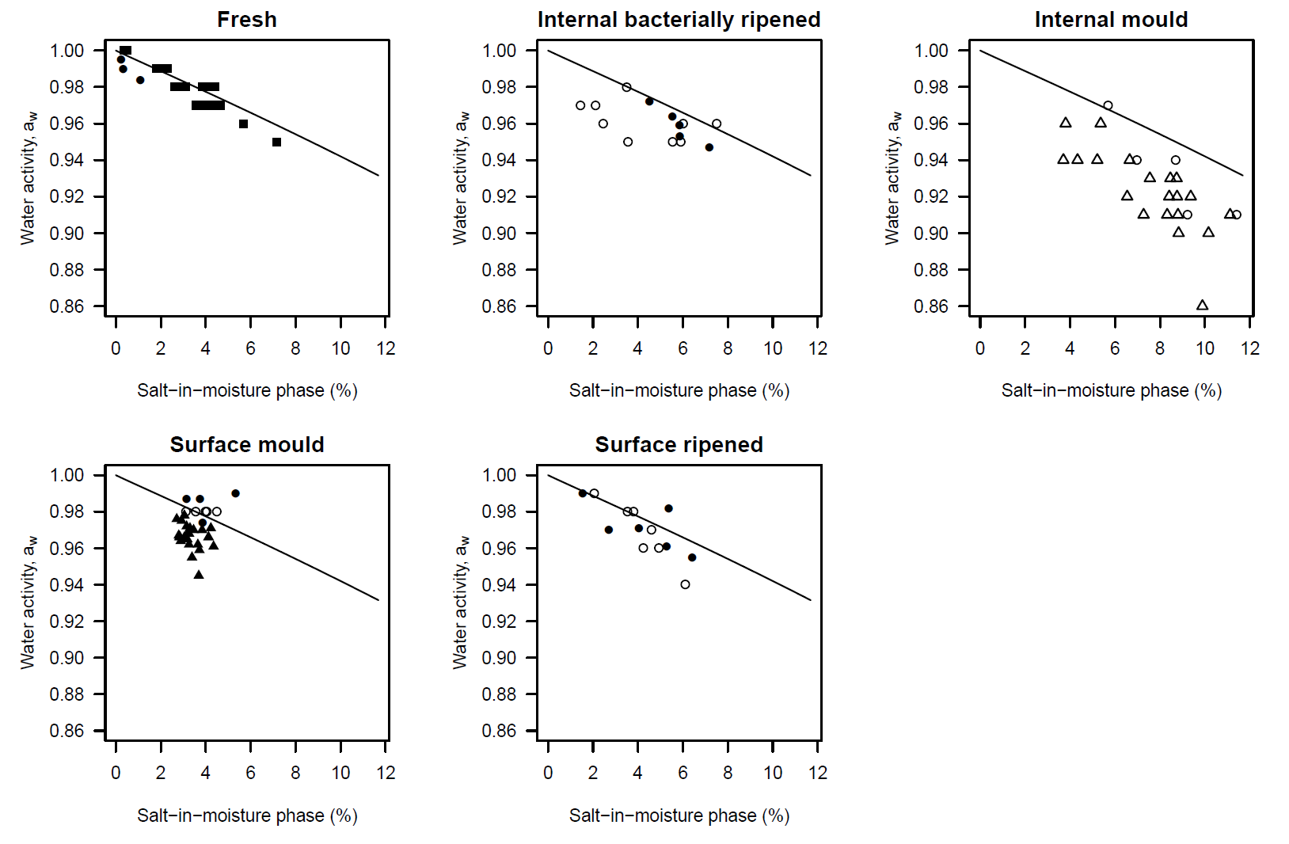
Figure 25: Measured water activity, a_{w} and salt-in-moisture phase (%) concentration for Fresh, Internal bacterially ripened, Internal mould, Surface mould and Surface ripened cheeses. The solid line is the predicted water activity calculated using the Pitzer equation. Data sources: Fernandez-Salguero et al. (1986) ; Marcos et al. 1981 ○; Marcos and Esteban (1982) ; Marcos et al. (1990) ; Rüegg and Blanc (1977) .
The measured water activities of Fresh cheeses are seen to fall along the Pitzer prediction line while the greatest difference is for the Internal mould cheeses due to the formation of proteolysis such as free amino acids. These non-salt solutes also act to reduce the water activity of the cheese.

To illustrate the use of the Ross (1975) equation, a Roquefort cheese from Marcos et al. (1981) (sample 27) with moisture of 40.2g/100g cheese and salt in moisture phase concentration of 11.41g/100g water is considered.

Substituting the molality (11.41x0.1711 = 1.95 mol/1000 g water) into the Pitzer equation returns an osmotic coefficient, $ϕ$ value of 0.98124:
$$ϕ=1-0.392\left(\frac{\sqrt{1.95}}{1+1.2\sqrt{1.95}}\right)+\left(0.0765+0.2666exp\left(-2\sqrt{1.95}\right)1.95+0.00127{\left(1.92\right)}^{2}\right)$$

and water activity due to salt:

$$a_{w,salt}^{°}=exp\left(\frac{0.98124×2×1.95}{-55.51}\right)=0.933$$

Rearranging the Ross (1975) equation to calculate a_{w,other}:

$$a_{w, other}=\frac{a_{w}}{a_{w,salt}^{°}}=\frac{0.91}{0.933}=0.975$$

A graphical summary of the water activity due to salt and other solutes is presented in Figure 26 and summarised in Table 6.
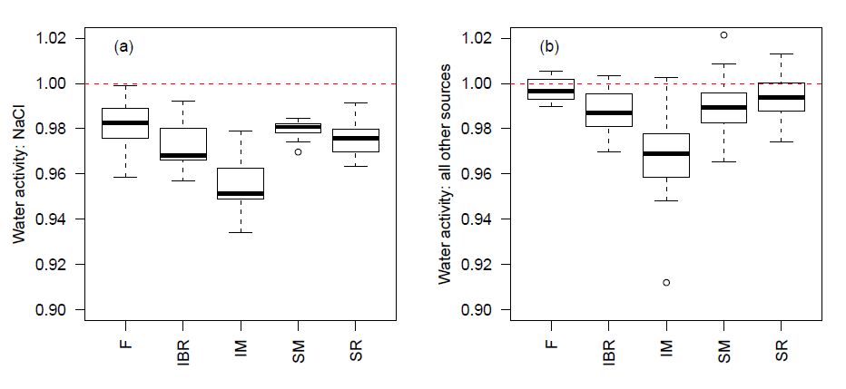
Figure 26: Water activity suppression due to salt (NaCl) only (left) and the predicted water activity from all other cheese solutes (right) calculated using the Ross (1975) equation
Table 6: Median values of measured a_{w}, a_{w} due to salt only, a_{w} due to other solutes and the difference between the measured and salt only a_{w}
Superfamily | Median a_{w} | Median a_{w,salt} | Median a_{w,other} | Median Δ(a_{w})
Fresh | 0.98 | 0.9825 | 0.9965 | -0.0025
Internally bacterially ripened | 0.96 | 0.9683 | 0.9870 | -0.0083
Internal mould | 0.92 | 0.9515 | 0.9690 | -0.0315
Surface mould | 0.97 | 0.9808 | 0.9894 | -0.0108
Surface ripened | 0.97 | 0.9758 | 0.9938 | -0.0058

The results indicated that the water activity differences between the measured and calculated using salt only differ between superfamilies. For the Fresh and Surface ripened superfamilies the median difference is less than 0.006 water activity units suggesting that salt alone could be used as to predict water activity. Internal mould cheeses have the greatest difference in median water activity with a value of -0.0315 water activity units. The Internal bacterially ripened and Surface mould superfamily group have intermediate differences of -0.0083 and -0.108 units.

These findings suggest that for some superfamily groups calculating water activities based on salt alone will result in predicted water activities much higher than would be measured. If these water activities were used in predictive models such as Augustin et al. (2005) the probability of growth would be greater than observed in a challenge study. The median Δ(a_{w}) values from Table 6 are used for adjusting the water activity from challenge study salt-in-moisture phase concentrations.

A visual summary of the influence of superfamily adjustments is presented in Figure 27. For the Heat coagulated group there is little effect as the salt concentration controls the water activity in these cheeses. For the Internal bacterially ripened and Surface mould cheeses the water activity is higher by about +0.01 water activity units. The major difference is observed for the Internal mould cheeses. When water activity is calculated using a superfamily adjustment the six of eight challenge study cheeses fall below the Codex (2007) default criteria. The remaining two cheeses lie close to the lower water activity criteria of 0.92. By contrast when water activity is calculated using salt alone all eight challenge study cheeses lay above the lower water activity limit. The Internal bacterially ripened – High salt cheeses lie to the left of the default boundary due to the low pH of these cheeses.

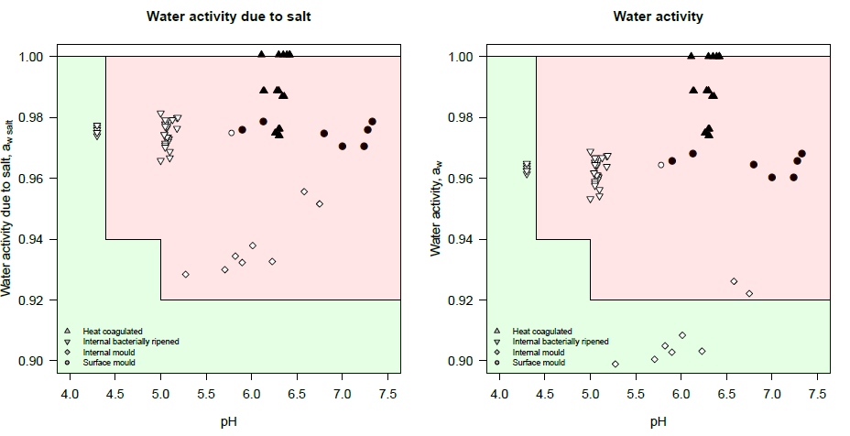
Figure 27: Prediction of water activity for challenge study cheeses due to salt alone (left) and salt plus superfamily adjustment due to other solutes (right) against the Codex (2007) default criteria.

References
Marcos A and Esteban MA (1991) Estimation of water activity in mould ripened cheese from chemical composition. International Dairy Journal 1:137-145

Esteban MA, Marcos A, Alcalá M, Gómez R (1991) Calculation of water activity in surface mould-ripened soft cheese from their chemical composition. Food Chemistry 40:147-157

Fox PF, Guinee TP, Cogan TM, McSweeney PLH (2004) Fundamentals of Cheese Science. Aspen Publishers

Ross KD (1975) Estimation of water activity in intermediate moisture foods. Food Technology 29:26, 28, 30, 32, 34

Rüegg M (1985) Water in dairy products related to quality, with special reference to cheese. In Simatos D, Multon JM (eds) Properties of water in foods. Martinus Nijhoff Publishers. Dordrecht.

Rüegg M and Blanc B (1981) Influence of water activity on the manufacture and aging of cheese. In Rockland, LB and Stewart GF (eds) Water activity: Influences on food quality. Academic Press. New York.

Appendix 4 – Quantifying acidification kinetics
The activity of starter cultures can be assessed using standard conditions, for example the amount of acid produced by a mesophilic starter with a 1% inoculum after 6 hours at 30°C (Cogan, 1978). Cogan et al. (1997) in a survey of lactic acid bacteria isolated from artisanal cheeses suggested that good acid producers should be capable of reducing the pH of milk to 5.3 in 6 hours at 30°C for mesophilic cultures and 42°C for thermophilic cultures.

This approach does not provide any information on the dynamic changes in acid production or the final pH achieved by the culture. These factors will influence the response of pathogens during the early stages cheese making.

Results of a typical starter culture activity experiment are presented in Figure 28. In this case a commercial start culture of Streptococcus lactis C6 was inoculated into skim milk at 30°C and the bacterial count and pH measured for 18 hours. The starter culture begins to grow exponentially for about eight hours before growth slows and the maximum concentration is reached. The pH of the skim milk declines only gradually during the first six hours followed by a period of rapid decline as the bacterial count reaches the maximum concentration. The rate of pH change then slows until a final pH of 4.3 is reached.

Predictive equations such as the Baranyi (Baranyi et al., 1993) and the Torrestiana (Torrestiana et al., 1994) equations can be used to quantify the changes in bacterial concentration or pH, respectively (Figure 28).
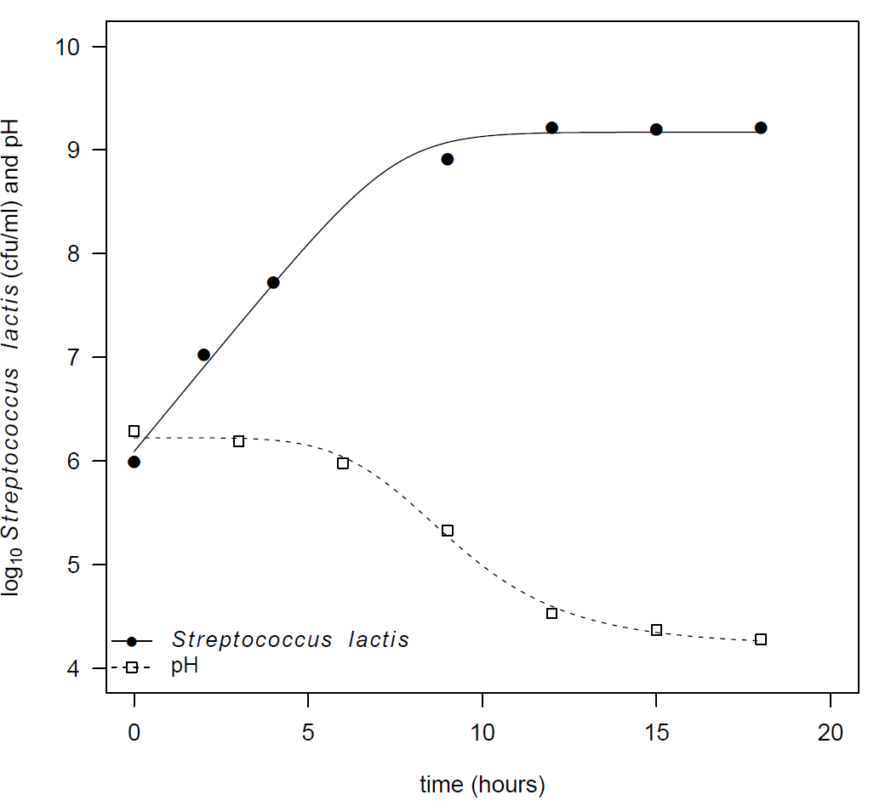
Figure 28: Growth of Streptococcus lactis C6 and pH against time in skim milk with an inoculum size of 0.25% at a temperature of 30°C (Park and Marth, 1972). Growth curve fitted using the Baranyi equation and pH using the Torrestiana et al. (1994) equation.
Spinnler and Corrieu (1989) and Picque et al. (1992) outlined approaches for measuring the activity of mesophilic and thermophilic starter cultures using pH measurements with very short time intervals (30-90 seconds). The data was then numerically analysed to determine a number of kinetic parameters which can then be used to characterise the pH changes by the starter culture.

Picque et al. (1992) defined six kinetic parameters to describe the activity of starter cultures:

(a) the maximum acidification rate (V_{m})
(b) the time at which V_{m} occurred, T_{m}
(c) pH at which V_{m} occurred, pH_{m}
(d) time range during which the observed rates were greater than V_{m}/2, T₅₀
(e) pH range during which the observed rates were greater than V_{m}/2, pH₅₀ and
(f) “lag time” which was defined as the time for the initial pH to drop by 0.08 pH units.

The kinetic parameters were used by Picque et al. (1992) to classify starter cultures using statistical methods.

Studies into the behaviour of pathogens in response to starter cultures, such as Park and Marth (1972) do not sample with the high frequency required to use the numerical methods described by Spinnler and Corrieu (1989) and Picque et al. (1992). The periods between sampling points are more likely to be measured in hours rather than seconds or minutes. An alternative approach is to use equations which have flexibility to describe the dynamics in the pH-time relationship during milk fermentation. One such equation, proposed by Torrestiana et al. (1994) for describing the pH-time profile kinetics of Lactobacillus bulgaricus cultures has four parameters:

$pH=\frac{\left(A-D\right)}{\left[1+{\left(\frac{t}{C}\right)}^{B}\right]}+D$ (1)

where A and D are the initial and final pH of the milk, B is related to the slope of the linear region of the pH-time curve and C represents the time at which half of the total pH decrease is observed. Equation (1) is fitted using nonlinear regression to the pH-time data from the milk challenge studies.

The maximum acidification rate, V_{m} can be readily determined by finding the time, T_{m} at which the first derivative of the Torrestiana equation is at its minimum:

$\frac{dpH}{dt}=\frac{\left(A-D\right)\left(\frac{B}{C}{\left(\frac{t}{C}\right)}^{\left(B-1\right)}\right)}{{\left(1+{\left(\frac{t}{C}\right)}^{B}\right)}^{2}}$ (2)

Figure 29 provides a graphical summary for five of the kinetic parameters described by Picque et al. (1992): V_{m}, T_{m}, pH_{m}, T₅₀ and pH₅₀ determined using the Torrestiana equation.

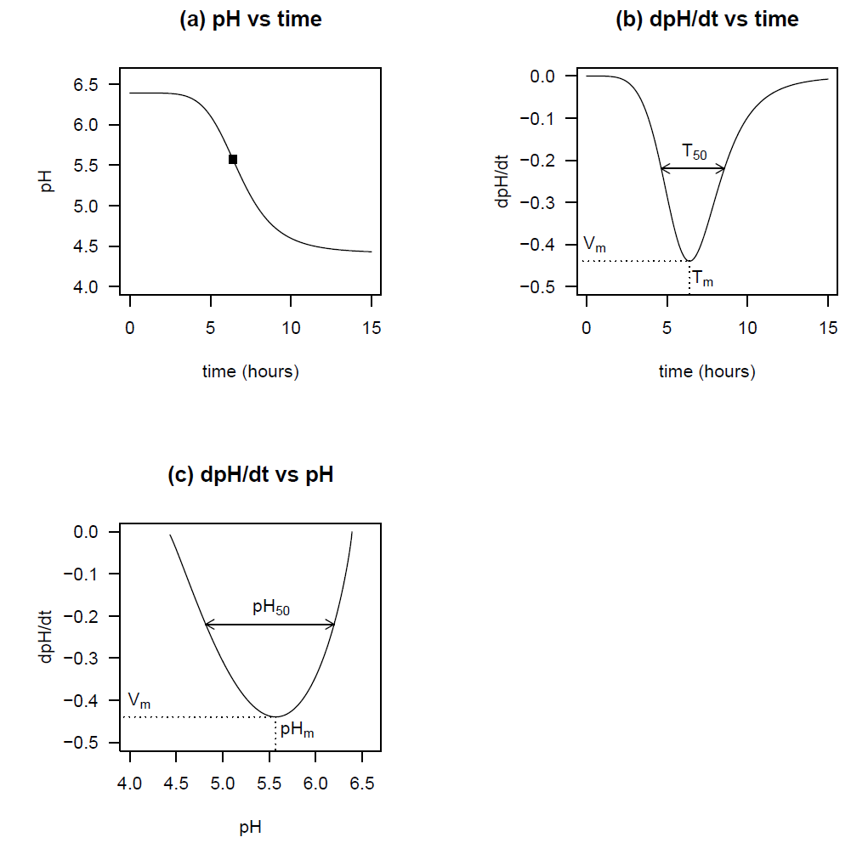
Figure 29: Changes in pH and acidification rates during milk fermentation: (a) changes in pH with time; (b) change in acidification rate with time; (c) change in acidification rate with pH. (after Spinnler and Corrieu, 1989)

Effect of temperature on acidification kinetics

Temperature is one of the most important factors which influence the growth of starter cultures and consequently the acidification kinetics. Willman and Willman (1999) report typical optimum growth temperatures of 30°C for mesophilic starter cultures, while lower temperatures reduce the growth rate and extend the time for setting of the curd (Table 4).

Withers and Couper (2012) in a study of the interactions of pathogens and commercial lactic acid starter cultures used Chr. Hansen / Fonterra FD-DVS pHageControl™ culture R-704. This commercial product contains a mixture of two subspecies of Lactococcus lactis, namely Lactococcus lactis subspecies cremoris and Lactococcus lactis subsp. lactis starter type A in Table 4. This product is a mixture of homofermentative strains and produces acid without the formation of CO₂.

Technical information for this culture includes figures showing the effect of temperature (22, 30, 37 and 40°C) on the acidification of heat treatment reconstituted laboratory milk with 9.5% total solids as extracted and hourly pH data is presented in Figure 30. The curve in each panel is the nonlinear regression fit of the Torrestiana equation, with the solid straight line representing the maximum acidification rate, V_{m}.
The vertical dashed line in each panel is T_{m}, the time at which the maximum acidification rates occur, while the horizontal dashed line is the corresponding pH_{m} at the maximum acidification rate.

The effect of temperature is evident for the maximum acidification rate, V_{m} and the time to reach the maximum rate, T_{m}. For V_{m}, the slopes of the straight lines are less at both 22 and 40°C and similar at 30 and 37°C. While for T_{m} the minimum is found at 37°C at 5.1 hours and the longest at 22°C at 9.5 hours. Temperature has only a slight influence on the pH_{m} value.

A graphical summary of the effect of temperature on V_{m} and T_{m} is presented in Figure 31. This data suggests that V_{m} is in the range of 30 to 37°C, typically for a mesophilic starter culture. The value of V_{m} value is nearly halved (0.48 to 0.26 pH units/hour) and T_{m} nearly doubles (5.6 to 9.5 hours) when the temperature is dropped from 30°C to 22°C.

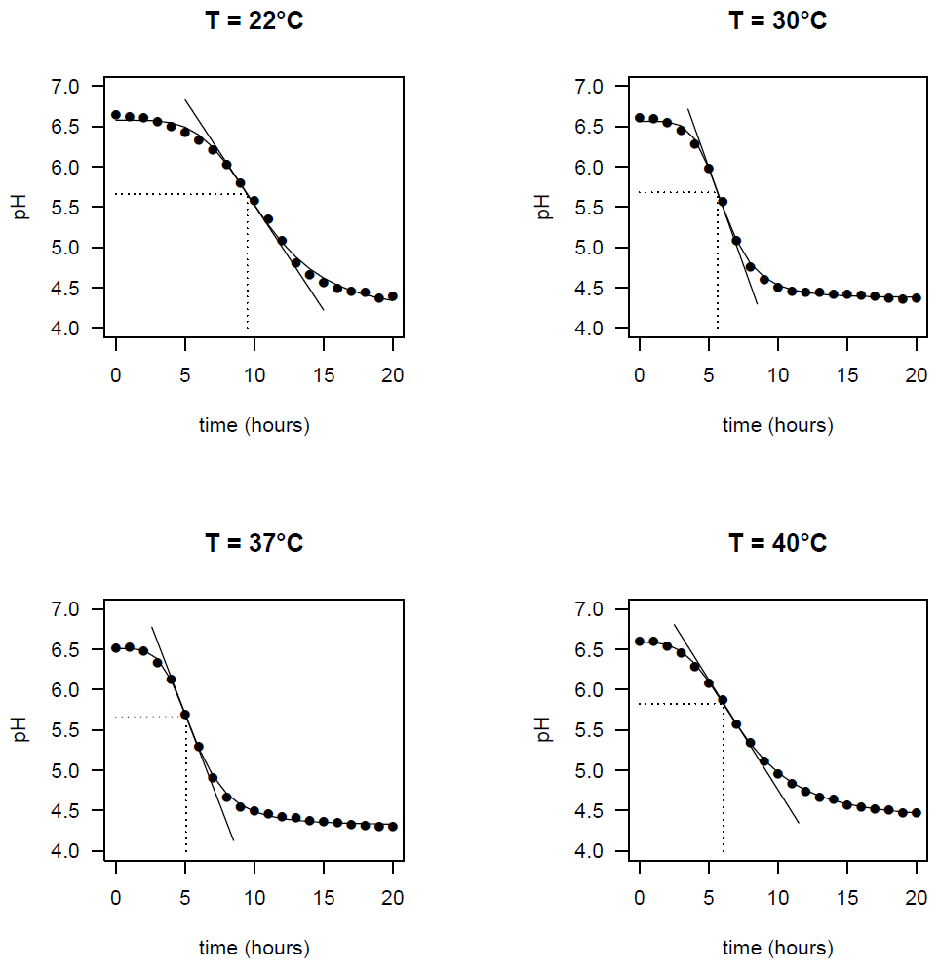
Figure 30: Effect of temperature on the acidification of laboratory milk (9.5% Total solids, temperature profile) using Chr. Hansen culture FD-DVS R-704 at 22, 30, 37 and 42 °C
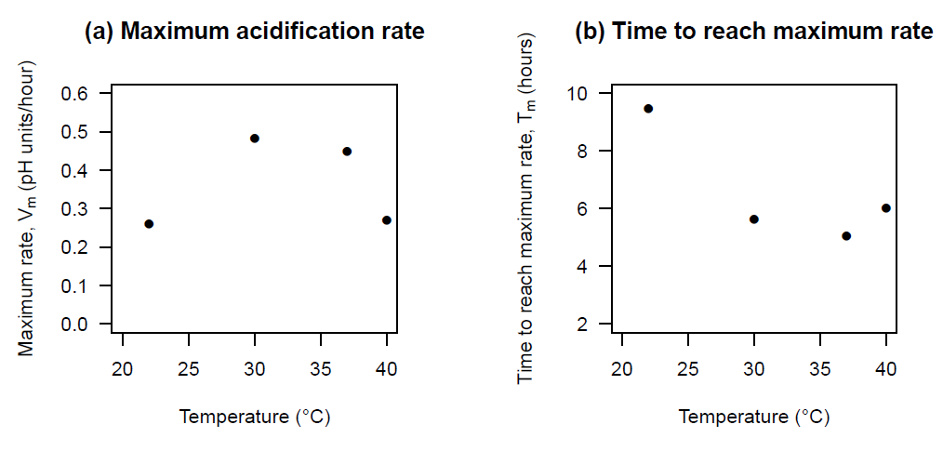
Figure 31: Effect of temperature on pH kinetic parameters: (a) maximum acidification rate, V_{m}; (b) time to reach maximum acidification rate, T_{m} determined using the Torrestiana equation (Torrestiana et al., 1994) for Chr. Hansen FD-DVS R-704 starter culture.

