22 May 2020
[124-20]

Supporting document 1

Safety Assessment Report – Application A1199

Food derived from Innate potato lines V11 & Z6

Executive summary

Background
Application A1199 seeks approval for the sale of food derived from genetically modified (GM) potatoes that have reduced acrylamide potential, reduced blackspot bruising and resistance to foliar late blight.

Two potato lines were generated using a two-step transformation process of the Snowden potato variety. Line V11 has been genetically modified to silence four endogenous genes via RNA interference (RNAi): Asn1 encoding asparagine synthetase; Ppo5 encoding polyphenol oxidase; PhL encoding phosphorylase-L; and R1 encoding water dikinase. Silencing of the Asn1, PhL and R1 genes results in reduced acrylamide potential and silencing of the Ppo5 gene results in reduced blackspot bruising.

Line Z6 was derived through further genetic modification of line V11 to introduce the Rpi-vnt1 gene encoding the VNT1 protein for late blight resistance, as well as silence (via RNAi) an additional endogenous gene: Vlnv encoding vacuolar invertase. In addition to being resistant to foliar late blight (a fungal pathogen of potatoes), Z6 exhibits a further reduction in acrylamide potential. Like V11, Z6 also has reduced blackspot bruising.

The enzymes encoded by the PhL, R1 and Vlnv genes are associated with the conversion of storage carbohydrates such as starch and sucrose into the reducing sugars, glucose and fructose. Asparagine synthetase encoded by the Asn1 gene is involved in the biosynthesis of asparagine from aspartate and glutamine. Polyphenol oxidase encoded by Ppo5 catalyses the oxidation of phenolic compounds in wounded plant tissues, resulting in the production of brown pigments.

Decreasing the amount of reducing sugars and asparagine in the tubers leads to reduced formation of acrylamide when potatoes are cooked at high temperatures. Minimising acrylamide in food is desirable because it has been shown to be a carcinogen in laboratory animals. The main reason for reducing blackspot bruising, which occurs during harvesting, packing and cutting, is to limit food wastage.

This safety assessment addresses food safety and nutritional issues associated with the GM food. It therefore does not address:

- risks related to the environmental release of GM plants used in food production
- the safety of animal feed, or animals fed with feed, derived from GM plants
- the safety of food derived from the non-GM (conventional) plant.

History of use
On a global scale, potato is the fourth most important food crop following maize, rice and wheat and is cultivated in over 100 countries. It has been cultivated for human consumption for thousands of years and has a long history of safe use as human food. Potatoes are typically cooked before consumption and are processed into food commodities such as potato chips, pre-cooked French fries, potato flour and potato starch. Potato is also used as a feed for domestic livestock and for the production of alcohol.

Molecular characterisation
Comprehensive molecular analyses indicate that a single insertion occurred with each transformation step generating lines V11 and Z6. Both expression cassettes are stably integrated into the potato genome and have the expected organisation, with no rearrangements or other DNA changes being identified. The molecular analyses also confirmed that no antibiotic resistance genes or other plasmid backbone sequences are present.

Molecular analyses also confirmed the silencing of all five targeted genes, with the expected changes to phenotype – reduced acrylamide potential and reduced blackspot bruising.

Characterisation and safety assessment of novel substances
The only newly expressed protein is the VNT1 protein which is present in line Z6. The safety of this protein has been assessed by FSANZ in a previous application (Application A1139). Additional bioinformatic analyses undertaken for this application confirmed the expressed protein is unlikely to be allergenic or toxic. Expression levels of the VNT1 protein in tubers is below the level of quantitation.

Other novel substances present in lines V11 and Z6 are the double-stranded RNA (dsRNA) molecules that are expressed to trigger RNAi. The safety of these dsRNA were also assessed as part of A1139. There are no safety concerns regarding the presence of these dsRNA molecules in V11 and Z6. The available data do not indicate the dsRNAs expressed in these lines possess different characteristics, or are likely to pose a greater risk, than other RNAi mediators naturally present in potato.

Compositional analyses
Detailed compositional analyses were performed on lines V11 and Z6. Analytes measured were proximates, fibre, vitamins, minerals, total amino acids, free amino acids, sucrose, reducing sugars (fructose and glucose), and glycoalkaloids. These analyses confirmed the expected changes to the levels of sucrose, reducing sugars and asparagine as a result of RNAi mediated gene silencing in both lines. These changes do not raise any food safety concerns. All other identified differences were within the range of natural variation.

Conclusion
No potential public health and safety concerns have been identified in the food safety assessment of lines V11 and Z6. On the basis of the data provided in the present application, and other available information, food derived from potato lines V11 and Z6 is considered to be as safe for human consumption as food derived from conventional potato varieties.

Table of contents
Executive summary i
Background i
History of use ii
Molecular characterisation ii
Characterisation and safety assessment of novel substances ii
Compositional analyses ii
Conclusion ii
Index of Figures 1
Index of Tables 1
List of abbreviations 2
1 Introduction 3
2 History of use 4
2.1 Host organism 4
2.2 Donor organisms 5
2.2.1 Solanum tuberosum 5
2.2.2 Solanum verrucosum 5
2.2.3 Solanum venturii 5
3 Molecular characterisation 5
3.1 Transformation Method 6
3.2 Detailed description of introduced DNA 8
3.2.1 pSIM1278 8
3.2.2 pSIM1678 12
3.3 Development of the potato lines from original transformants 14
3.4 Characterisation of the inserted DNA and site(s) of insertion 15
3.4.1 Identifying the number of integration sites 15
3.4.2 Detection of backbone sequence 15
3.4.3 Inheritance and genetic stability of the inserted DNA 15
3.4.4 Insert integrity and site of integration 15
3.4.5 Open read frame (ORF) analysis 17
3.4.6 Silencing of targeted genes 18
3.4.7 Conclusion 21
4 Characterisation and safety assessment of novel substances 22
4.1 Newly expressed protein 22
4.1.1 Description of the VNT1 protein 22
4.1.2 Expression of the Rpi-vnt1 gene and VNT1 protein in potato tissues 23
4.1.3 Characterisation of VNT1 protein in the Z6 line 23
4.1.4 Bioinformatics analyses of VNT1 23
4.1.5 Conclusion 24
4.2 Newly expressed dsRNA 24
5 Compositional analysis 25
5.1 Study design and conduct for key components 25
5.2 Analyses of key components in tubers 26
5.2.1 Key components 27
5.2.2 Comparison of total amino acid levels 28
5.2.3 Comparison of free amino acid levels 30
5.2.4 Changes in sucrose and reducing sugars 31
5.3 Conclusions of the compositional analyses 32
6 Nutritional impact 32
7 References 33
8 Appendix 1 36

Index of Figures
 | Title | Page
Figure 1 | Outline of the Maillard reaction | 3
Figure 2 | Plasmid maps of pSIM1278 and pSIM1678 | 7
Figure 3 | Design of the T-DNA region in pSIM1278 | 8
Figure 4 | Design of the T-DNA region in pSIM1678 | 12
Figure 5 | Generations of potato derived from vegetative propagation | 14
Figure 6 | A representation of the restriction enzyme map and probe binding sites of the inserted T-DNA regions | 16
Figure 7 | The interrelationship between asparagine and glutamine biosynthesis pathways | 30

Index of Tables
 | Title | Page
Table 1 | The genetic elements contained in the T-DNA region of pSIM1278, used to create V11 | 9
Table 2 | Description of the genetic elements contained in the backbone of pSIM1278 | 11
Table 3 | The genetic elements contained in the T-DNA region of pSIM1678, used to create Z6 | 13
Table 4 | Molecular characterisation studies performed in Z6 | 14
Table 5 | Reduction in asparagine levels in the transformed lines compared to the parental control | 19
Table 6 | The change in sucrose and reducing sugar levels between transformed lines and the parental control in freshly harvested or cold-stored potatoes | 20
Table 7 | Percent reduction in acrylamide levels between transformed lines and the parental control in cooked chips prepared from freshly harvested or cold-stored potatoes | 20
Table 8 | Field trial information for the V11 and Z6 lines | 26
Table 9 | Analytes measured in the potato samples | 26
Table 10 | Summary of results from the compositional analyses | 28
Table 11 | Summary of total amino acids in the transformed lines | 28
Table 12 | Summary of total asparagine and glutamine levels in the transformed lines | 29
Table 13 | Summary of free asparagine and glutamine results | 30
Table 14 | Summary of the sucrose and reducing sugar levels in freshly harvested and cold-stored potatoes | 31

List of abbreviations
Asn1 | asparagine synthetase-1 gene
BLAST | Basic Local Alignment Search Tool
BLASTP | Basic Local Alignment Search Tool for Proteins
bp | base pairs
Code | Australia New Zealand Food Standards Code
ddPCR | droplet digital Polymerase Chain Reaction
DNA | deoxyribonucleic acid
dsRNA | double stranded RNA
FDA | US Food and Drug Administration
FAO | Food and Agriculture Organization of the United Nations
FARRP | Food Allergy Research and Resource Program
FASTA | Fast Alignment Search Tool - All
FSANZ | Food Standards Australia New Zealand
g | gram
GA | glycoalkaloid
GM | genetically modified
HPLC | High Performance Liquid Chromatography
ipt | isopentenyl transferase gene
kDa | kiloDalton
LB | left border of T-DNA (Agrobacterium tumefaciens)
LOQ | limit of quantitation
mg | milligram
mRNA | messenger RNA
NBY | Nutrient Broth-Yeast
NCBI | National Centre for Biotechnology Information
NGS | Next Generation Sequencing
OECD | Organisation for Economic Co-operation and Development
ORF | Open Reading Frame
pAgp | ADP glucose pyrophosphorylase gene promoter
PCR | Polymerase Chain Reaction
pGbss | granule-bound starch synthase promoter
PhL | phosphorylase-L gene
PPO | polyphenol oxidase
Ppo5 | polyphenol oxidase-5 gene
R1 | water dikinase R1 gene
RB | right border of T-DNA (Agrobacterium tumefaciens)
RNA | ribonucleic acid
RNAi | RNA interference
Rpi-vnt1 | VNT1 gene
SAS | Statistical Analysis Software
SPSII | Simplot Plant Sciences International Inc.
ssDNA | single stranded DNA
T-DNA | transfer DNA
US | United States of America
USDA | United States Department of Agriculture
VInv | vacuolar invertase gene
VNT1 | Late blight resistance protein

1 Introduction
FSANZ received an application from Simplot Plant Sciences International Inc. (SPSII) to vary Schedule 26 in the Australia New Zealand Food Standards Code (the Code) to include food derived from two genetically modified (GM) potato lines from the Simplot Innate brand: line V11 (OECD Unique Identifier SPS-ØØV11-6) and line Z6 (OECD Unique Identifier SPS-ØØØZ6-5). Line Z6 is derived from further genetic modification of line V11. Both lines have reduced acrylamide potential and reduced black spot bruising. Line Z6 is also resistant to foliar late blight, a fungal pathogen of potatoes.

Reduced acrylamide potential is achieved by introducing DNA sequences that silence the expression of four endogenous genes using a mechanism known as RNA interference or RNAi (Hannon, 2002). The introduced DNA sequences are derived from the endogenous genes targeted for silencing and in this case, were derived from the Ranger Russet potato variety. The genes targeted for silencing in line V11 are the Asn1 gene encoding asparagine synthetase, the PhL gene encoding phosphorylase-L and the R1 gene encoding water dikinase. Line V11 contains a similar genetic modification to that found in lines F10 and J3 that were assessed in Application A1139 (FSANZ 2017) and line E12 that was assessed in Application A1128 (FSANZ 2016). In addition to these genes, the Vlnv gene encoding vacuolar invertase is also silenced in line Z6. Line Z6 contains similar genetic modifications to that found in lines W8, X17 and Y9 that were assessed in Application A1139 (FSANZ 2017).

Silencing the Asn1 gene leads to a lower concentration of free asparagine in the potato. This, combined with a reduction in the breakdown of starch to glucose from silencing the PhL and R1 genes results in reduced formation of acrylamide when the potatoes are cooked at temperatures above 120°C. Silencing the Vlnv gene in line Z6 leads to reduced conversion of stored sucrose into glucose and fructose, particularly on the outer edge of the potatoes, which has been associated with darkening on the ends of potato chips (crisps) and French fries (Zhu et al., 2014). The activity of vacuolar invertase also increases with decreasing temperature, leading to an increase in reducing sugar formation at the cold temperatures normally used for storage of potatoes (Bhaskar et al., 2010; Sowokinos et al., 2001). Silencing of the Vlnv gene in line Z6 is therefore intended to further reduce the potential for acrylamide formation upon cooking.

Acrylamide, a known carcinogen, has been shown to form in high carbohydrate-rich foods such as potatoes (FDA 2016; Tareke et al., 2002) when they are fried, roasted or baked between 120-200°C (Rydberg et al., 2005). The acrylamide forms when the amino acid asparagine reacts with reducing sugars such as glucose and fructose (Figure 1), by the Maillard reaction (Stadler et al., 2002).
NH₂
C=O
CH₂
NH₂-CH-COOH
asparagine
O
C
R R′

+
→
carbonyl group from glucose or fructose
NH₂
C=O
CH
CH₂
acrylamide
Figure 1: Outline of the Maillard reaction. The amino acid asparagine reacts with the carbonyl group found in glucose or fructose to produce acrylamide.

Reduced blackspot bruising is achieved by introducing DNA sequences that silence the Ppo5 gene encoding polyphenol oxidase (PPO). The introduced DNA sequences were derived from the wild edible potato, Solanum verrucosum. Blackspot is the discolouration that sometimes forms in damaged or cut potatoes and is associated with PPO activity. PPO converts colourless polyphenols in the plant tissue to coloured quinones, which further react to produce dark melanin pigments. This discoloration results in reduced organoleptic properties, leading to increased food wastage by growers, processers and consumers.

Resistance to foliar late blight in line Z6 was achieved by introducing the Rpi-vnt1 gene encoding the VNT1 protein. The introduced gene is derived from the wild potato species Solanum venturii. The resulting VNT1 resistance protein allows the plant to detect the presence of the infecting organism Phytophthora infestans, leading to the induction of the plant’s immune response and elimination of the fungus. VNT1 does not directly inhibit the fungal pathogen.

The applicant has indicated that none of these potato lines are currently intended to be grown in Australia or New Zealand but their processed products may enter the local food market through imports. At this stage, the progenitor V11 line has limited food use. The second generation line Z6 is considered to have greater commercial potential.

2 History of use

2.1 Host organism
The information provided here is summarised from more detailed reports published by the Canadian Food Inspection Agency (CFIA 2015) and the Organisation for Economic Co-operation and Development (OECD 2002, 1997), with independent citations provided in the text. Statistical data is from the FAOSTAT website managed by the Food and Agriculture Organization of the United Nations (FAO 2016).

The potato (Solanum tuberosum) originated from South America, where it has been cultivated for human consumption for thousands of years (Ugent & Peterson 1988). Potato is propagated vegetatively using small tubers or pieces of tuber typically referred to as seed or seed potatoes. Potato can also be propagated via sexually produced seed, contained within tomato-like berries. However, seed production and breeding are challenging.

Internationally, potato is the fourth most important food crop following maize, rice and wheat and is cultivated in over 100 countries. Global potato production was estimated at over 368 million tonnes in 2018, with China the top producer at 90 million tonnes. In 2017, worldwide consumption of fresh and processed potatoes was about 33 kg/person/year with higher consumption in Australia and New Zealand at about 47 kg/person/year.

Potato is not a major crop in Australia and New Zealand, with production around 1.2 million tonnes and 0.5 million tonnes in 2018, respectively. In 2017, Australia exported 45,000 tonnes and imported about 154,000 tonnes of potatoes and potato products. In the same time period, New Zealand exported about 113,000 tonnes and imported about 40,000 tonnes of potato and potato products.

Whole potatoes are typically cooked before consumption or are processed into food commodities such as potato chips (crisps), pre-cooked French fries and dehydrated potato products (diced, flaked or granules). Potato is also used for the production of industrial starch and alcohol, with the by-products and residues having the potential to be used to supplement animal feedstock.
The Snowden potato variety chosen by the applicant for genetic modification is predominantly used to make potato chips (CFIA 2016). With its use in the chipping market, there is increased potential that acrylamide will be formed in the final potato products. The Snowden potato variety is also susceptible to foliar late blight infection, a problem facing potato growers in North America and around the world (Saville et al., 2016). A genetic modification process was chosen to address these issues because the Snowden variety is infertile and therefore standard crossbreeding cannot be performed in this variety.

Potato has a long history of safe use as food. Potato and other members of the Solanaceae family, such as tomatoes and eggplants, naturally produce a pesticidal group of compounds called glycoalkaloids (GAs), which can be toxic to humans if consumed in high quantities (greater than 1 mg GA per kg bodyweight). However, humans are rarely exposed to such high levels of GA. A maximum limit of 200 mg/kg fresh potato is the widely accepted safe limit for total GA in registered potato varieties. Proper storage conditions and peeling the potato before use help reduce levels of GA.

2.2 Donor organisms

2.2.1 Solanum tuberosum
The majority of the introduced DNA sequences are derived from S. tuberosum, variety Ranger Russet. This potato variety was commercially released by the USDA and Agricultural Experiment Stations in 1991 and has therefore been in the food chain for almost 30 years (Pavek et al., 1992). DNA sequences from this source include the ADP glucose pyrophosphorylase gene promoter (pAgp) and the granule-bound starch synthase promoter (pGbss), the Asn1, PhL, R1 and Vlnv DNA sequences, some of the Left and Right Border region and spacer DNA sequences (see Tables 3 and 5 in Section 3.2). Intervening DNA sequences were also derived from S. tuberosum (variety unspecified).

2.2.2 Solanum verrucosum
The Ppo5 DNA sequences were derived from S. verrucosum. This is a wild, edible species of potato from Mexico that has been used as a bridging species for the conventional breeding of desirable traits into the domesticated S. tuberosum potato.

2.2.3 Solanum venturii
The Rpi-vnt1 promoter, gene and termination sequence are derived from S. venturii. This is a wild species of potato with high resistance to foliar late blight, found in Argentina (Hawkes and Hjerting, 1960). The late blight resistance gene Rpi-vnt1 belongs to a family of resistance genes found in many plant species, including food crops like the potato (Marone et al., 2013; Xu et al., 2011). This diploid species would not produce viable offspring if bred with tetraploid S. tuberosum varieties.

3 Molecular characterisation
Molecular characterisation is necessary to provide an understanding of the genetic material introduced into the host genome and helps to frame the subsequent parts of the safety assessment. The molecular characterisation addresses three main aspects:

- the transformation method together with a detailed description of the DNA sequences introduced to the host genome
- a characterisation of the inserted DNA, including any rearrangements that may have occurred as a consequence of the transformation
- the genetic stability of the inserted DNA and any accompanying expressed traits.

The applicant has submitted the following unpublished studies for the molecular characterisation of lines V11 and Z6. As the molecular characterisation of Z6 includes analysis of both transformations, the characterisation is also applicable to the progenitor line V11.
Unpublished studies
- Z6 Insert Characterization by Southern Blotting (2019). Simplot Plant Sciences.
- Sequence Characterization of the Inserts in Z6 (2019). Simplot Plant Sciences.
- Evidence for the Absence of Plasmid Backbone DNA in Event Z6 (2018). Simplot Plant Sciences.
- Stability of Inserts in Vegetatively Propagated Z6 (2019). Simplot Plant Sciences.
- Allergen and Toxin Evaluation of Open Reading Frames in Z6 (2019). Simplot Plant Sciences.
- Expression of RNAi Targeted Transcripts in Snowden V11 (2016). Simplot Plant Sciences.
- Expression of RNAi-targeted Transcripts in Z6 (2019). Simplot Plant Sciences.
- Efficacy of Reduced Polyphenol Oxidase Activity in Z6 Tubers compared to Snowden at Harvest and After Storage (2019). Simplot Plant Sciences.

3.1 Transformation Method
In order to create the Z6 line, two sequential transformations were carried out. The first transformation, using plasmid pSIM1278, generated the V11 line. Line V11 was then subject to a second transformation, using plasmid pSIM1678, generating the Z6 line.

Plasmid pSIM1278 was used to introduce DNA sequences derived from the Asn1, Ppo5, PhL and R1 genes (Figure 2). Plasmid pSIM1678 introduced DNA sequences derived from the Vlnv gene as well as Rpi-vnt1 gene for late blight resistance (Figure 2).

The methodology used to establish and select the transformed potatoes has been previously published by SPSII (Richael et al., 2008; Richael and Rommens, 2012) and assessed by FSANZ in applications A1128 and A1139. The full methodology is outlined in the flowcharts presented in Appendix 1. In summary, the transformation involved infection of plant tissue with a Agrobacterium strain AGL1, containing the plasmids pSIM1278 or pSIM1678. Plantlets were then grown on media containing the antibiotic timentin to suppress the growth of the agrobacterium. To identify transformants that had inadvertently taken up the plasmid backbone, explants that produced abnormal or stunted shoots indicative of expression of the ipt gene (in the backbone region) (see section 3.2.1) were discarded. The absence of backbone sequences was later confirmed by sequencing and Southern blotting. In order to then identify transformants that had incorporated the transfer DNA (T-DNA) insert for further propagation, polymerase chain reaction (PCR) analysis was employed. Since potato is prone to somaclonal variation, several steps were taken during the propagation stages to identify and remove events with chromosomal rearrangements.

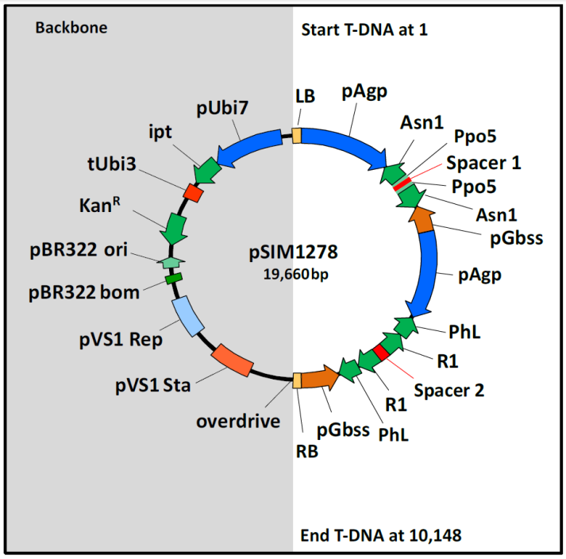
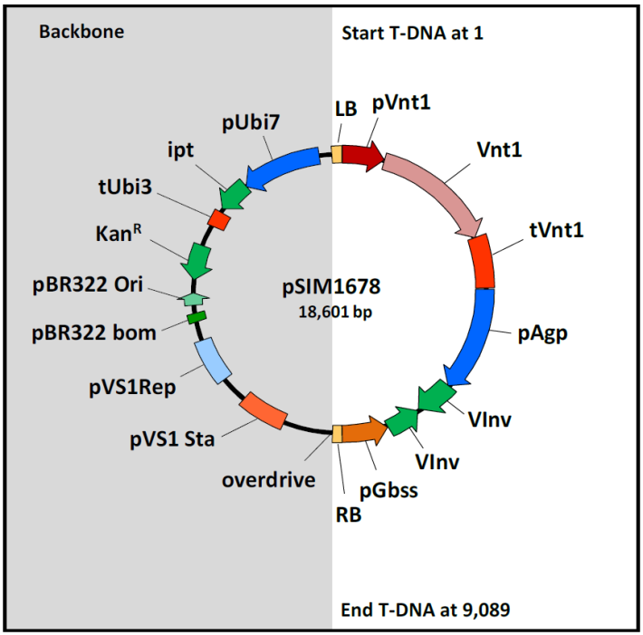
Figure 2: Plasmid maps of pSIM1278 and pSIM1678. Representation of the plasmids used to transform the Snowden potato variety. Both plasmids contain a T-DNA insert region that contains the DNA sequences of interest and are shown with a white background. The plasmid backbone region is shown with a grey background.

3.2 Detailed description of introduced DNA
The sequential two-step transformation process (described in Section 3.1) to generate the Z6 line makes use of two distinct plasmids. Each plasmid is described below.

3.2.1 pSIM1278
The pSIM1278 plasmid was used to generate line V11. FSANZ has previously described pSIM1278 in Application A1128 (FSANZ 2016) and A1139 (FSANZ 2017).

A representation of the T-DNA region for pSIM1278, mapping the location of each of the genetic elements is shown in Figure 3 and a description of the genetic elements contained within pSIM1278 is presented in Tables 1 (T-DNA region) and 2 (backbone region). Only the DNA sequences in the T-DNA region are intended for incorporation into the potato genome.
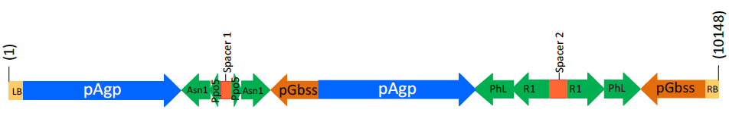
Asn/Ppo cassette
PhL/R1 cassette

Figure 3: Design of the T-DNA region in pSIM1278

The T-DNA region is encompassed by the left and right border regions, containing sequences to allow transfer of the T-DNA region from the plasmid into the plant genome, after the plasmid has been taken up by the potato cells. Within the T-DNA are two cassettes, each with inverted repeats of DNA sequences derived from the four genes being targeted for silencing: Asn1, Ppo5, PhL and R1. The inverted repeats are made up of complementary sense and antisense sequences from each gene, located around a spacer region. After transcription into RNA, the complementary sequences come together, forming a double-stranded (ds) RNA hairpin molecule (Wesley et al., 2001). This dsRNA acts as a trigger for the plants own RNAi regulatory pathway, resulting in the enzymatic degradation of mRNA corresponding to the target gene, thereby silencing the target gene. The expression of these dsRNAs is controlled by promoters from the ADP glucose pyrophosphorylase (Agp) gene and the granule-bound starch synthase (Gbss) gene. These promoters are highly active in tuber cells and should therefore allow high expression of the dsRNAs in the tuber (Rommens et al., 2008; Muller-Rober et al., 1994; Visser et al., 1991).

The DNA contained within the backbone region of the plasmid is not intended for insertion into the potato genome. The sequences are required for preparing the plasmid, passaging through standard laboratory E. coli and into Agrobacterium and finally for ensuring entry into the plant cells. The majority of the sequences are from a parent plasmid known as pCAMBIA-1301. The sequence of pCAMBIA is publically available in GenBank. The applicant has further modified pCAMBIA to include the isopentenyl transferase (ipt) gene, driven by a potato polyubiquitin promoter (Ubi7) and finishing with the terminator sequence from the potato ubiquitin-3 (tUbi3) gene (Forsyth et al., 2016; Richael et al., 2008). Expression of the ipt gene is used as a negative selection marker, as it allows identification and removal of plantlets that have incorporated the backbone region of the plasmid (Richael et al., 2008).
Table 1: The genetic elements contained in the T-DNA region of pSIM1278, used to create V11
Genetic element | Relative position | Size (bp) | Source | Description, Function & Reference
Left border (LB) | 1 - 25 | 25 | Synthetic¹ | Secondary cleavage site. Releases ssDNA² insert from pSIM1278 (van Haaren et al., 1989)
LB region | 26 - 187 | 162 | S. tuberosum  (var. Ranger Russet) | Supports secondary cleavage at LB and provides buffer for truncations
Intervening sequence | 188 - 193 | 6 | S. tuberosum | Sequence used for DNA cloning
Promoter for the Agp gene (pAgp)  1st copy | 194 -2,453 | 2260 | S. tuberosum  (var. Ranger Russet) | One of two convergent promoters driving expression of Asn1 and Ppo5 inverted repeats, especially in the tuber
Fragment of Asn1 gene  1st copy in antisense orientation | 2,454 - 2,858 | 405 | S. tuberosum  (var. Ranger Russet) | Binds to 2nd copy of Asn1 fragment to generate dsRNA³ that down regulates asparagine synthetase to impair asparagine formation (Chawla et al., 2012)⁴
3’-untranslated sequence of Ppo5 gene 1st copy in antisense orientation | 2,859 - 3,002 | 144 | S. verrucosum | Binds to 2nd copy of Ppo5 fragment to generate dsRNA that triggers the down regulation of polyphenol oxidase (PPO) to reduce blackspot development
Intervening sequence | 3,003 – 3,008 | 6 | S. tuberosum | Sequence used for DNA cloning
Spacer-1 | 3.009 – 3,165 | 157 | S. tuberosum  (var. Ranger Russet) | Sequence between the antisense and sense inverted repeats of Asn1 and Ppo5: transcript forms loop in the dsRNA molecules
3’-untranslated sequence of Ppo5 gene 2nd copy in sense orientation | 3,166 – 3,309 | 144 | S. verrucosum | Binds to 1st copy of Ppo5 fragment to generate dsRNA that triggers the down regulation of PPO to reduce blackspot development
Fragment of Asn1 gene  2nd copy in sense orientation | 3,310 – 3,715 | 406 | S. tuberosum  (var. Ranger Russet) | Binds to 1st copy of Asn1 fragment to generate dsRNA that down regulates asparagine synthetase to impair asparagine formation
Intervening sequence | 3,716 – 3,721 | 6 | S. tuberosum | Sequence used for DNA cloning
Promoter for the Gbss gene (pGbss)  1st copy | 3,722 – 4,407 | 686 | S. tuberosum  (var. Ranger Russet) | One of two convergent promoters driving expression of the inverted repeat fragments of Asn1 and Ppo5, especially in the tuber
Intervening sequence | 4,408 – 4,423 | 16 | S. tuberosum | Sequence used for DNA cloning
Promoter for the pAgo gene  2nd copy | 4,424 – 6,683 | 2260 | S. tuberosum  (var. Ranger Russet) | One of two convergent promoters driving expression of the inverted repeat fragments of PhL and R1, especially in the tuber
Fragment of PhL gene promoter (pPhL) 1st copy in antisense orientation | 6,684 – 7,192 | 509 | S. tuberosum  (var. Ranger Russet) | Binds to 2nd copy of PhL fragment to generate dsRNA that triggers the degradation of PhL transcripts to limit the formation of reducing sugars
Fragment of R1 gene promoter (pR1)  1st copy in antisense orientation | 7,193 – 7,724 | 532 | S. tuberosum  (var. Ranger Russet) | Binds to 2nd copy of RI fragment to generate dsRNA that triggers the degradation of R1 transcripts to limit the formation of reducing sugars
Intervening sequence | 7,725 – 7,730 | 6 | S. tuberosum | Sequence used for DNA cloning
Spacer-2 | 7,731 – 7,988 | 258 | S. tuberosum  (var. Ranger Russet) | Sequence between the antisense and sense inverted repeats of PhL and R1: transcript forms loop in the dsRNA molecules
Fragment of R1 gene promoter (pR1)  2nd copy in sense orientation | 7,989 – 8,520 | 532 | S. tuberosum  (var. Ranger Russet) | Binds to 1st copy of R1 fragment to generate dsRNA that triggers the degradation of R1 RNA to reduce levels of reducing sugars
Fragment of PhL gene promoter (pPhL)  2nd copy in sense orientation | 8,521 – 9,029 | 509 | S. tuberosum  (var. Ranger Russet) | Binds to 1st copy of PhL fragment to generate dsRNA that triggers the degradation of PhL RNA to reduce levels of reducing sugars
Promoter for the Gbss gene (pGbss)  2nd copy | 9,030 – 9,953 | 924 | S. tuberosum  (var. Ranger Russet) | One of the two convergent promoters driving expression of the inverted repeat fragments of PhL and R1
Intervening sequence | 9,954 – 9,962 | 9 | S. tuberosum | Sequence used for DNA cloning
Right border (RB) region | 9,963 – 10,123 | 161 | S. tuberosum (var. Ranger Russet) | Supports secondary cleavage at RB site and provides buffer for truncations
RB | 10,124 -10,148 | 25 | Synthetic¹ | Primary cleavage site used to release ssDNA insert from pSIM1278 (van Haaren et al., 1989)
¹The LB and RB sequences (25 bp each) were synthetically designed to be similar to and function like T-DNA borders from Agrobacterium tumefaciens.
²ssDNA: single stranded DNA molecule
³dsRNA: double stranded RNA molecule
⁴ASN1 is referred to as StAst1 in Chawla et al., 2012

Table 2: Description of the genetic elements contained in the backbone of pSIM1278
Genetic element | Relative position | Size (bp) | Source | Description, Function & Reference
Intervening sequence | 10,149 – 10,154 | 6 | Synthetic | Sequence used for DNA cloning
Overdrive | 10,155 – 10,184 | 30 | A. tumefaciens  Ti-plasmid | Enhances cleavage of A. tumefaciens RB site¹
Intervening sequence | 10,185 – 11,266 | 1,082 | Pseudomonas fluorescens pVS1 | pVS1 backbone¹
pVS1 partitioning protein StaA  (pVS1 Sta) | 11,267 – 12,267 | 1,001 | P. fluorescens pVS1 | pVS1 stability in Agrobacterium¹
Intervening sequence | 12,268 – 12,860 | 593 | P. fluorescens pVS1 | pVS1 backbone¹
pVS1 replicon  (pVS1Rep) | 12,861 – 13,861 | 1001 | P. fluorescens pVS1 | pVS1 region for replication in Agrobacterium¹
Intervening sequence | 13,862 – 14,099 | 238 | P. fluorescens pVS1 | pVS1 backbone¹
Intervening sequence | 14,100 – 14,270 | 171 | pBR322 | pCambia-1301 backbone¹
pBR322 bom | 14,271 – 14,531 | 261 | pBR322 | pBR322 region for replication in E. coli¹
Intervening sequence | 14,532 – 14,670 | 139 | pBR322 | pCambia-1301 backbone¹
Origin of replication for pBR322  (pBR322 ori) | 14,671 – 14,951 | 281 | pBR322 | Bacterial origin of replication¹
Intervening sequence | 14,952 – 15,241 | 290 | pBR322 | pCambia-1301 backbone¹
Neomycin phosphotransferase II (nptII) gene | 15,242 – 16,036 | 795 | Tn5 transposon | Aminoglycoside phosphotransferase for kanamycin resistance; to selective positive bacterial transformants¹
Intervening sequence | 16,037 – 16,231 | 195 | Vector DNA | pCambia-1301backbone¹
Terminator of the ubiquitin-3 gene (tUbi3) | 16,232 – 16,586 | 355 | S. tuberosum | Terminator for ipt gene transcription
Intervening sequence | 16,587 – 16,937 | 351 | A. tumefaciens  Ti-plasmid | Sequence for DNA cloning
Isopentenyl transferase (ipt) gene | 16,938 – 17,660 | 723 | A. tumefaciens  Ti-plasmid | Allows for identification of plantlets that have incorporated the backbone DNA
Intervening sequence | 17,661 – 17,672 | 12 | Synthetic DNA | Sequence used for DNA cloning
Polyubiquitin promoter (Ubi7) | 17,673 – 19,410 | 1,738 | S. tuberosum  (var. Ranger Russet) | Promoter to drive expression of the ipt backbone marker gene
Intervening sequence | 19,411 – 19,660 | 250 | Vector DNA | pZP200 vector backbone¹
¹pCAMBIA-1301 sequence as indicated by the blue shading is available at http://www.ncbi.nlm.nih.gov/nuccore/AF234297.1

3.2.2 pSIM1678
The plasmid pSIM1678 was used to transform V11, generating the Z6 line. A representation of the T-DNA region for pSIM1678, mapping the location of each of the genetic elements is shown in Figure 4 and a description of the genetic elements contained within the T-DNA region of pSIM1678 is presented in Table 3. The backbone region for this vector is the same as that described for pSIM1278 (Section 3.2.1 and Table 2).
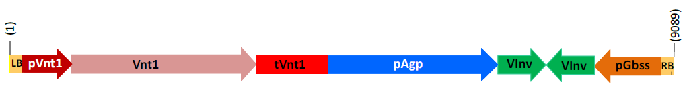
Rpi-vnt1 cassette
Vlnv cassette
Figure 4: Design of the T-DNA region in pSIM1678

Similar to pSIM1278, the T-DNA region from pSIM1678 is encompassed by border regions containing sequences to allow transfer of the T-DNA region into the plant genome. Within the T-DNA is the late blight resistance gene (Rpi-vnt1) cassette under the control of the native Rpi-vnt1 gene promoter and terminator. Use of the native promoter ensures high expression of the protective protein in foliage (Gao & Bradeen, 2016), where the disease occurs. Also contained within the T-DNA are the inverted repeats derived from the Vlnv gene, located around a spacer region (not identified in Figure 4). The expression of the sense and antisense fragments are under the control of promoter sequences from the Agp gene and the Gbss gene, which ensure that the dsRNAs are highly expressed in the tuber (Muller-Rober et al. 1994; Rommens et al. 2008; Visser et al. 1991).
Table 3: The genetic elements contained in the T-DNA region of pSIM1678, used to create Z6
Genetic element | Relative position | Size (bp) | Source | Description, Function & Reference
Left border (LB) | 1 - 25 | 25 | Synthetic¹ | Secondary cleavage site. Releases ssDNA² insert from pSIM1678 (van Haaren et al., 1989)
LB region | 26 - 187 | 162 | S. tuberosum  (var. Ranger Russet) | Supports secondary cleavage at LB and provides buffer for truncations
Intervening sequence | 188 - 193 | 6 | S. tuberosum | Sequence used for DNA cloning
Native Rpi-vnt1 gene promoter | 194 - 902 | 709 | S. venturii | Drives expression of the Rpi-vnt1 gene, especially in the leaves
Rpi-vnt1 gene coding sequence | 903 - 3,578 | 2676 | S. venturii | Expresses the VNT1 protein for late blight protection
Native Rpi-vnt1 gene terminator | 3,579 - 4,503 | 925 | S. venturii | Terminates transcription of Rpi-vnt1
Intervening sequence | 4,504 - 4,510 | 7 | S. tuberosum | Sequence used for DNA cloning
Promoter for the Agp gene (pAgp) | 4,511 - 6,770 | 2260 | S. tuberosum  (var. Ranger Russet) | One of two convergent promoters driving expression of Vlnv inverted repeats, especially in the tuber
Intervening sequence | 6,771 - 6,776 | 6 | S. tuberosum  (var. Ranger Russet) | Sequence used for DNA cloning
Fragment of Vlnv gene in sense orientation | 6,777 - 7,274 | 498 | S. tuberosum  (var. Ranger Russet) | Binds to antisense fragment of Vlnv fragment to generate dsRNA³ that down regulates vacuolar invertase to impair the formation of reducing sugars
Fragment of Vlnv gene in sense orientation | 7,275 - 7,455 | 181 | S. tuberosum  (var. Ranger Russet) | Spacer sequence between the inverted repeats; transcript forms loop in dsRNA
Intervening sequence | 7,456 - 7,461 | 6 | S. tuberosum  (var. Ranger Russet) | Sequence used for DNA cloning
Fragment of Vlnv gene in antisense orientation | 7,462 - 7,959 | 498 | S. tuberosum  (var. Ranger Russet) | Binds to sense fragment of Vlnv fragment to generate dsRNA that down regulates vacuolar invertase to impair the formation of reducing sugars
Intervening sequence | 7,960 - 7,971 | 12 | S. tuberosum  (var. Ranger Russet) | Sequence used for DNA cloning
Promoter for the Gbss gene (pGbss) | 7,972 - 8,894 | 923 | S. tuberosum  (var. Ranger Russet) | One of the two convergent promoters driving expression of the inverted repeat fragments of Vlnv, especially in the tuber
Intervening sequence | 8,895 - 8,903 | 9 | S. tuberosum | Sequence used for DNA cloning
Right border (RB) region | 8,904 - 9,064 | 161 | S. tuberosum (var. Ranger Russet) | Supports cleavage at RB site and provides buffer for truncations
RB | 9,065 - 9,089 | 25 | Synthetic¹ | Primary cleavage site used to release ssDNA insert from pSIM1678 (van Haaren et al., 1989)
¹The LB and RB sequences (25 bp each) were synthetically designed to be similar to and function like T-DNA borders from Agrobacterium tumefaciens.
²ssDNA: single stranded DNA molecule
³dsRNA: double stranded RNA molecule

3.3 Development of the potato lines from original transformants
After the transformation and selection process, plantlets were maintained in tissue culture or cultured in media to allow root formation. Plantlets with roots were transferred to soil or a hydroponic system in greenhouses to produce tubers. Tubers from greenhouse-grown potatoes were then replanted in the greenhouse or planted in fields, to generate multiple propagules. The use of the tuber or part thereof as a propagule is a characteristic of potato, allowing cultivation by vegetative propagation rather than by sexual reproduction. The progeny arising from this form of asexual reproduction will be genetically the same as the parent plant.

When characterising the Z6 line, different generations of plants were analysed. Plants and tubers arising from the initial planting of plantlets into soil are referred to as G0 and the plants and tubers arising from the planting of G0 tubers are referred to as G1 and so forth (Figure 5). The type of characterisations performed and at what generation they were analysed are summarised in Table 4 for the Z6 line.

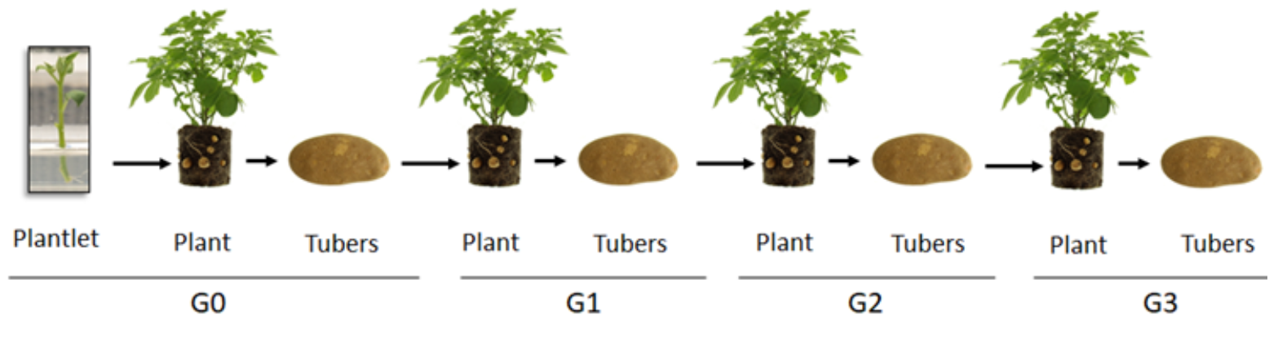Figure 5: Generations of potato derived from vegetative propagation

Table 4: Molecular characterisation studies performed in Z6
Analysis | generation analysed | Control(s) used | Reference comparators
Identifying number of integration sites (Section 3.4.1) | G0 / leaf | Snowden, V11 | Snowden spiked with plasmid DNA (pSIM1278 or pSIM1678)
Detection of backbone sequence (Section 3.4.2) | G0 / leaf | Snowden | Snowden spiked with pSIM1278
Inheritance and genetic stability (Section 3.4.3) | G0 – G3 / leaf | Snowden | —
Insert integrity and site of integration (Section 3.4.4) | G0 / leaf | Snowden | Reference sequence: assembly of T-DNA insert and flanking sequences
RNAi silencing of targeted genes (Section 3.4.6)
Suppression of RNA transcripts (Section 3.4.6.1) | G1 / tuber, root, leaf, stem, flower | Snowden | —
Asparagine and reducing sugar levels (Section 3.4.6.2) | G1 / tuber | Snowden | —
Suppression of acrylamide production (Section 3.4.6.2) | G1 / tuber | Snowden | —
Suppression of PPO activity  (Section 3.4.6.3) | G1 / tuber | Snowden | —

3.4 Characterisation of the inserted DNA and site(s) of insertion
A range of analyses were undertaken to characterise the genetic modification in the Z6 line. These analyses focussed on the nature and stability of the insertion and whether any unintended rearrangements or products may have occurred as a consequence of the transformation procedure. In the analysis of the transformation results involving pSIM1278, the data are applicable to both V11 and Z6. When considering the transformation results related to pSIM1678, the analysis is only applicable to Z6.

3.4.1 Identifying the number of integration sites
Southern blot analysis was performed on leaf-derived genomic DNA digested with restriction enzymes and hybridised with a series of probes spanning the T-DNA region of both pSIM1278 and pSIM1678. Some of the probes matched sequences in both T-DNA regions due to the presence of the Agp and Gbss promoters in both plasmids. The results showed a single integration of T-DNA from the pSIM1278 plasmid in V11 and a single integration of T-DNA from the pSIM1678 plasmid in Z6. The single copy integration of both the pSIM1278 and pSIM1678 T-DNA insert in Z6 was further confirmed using droplet digital PCR analysis (ddPCR) and Illumina next generation sequencing (NGS).

3.4.2 Detection of backbone sequence
NGS analysis was performed on leaf-derived genomic DNA to detect possible plasmid backbone sequences. NGS reads were mapped to vector backbone sequences and analysed to see whether reads aligned to the potato genome or if they might be derived from common laboratory high copy plasmid DNA. The results from this experiment showed that no backbone sequences, including the kanamycin antibiotic resistance gene that is present in both plasmids (Figure 2), were incorporated into the genome of Z6. Southern blot analysis with probes targeting the backbone sequences of pSIM1278 and pSIM1678 plasmids further confirmed the absence of plasmid backbone sequences in Z6. As the sequences are absent in Z6, they would also be absent from V11.

3.4.3 Inheritance and genetic stability of the inserted DNA
As commercial potatoes are vegetatively propagated, standard Mendelian segregation analysis could not be used to determine inheritance. In order to confirm that the progeny were genetically the same as the parent and to ensure the stability of the inserted DNA over time, Southern blot analysis was performed on leaf-derived genomic DNA obtained from G0 to G3 plants (Figure 5). A series of probes were used to examine common regions across the two T-DNAs (e.g. Agp and Gbss promoters) and unique regions within each T-DNA insert (e.g. Asn1 and R1 for pSIM1278; Rpi-vtn1 and Vlnv for pSIM1678). This strategy ensured that sufficient evidence of gene flow and stability for both pSIM1278 and pSIM1678 T-DNA inserts was collected. The results confirmed that the inserted DNA was stably incorporated over 3 successive clonal generations and remained stable over this time period for Z6. As Z6 is derived from V11, it can also be assumed that the inserted DNA in V11 is also stably integrated.

3.4.4 Insert integrity and site of integration
In order to identify rearrangements, deletions and insertions in the integrated DNA, genomic DNA was mapped using probes spanning the T-DNA regions of both plasmids by Southern blotting. For this Southern blotting procedure, a range of different restriction enzymes were used to generate fragments of different sizes that would overlap in sequence, and which when probed would show the position of each labelled fragment. A representation of the digest and probe binding sites for the T-DNA region of each plasmid is shown in Figure 6.
The Southern blotting results were then confirmed by a combination of PCR, Sanger sequencing and Illumina NGS. The subsequent DNA sequencing analysis also allowed for identification of sites of integration in the host genome through alignment to the potato reference genome from the Potato Genome Sequencing Consortium, 2011 (Sharma et al., 2013).

pSIM1278 T-DNA
pSIM1678 T-DNA
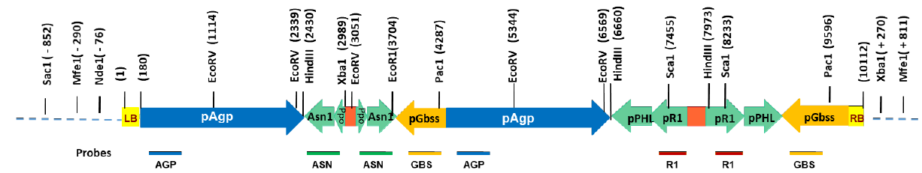

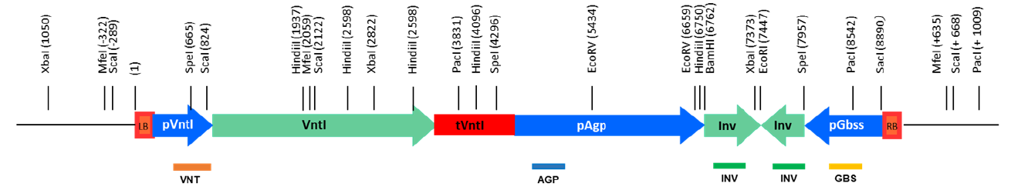
Figure 6: A representation of the restriction enzyme map and probe binding sites of the inserted T-DNA regions. A Southern blotting method was used to determine the structure of the inserted DNA, incorporating a range of restriction enzymes and probes specific to each plasmid insert.

3.4.4.1 pSIM1278 insert structure in V11 and Z6
The applicant provided results from Southern blotting and DNA sequencing analysis that characterised the pSIM1278 T-DNA insert in Z6. These analyses confirmed that a single copy of the pSIM1278 T-DNA insert was integrated into the host genome and the organisation of the insert is as expected. No deletions, insertions, mutations or rearrangements of the inserted DNA were detected when Illumina NGS reads were aligned to the potato genome and a reference sequence. The reference sequence was assembled from the known T-DNA plasmid sequence and Sanger sequenced 5’ and 3’ insert-to-flank DNA junctions.

PCR and DNA sequencing of untransformed Snowden potato genomic DNA and the 5’ and 3’ insert-to-flank DNA junctions of the pSIM1278 insert in Z6 were used to characterise the site of integration. Comparison of the untransformed Snowden potato and Z6 sequences revealed that a small 72 base deletion of potato genomic DNA had occurred during T-DNA integration. Additionally, the 5’ and 3’ flanking sequence of the pSIM1278 insert had a 14 base and 23 base deletion, respectively. Changes such as these are common during plant transformation (Anderson et al., 2016) and would not affect the expression of Asn1, Ppo5, PhL and R1 dsRNAs.

The location of integration for the pSIM1278 T-DNA insert in Z6 was identified by DNA sequence analysis and was shown to have occurred in chromosome 4. At the identified insertion site, there are no known annotated genes thus the insertion should not have disrupted any endogenous host genes.

3.4.4.2 pSIM1678 insert structure in Z6
The applicant provided results from Southern blotting and DNA sequencing analysis that characterised the pSIM1678 T-DNA insert in Z6. These analyses confirmed that a single copy of the pSIM1678 T-DNA insert was integrated into the host genome and the organisation of the insert is as expected. No deletions, insertions, mutations or rearrangements of the inserted DNA were detected when Illumina NGS reads were aligned to the potato genome and a reference sequence. The reference sequence was assembled from the T-DNA plasmid sequence and sanger sequenced 5’ and 3’ insert-to-flank DNA junctions.

PCR and DNA sequencing of untransformed Snowden potato genomic DNA and the 5’ and 3’ insert-to-flank DNA junctions of the pSIM1678 insert in Z6 was used to characterise the site of integration. By comparing the untransformed Snowden potato and Z6 sequences the analysis indicated a duplication of potato genomic DNA occurred during T-DNA integration. The duplication involves a 957 bp sequence located at both the left and right flanking regions. Additionally, the 5’ and 3’ flanking sequence of the pSIM1678 insert had a 9 base and 36 base deletion, respectively. Changes such as these are common during plant transformation (Anderson et al., 2016) and would not affect the expression of the VTN1 protein and Vlnv RNAi.

The location of integration for the pSIM1678 T-DNA insert in Z6 was identified by DNA sequence analysis and was shown to have occurred in chromosome 9. At the identified insertion site, there are no known annotated genes thus the insertion should not have disrupted any endogenous host genes.

3.4.5 Open read frame (ORF) analysis
The applicant used proprietary Python script to identity all start-to-stop ORFs in both the inserted DNA and junctions between the insert and genomic DNA. All six reading frames were analysed. ORFs of 30 or more amino acids were captured for further analysis, as proteins shorter than 29 amino acids would not meet the minimum requirements of a 35% match over an 80 amino acid sequence (Codex 2009).

In total, 60 putative ORFs were identified in Z6 that were associated with either the pSIM1278 and pSIM1678 inserts, the junction between the insert and genomic DNA, or the Rpi-vnt1 gene sequence from pSIM1678. Although the number of putative ORFs seems high, the majority of the ORFs will not be transcribed as they lack appropriate transcription initiation, capping, splicing and polyadenylation signals. The VNT1 protein was correctly identified as an ORF, is associated with appropriate regulatory signals such as a promoter and thus would be transcribed. As this is a novel protein, the potential allergenicity and toxicity of VNT1 was reviewed (see Section 4).

As the ORF analysis includes the pSIM1278 transformation event, the analysis would also be relevant for V11.

3.4.5.1 Bioinformatic analysis for potential allergenicity
The applicant has provided the results of analyses comparing amino acid sequences from the 60 identified ORFs to known allergenic proteins in the Food Allergy Research and Resource Program (FARRP) dataset, which is available through AllergenOnline (University of Nebraska). The version of the database used (v19) contains 2,129 entries. Three types of analyses were done for this comparison:

(a) Full length sequence search – a FASTA (Fast Alignment Search Tool – All) alignment was performed comparing the whole sequence to the database entries. Significant homology was determined when there was (i) greater than 50% homology between query protein and database entry and (ii) the E-value was less than 10⁻⁴. The lower the E-value, the less likely the similarity is due to chance.

(b) 80-mer sliding window search – a FASTA alignment was performed comparing all contiguous 80 amino acids within the ORF to the database entries. Matches were identified if there was greater than 35% homology (E-value < 10⁻⁴).

(c) 8-mer exact match search – A FASTA alignment was performed comparing contiguous 8 amino acids within the ORF to the database entries. Matches were identified if there was 100% homology.

A protein generated by a putative ORF coinciding with the inverted Vlnv DNA sequences in pSIM1678 insert matched a minor allergenic vacuolar invertase protein from tomato (S. lycopersicum; AAL75449, AAL75450). The vacuolar invertase proteins from tomato and potato share 95% sequence homology but have different glycosylation patterns that can impact allergenicity potential. In potato, the native protein has not been identified as allergenic. This match therefore does not raise any allergenicity concerns.

3.4.5.2 Bioinformatic analysis for potential toxicity
The Applicant provided results from analyses comparing the amino acid sequences from identified ORFs to known protein toxins identified in the NCBI Protein databases. A BLASTP search comparing the potential peptides generated by the identified ORFs to proteins designated as toxins, did not identify homology to any biologically relevant toxins. There was homology to enzymes found in toxigenic bacteria but the enzymes themselves are not considered toxins.

3.4.6 Silencing of targeted genes
To confirm that the targeted genes had been silenced as intended, the applicant provided data examining RNA transcript levels in V11 and Z6 compared to the parental untransformed line (Snowden). Polyphenol oxidase (encoded by the ppo5 gene) activity in Z6 compared to Snowden plants was also provided.

3.4.6.1 RNA transcripts
Northern blotting was used to examine the levels of RNA transcripts for each of the targeted genes in V11 and Z6. Expression levels were examined in the edible portion of the plant, the tuber, as well as in the flower, leaf, stem and root tissue.

These analyses showed that in the V11 and Z6 tuber there were reduced levels of RNA transcript for all of the targeted genes. Similar reductions in transcript levels for the target genes were not observed in flower, leaf, stem or root tissue. These results indicate that Agp and Gbss promoters are providing tuber-specific silencing of target genes.

3.4.6.2 Effects on asparagine and reducing sugar levels
The applicant showed there are reduced levels of RNA transcript for the Asn1, PhL, R1 and Vlnv target genes. Further analysis was done to confirm that the reduced RNA transcript levels corresponded to reduced levels of asparagine and reducing sugars.

Asparagine levels were determined by High Performance Liquid Chromatography (HPLC) and results showing the difference in total and free asparagine levels between the parental control and transformed lines are presented in Table 5. Total levels look at all the asparagine and aspartic acid that are bound up in proteins and include free or unbound forms. The free levels only include unbound asparagine that arises from the biosynthesis of new amino acids and the hydrolysis of proteins. The results show there was a 1.6-1.7 fold reduction in total asparagine levels and a 3.8-3.9 fold reduction in free asparagine levels in the V11 and Z6 lines, respectively. These results were statistically significant. This indicates there is a correlation between reduced transcript levels for the Asn1 gene (encoding asparagine synthetase) and reduced asparagine levels.

Table 5: Reduction in asparagine levels in the transformed lines compared to the parental control
Variable | Fold Change
 | V11 | Z6
Total Asparagine | 1.7¹ | 1.6
Free Asparagine | 3.9 | 3.8
1. Bolded and underlined results indicate statistical significance when comparing the control to the transformed event.

The results presented by the applicant for reducing sugars were obtained by chromatography. Reducing sugars are simple sugars like glucose and fructose that contain an aldehyde group, which can act as a reducing agent in a redox reaction. Reducing sugar levels are increased by the hydrolysis of starch and sucrose, two major carbohydrate forms found in plants. The phosphorylase-L (encoded by the PhL gene) and water dikinase (encoded by the R1 gene) enzymes hydrolyse starch into glucose, while vacuolar invertase (encoded by the Vlnv gene) hydrolyses sucrose into glucose and fructose. The levels of sucrose were also included in the results.

As shown in Table 6, for fresh V11 tubers, there was no increase in the concentration of sucrose and a 1.3-fold decrease in reducing sugars. These changes were not statistically significant and indicate the reduced transcript levels for the PhL and R1 genes in V11 and Z6 (Section 3.4.6.1) produces only a minimal reduction in reducing sugars. For fresh Z6 tubers, there was a small but significant increase in the concentration of sucrose, which was associated with a larger decrease (2.6-fold) in reducing sugars compared to V11. However, the reducing sugar change in Z6 was not statistically significant. These data indicate that for the Z6 line, the changes in sucrose and reducing sugar levels compared to V11 can be primarily attributed to silencing of the Vlnv gene.

As vacuolar invertase also plays a role in the process of cold-induced sweetening (CIS) (Sowokinos 2001), levels of sugars were assessed in fresh potatoes and potatoes stored at 10°C for 9 months (V11) or 7°C for 6 months (Z6) and compared to the amounts in the parental control. The data presented (Table 6) showed that sucrose levels were not significantly different over storage time for both V11 and Z6. There was however, a statistically significant decrease in accumulation of reducing sugars in the Z6 line after 6 months of cold storage but not for the V11 line. These data indicate the breakdown of sucrose at lower temperatures has been impaired in the Z6 line and can be correlated with silencing of the Vlnv gene.

Table 6: The change in sucrose and reducing sugar levels between transformed lines and the parental control in freshly harvested or cold-stored potatoes
Temperature | Variable | Sucrose Fold change |  | Reducing Sugars Fold change
 |  | V11 | Z6 | V11 | Z6
 | Fresh | 1.0 | 1.1 | 1.3 | 2.6
7 or 10˚C | 3 months | 0.8 | – | 2.8 | –
 | 6 months | 1.3 | 1.0 | 0.4 | 4.3
 | 9 months | 1.2 | – | 1.1 | –
1. Bolded and underlined results indicate statistical significance when comparing the control to the transformed event.

3.4.6.3 Gene silencing effects on acrylamide production
In order to determine the effectiveness of silencing of genes associated with asparagine and reducing sugar levels on the acrylamide potential of the transformed potato lines, cooked chips were prepared from both fresh and cold-stored potatoes. The measurement of acrylamide levels were based on a procedure specified by the FDA (2003).

The data presented in Table 7 also shows that acrylamide production in cooked chips made from V11 fresh tubers was statistically significantly decreased by 64% compared to the parental control. While this reduction is correlated to the silencing of the Asn1, PhL and R1 genes in V11, the additional suppression of the Vlnv gene in Z6 resulted in an even larger reduction (78%) of acrylamide production.

Levels of acrylamide were also assessed in cooked chips prepared from potatoes after storage at 10°C for 9 months (V11) or 7°C for 6 months (Z6). Data for the V11 line (Table 7) showed a statistically significant 49% reduction in acrylamide production following 3 month cold storage and no statistically significant reductions with further cold storage. For the Z6 line, there was a statistically significant 74% reduction in acrylamide production following 6 month cold storage (Table 7). These results indicate that the additional silencing of the Vlnv gene in Z6 results in larger reductions in acrylamide production following cold storage.

Table 7: Percent reduction in acrylamide levels between transformed lines and the parental control in cooked chips prepared from freshly harvested or cold-stored potatoes
Temperature | Variable | Percent (%) Reduction
 |  | V11 | Z6
 | Fresh | 64 | 78
7 or 10˚C | 3 months | 49 | -
 | 6 months | 48 | 74
 | 9 months | 16 | -
1. Bolded and underlined results indicate statistical significance when comparing the control to the transformed event.

3.4.6.4 Silencing of the Ppo5 gene
In order to correlate Ppo5 transcript levels in the tuber with PPO activity, a qualitative colorimetric assay was performed that examined enzyme action on the substrate catechol. Results were compared between the untransformed parental line and the Z6 line. PPO activity was significantly reduced compared to that in the untransformed parental controls in both fresh tubers and tubers stored for 6 months at 7°C. This result was expected given the northern blot analysis (see Section 3.4.6.1) showed reduced Ppo5 transcript levels. As the DNA sequences targeting the Ppo5 gene were introduced into V11 in the first transformation step, these results are also applicable to that line. Reduced PPO activity results in reduced blackspot bruising in transformed tubers compared to the parental line.

3.4.7 Conclusion
Data provided by the Applicant showed that a single integration event occurred with each transformation step producing the V11 and Z6 lines. Some rearrangements to the host DNA flanking the inserted DNA were identified, but no rearrangements of the inserted DNA are apparent. Molecular studies have also confirmed that only the required sequences (T-DNA) have been integrated into the modified potatoes, with no antibiotic resistance genes or other plasmid backbone sequences being present. The introduced genetic elements are stably maintained through clonally propagated generations.

Molecular analyses also confirmed the silencing of the Asn1, Ppo5, PhL and R1 genes in V11 and Z6, and Vlnv in Z6 with corresponding changes to phenotype resulting in reduced blackspot bruising and reduced acrylamide potential in both lines.

4 Characterisation and safety assessment of novel substances
Two novel substances are expressed in the Z6 line, the VNT1 protein which provides resistance to the foliar late blight pathogen and dsRNA molecules which mediate silencing (by RNAi) of the endogenous Asn1, Ppo5, PhL, R1 and VInv genes. In the V11 line, only dsRNA molecules targeting the Asn1, Ppo5, PhL, and R1 genes are present. The Applicant provided data from a range of analyses undertaken to characterise VNT1 in Z6 and also provided discussion of dsRNA safety in V11 and Z6. In considering the safety of newly expressed substances it is important to note that a large and diverse range of proteins and dsRNAs are ingested as part of the normal human diet without any adverse effects.

4.1 Newly expressed protein
Only a small number of dietary proteins have the potential to impair health, because they have anti-nutrient properties or they can cause allergies in some consumers (Delaney et al., 2008). As proteins perform a wide variety of functions, different possible effects have to be considered during the safety assessment including potential toxic, anti-nutrient or allergenic effects.

To effectively identify any potential hazards, knowledge of the characteristics, concentration and localisation of all newly expressed proteins in the organism as well as a detailed understanding of their biochemical function and phenotypic effects is required. It is also important to determine if the newly expressed protein is expressed in the plant as expected, including whether any post-translational modifications have occurred.

The Applicant has submitted the following unpublished studies characterising the VNT1 protein expressed in Z6.
Unpublished studies
- VNT1 Protein and Rpi-vnt1 Gene Expression in Z6 (2019). Simplot Plant Sciences.
- Characterization of Rpi-vnt1 expression in Y9 (2017). Simplot Plant Sciences.
- 2016 Field Efficacy of Potato Event Z6 against Phytophthora infestans (Late Blight) (2019). Simplot Plant Sciences.

4.1.1 Description of the VNT1 protein
The VNT1 protein is encoded by the native Rpi-vnt1 gene, promoter and terminator from S. venturii, a wild relative to S. tuberosum. The protein consists of 891 amino acids and is one of three variants expressed in S. venturii (Foster et al., 2009). The predicted size of the mature protein is ~102 kDa.

VNT1 belongs to a group of common plant resistance proteins (R-proteins) that contain nucleotide binding (NB) and leucine-rich repeat (LRR) domains. These NB-LRR proteins are used by the plant to detect the presence of pathogenic molecules known as effectors that are indicative of an infection (Jones and Dangl 2006; McHale et al., 2006). Once the presence of an effector is detected the plant’s defence responses are activated resulting in the eventual development of immunity to the pathogen. The pathogen that VNT1 recognises and mediates a response to is the oomycete P. infestans (Jones et al., 2014; Foster et al., 2009). This pathogen causes foliar late blight, a devastating fungal disease responsible for the Great Irish Potato Famine and which still poses a major threat to global potato cultivation.

Although VNT1 is unique to the S. venturii species, it shares high homology to several R-proteins, actual and predicted, from edible food crops across the Solanaceae family, including potatoes, tomatoes and capsicums (sweet and chilli peppers). It is therefore similar to proteins that have a history of safe human exposure.

4.1.2 Expression of the Rpi-vnt1 gene and VNT1 protein in potato tissues
In order to identify the tissues in which VNT1 was actively transcribed, real-time PCR was used to investigate the presence of Rpi-vnt1 mRNA in leaves, stems, roots, flowers and tubers from Z6 and its parental control (Snowden). The mRNA expression levels for Rpi-vnt1 were compared to that of leaf tissue from S. venturii. Rpi-vnt1 mRNA was not detected in any tissue of the parental control, which is expected as the Snowden variety does not have the gene. High mRNA expression levels were observed in the leaf with only minimal levels in the flower and tuber.

The VNT1 protein has been considered by FSANZ in a previous safety assessment (A1139; FSANZ, 2017). Similar to that assessment, the VNT1 protein was below the limit of quantitation (LOQ) in Z6. These result are in line with the published literature as R-proteins are known to be expressed at low levels and are considered to be intractable proteins (Bushey et al., 2014; McHale et al., 2006). The Applicant provided indirect evidence for expression of VNT1 protein in Z6 (Section 4.1.3) and updated bioinformatic analyses (Section 4.1.4).

4.1.3 Characterisation of VNT1 protein in the Z6 line
A late blight field efficacy study was done on Z6 and its parental control to provide indirect evidence for expression of the VNT1 protein in Z6. This study was undertaken at 2 sites (Michigan and Pennsylvania) during the 2016 growing seasons. Using a randomised complete block design, replicate plots (n=5) were established containing rows of 5-10 plants of the control (Snowden) and the test line (Z6), with late blight-susceptible spreader plants (Atlantic variety) planted on either side of the control and test samples. Region specific agronomic practices were used for pest control, maintenance and irrigation and the entire trial at each site was treated with same agronomic inputs, pesticide and fertiliser application. If fungicide was required, a treatment that would not affect P. infestans was used. The plots were irrigated regularly to ensure an environment that would facilitate infection and the spreader plants only were inoculated with P. infestans. One common pathogenic strain of P. infestans was used in the study (US-23). This strain is one of four dominant strains isolated from fungal blight epidemics that occurred in North America between the years 2009-2011 (Danies et al., 2013) and are still persistent to the present day.

The Z6 line was fully resistant to P. infestans strain US-23, whereas the parental control showed full susceptibility, over the time period analysed. The data provide indirect evidence the VNT1 protein is expressed in the Z6 line and functions as expected.

4.1.4 Bioinformatics analyses of VNT1
FSANZ has previously assessed bioinformatic analyses of VNT1 in A1139’s safety assessment (FSANZ, 2017) and concluded that VNT1 is unlikely to be allergenic or toxic and would be as susceptible to digestion as the vast majority of dietary proteins. The bioinformatics analyses have been updated for this application.

4.1.4.1 Assessment of VNT1 allergenicity
The applicant provided the results of bioinformatic analyses comparing the VNT1 amino acid sequence to known allergenic proteins in the FARRP dataset, using the same dataset and search criteria as outlined in Section 3.4.5.1. The FASTA search did not identify any known allergens with homology to VNT1.

4.1.4.2 Assessment of VNT1 toxicity
The applicant has provided the results of bioinformatic analyses comparing the amino acid sequence of VNT1 to proteins identified as “toxins” from the NCBI protein databases. A BLASTP search identified 4 potential toxins with a sequence overlap of greater than 50%.

All of the toxigenic proteins identified were plant resistance-like proteins that provide protection from pathogenic microorganisms. As resistance proteins exist in the majority of plants including food crops (McHale et al. 2006) and to date, have not been shown to have adverse effects after consumption of food or feed, it can be concluded that VNT1 is not homologous to any biologically relevant toxins.

4.1.5 Conclusion
Data for this application shows VNT1 is expressed as expected in Z6 and produces the appropriate phenotype (i.e. late blight resistance). Updated bioinformatic analyses confirm it is unlikely to be allergenic or toxic to humans and the results do not alter conclusions reached in the previous assessment undertaken for A1139.

4.2 Newly expressed dsRNA
Double-stranded RNA constructs were introduced to both V11 and Z6 lines. In V11, dsRNA sequences were encoded that targeted the Asn1, Ppo5, PhL and R1 genes, and additional dsRNA sequences were expressed in Z6 targeting the Vlnv gene. These molecules are then processed by the RNAi post-transcriptional regulatory pathway in the cell, forming a RNA-induced silencing complex. This complex binds to the target gene mRNA resulting in cleavage and degradation of the mRNA. This process exists innately in most eukaryotic organisms, including food-based crops.

Evidence has been provided by the applicant to show that the target genes Asn1, Ppo5, PhL, R1 and Vlnv have been effectively silenced in the tubers (Section 3.4.6).

The safety of these dsRNAs has been previously assessed in A1139 (FSANZ, 2017). The available data do not indicate these dsRNAs possess different characteristics, or are likely to pose a greater risk, than other RNAi mediators naturally present in potato. A history of safe human consumption of RNAi mediators exists, including those with homology to human genes. The evidence published to date also does not indicate that dietary uptake of such RNA from plant food is a widespread phenomenon in vertebrates (including humans) or, if it occurs, that sufficient quantities are taken up to exert a biologically relevant effect (FSANZ, 2013).

5 Compositional analysis
The main purpose of compositional analyses is to determine if, as a result of the genetic modification, an unexpected change has occurred to the food. These changes could take the form of alterations in the composition of the plant and its tissues and thus its nutritional adequacy. Compositional analyses can also be important for evaluating the intended effect where there has been a deliberate change to the composition of the food.

The classic approach to the compositional analyses of GM food is a targeted one. Rather than analysing every possible constituent, which would be impractical, the aim is to analyse only those constituents most relevant to the safety of the food or that may have an impact on the whole diet. Important analytes therefore include the key nutrients, toxicants and anti-nutrients for the food in question. The key nutrients and anti-nutrients are those components in a particular food that may have a substantial impact in the overall diet. They may be major constituents (fats, proteins, carbohydrates or enzyme inhibitors such as anti-nutrients) or minor constituents (minerals, vitamins). Key toxicants are those toxicologically significant compounds known to be inherently present in an organism, such as compounds whose toxic potency and level may be significant to health (e.g. glycoalkaloids in potatoes).

There are a number of key components in potato that are considered important for compositional analysis (OECD 2015; OECD 2002). As a minimum, the key nutrients of potato tubers appropriate for a comparative study include the proximates (dry matter, moisture, carbohydrates, protein, fat), the most highly prevalent vitamins and minerals (vitamin B₃, vitamin C and inorganic molecules such as potassium) and the anti-nutrient glycoalkaloids. In the analysis of carbohydrates, both crude fibre and sugar levels are measured. Furthermore, as the RNAi mechanism silences the expression of genes that would impact the levels of asparagine and reducing sugars in the potato, the compositional analyses should also include total and free amino acids and reducing sugar levels.

5.1 Study design and conduct for key components
Field trials were conducted for lines V11 and Z6 at several potato-growing regions in the United States during the 2012, 2013 and 2018 growing seasons.

The agronomic practices and pest control measures used were location-specific and were typical for all aspects of potato cultivation including soil preparation, fertiliser application, irrigation and pesticide-based control methods. The materials tested in the field trials included the transformed potato, the parental control (comparator) and a range of reference varieties (for the V11 study only). The material planted was either mini-tubers (G0) or field-grown tubers (G1). The field trials were established in a randomised complete block design, with replicates of 4 rows of 20 foot long plots. Although some trials occurred in the same county over two years, the trials were not planted in the same location. Specific information for the field trials is presented in Table 8.

The compositional analyses were based on internationally recognised procedures including official methods specified by the Association of Official Analytical Chemists (AOAC), the USDA and published articles or technical notes from industrial-based sources. The analyses were performed through contracted services from Covance Laboratories.

Table 8: Field trial information for the V11 and Z6 lines
Line | Growth Seasons | Number of sites | Number of replicates | Comparator | Reference Varieties
V11 | 2012-13 | 6 | 3-4 | Snowden | Atlantic, Bintje, Gala, Golden Sunburst, Nicolet, Norkotah, Purple Majesty,  Snowden and Proprietary varieties
Z6 | 2018 | 4 | 4 | Snowden | –
Unpublished studies
- Compositional Assessment of V11 Compared to Snowden (2016). Simplot Plant Sciences Regulatory Lab.
- Compositional Assessment of Z6 Compared to Snowden (2020). Simplot Plant Sciences.

5.2 Analyses of key components in tubers
Homogenised samples were prepared for analysis using 6 whole raw tubers, including the peel. The analytes that were measured in these samples are listed in Table 9. In total, 38 different analytes were measured. Statistical analyses were performed using SAS 9.3 (SAS Institute, Cary, North Carolina). For each analyte, ‘descriptive statistics’ (mean and standard error) were generated. A linear mixed model analysis of variance was used by combining data from multiple test years and locations. In assessing the significance of any difference between the mean analyte value for lines V11 and Z6 and their appropriate parental controls, a P-value of 0.05 was used. This means that approximately 5% of statistically significant differences are expected to occur due to chance alone.

Table 9: Analytes measured in the potato samples
Proximates and Fibre (7)
Protein |  | Fat |  | Ash (dry matter)
Crude Fibre |  | Carbohydrates |  | Calories
Moisture
Vitamins (3)
Vitamin B₃ |  | Vitamin B₆ |  | Vitamin C
Minerals (3)
Copper |  | Magnesium |  | Potassium
Total Amino Acids (18)
Alanine  Arginine  Aspartic acid + Asparagine  Cystine (including Cysteine)  Glutamic Acid + Glutamine  Glycine |  | Histidine  Isoleucine  Leucine  Lysine  Methionine  Phenylalanine |  | Proline  Serine  Threonine  Tryptophan  Tyrosine  Valine
Free Amino Acids (4)
Asparagine |  | Aspartic Acid
Glutamine |  | Glutamic Acid
Sugars (2)
Reducing sugars¹ –  glucose and fructose |  | Sucrose¹
Anti-nutrients (1)
Glycoalkaloids
1. Measured in fresh tubers and in tubers kept in cold storage for specific time intervals

For the V11 study, a tolerance interval was determined for each analyte from a number of non-GM reference lines (commercial and proprietary lines; outlined in Table 8) to show the range of natural variation that exists in conventional potato varieties. The interval was calculated to contain, with 95% confidence, 99% of the values in the population.

For both the V11 and Z6 studies, data for the natural range of each analyte from all edible and commercial varieties of potato was compiled from the published literature (Shepherd et al., 2010; Kozukue et al., 2008; Vivanti et al., 2006; Amrein et al., 2003; OECD, 2002; Rogan et al., 2000; Horton and Anderson, 1992; Lisinska and Leszczynski, 1989; Talburt et al., 1987; Davies et al., 1977) or the ILSI Crop Composition Database (v.7, ILSI-CCDB).

If a statistically significant difference was observed between the transformed event and the parental control (the comparator), the value was compared to the tolerance interval (in the V11 study) and published literature ranges (in both the V11 and Z6 studies) to determine equivalence to that found in nature. It is noted that information in the published literature is limited and is unlikely to provide a broad reflection of the natural diversity that occurs within potato. Therefore, even if a value falls outside the published range, this would not necessarily be of concern.

The combined data of published literature values and ILSI database v.7 is shown as the ‘combined literature range’ (minimum – maximum) in the data tables (Tables 10 – 13).

5.2.1 Key components
Proximate levels in V11 or Z6 and control tubers were measured and the results obtained for these analytes are shown in Table 10. No differences were observed in the moisture, protein, total fat, dry matter, crude fibre, carbohydrates and total calories in V11. For Z6, there was a small but statistically significant decrease in moisture and a small but statistically significant increase in carbohydrates and total calories. These changes fall well within the range of natural variation that exists for potato.

The predominant vitamins and minerals found in potatoes that may contribute to dietary intake include vitamin B₃ (niacin), vitamin C and potassium. As presented in Table 10, there was a small but statistically significant increase in vitamin B₃ in Z6 and in vitamin C in V11 and Z6. There were no differences reported for vitamin B₆, copper, magnesium or potassium in any of the lines analysed (Table 10). The differences that were observed in the transformed lines fall within the tolerance interval reported in the V11 study and combined published data indicating they are within the range of natural variation that exists for potato.

The levels of glycoalkaloids (GA), an anti-nutrient found in tubers, was also measured (Table 10). While V11 showed no difference in GA levels, Z6 showed a small but statistically significant decrease. Since the Z6 mean GA value was within the combined literature range, this difference is not considered biologically significant.

Table 10: Summary of results from the compositional analyses
Variable | Sample | Mean |  | Tolerance Interval  (min-max) | Combined Literature range  (min-max)
 |  | V11 | Z6
Moisture (%) | Control | 79.2 | 78.5 | 71.7-87.0 | 63.2-86.9
 | Transformant | 78.5 | 77.4
Protein (%) | Control | 2.33 | 2.31 | 0.83-3.48 | 0.7-4.6
 | Transformant | 2.34 | 2.33
Total Fat (%) | Control | 0.162 | 0.178 | 0.10-0.50 | 0.02-0.74
 | Transformant | 0.166 | 0.158
Ash (dry matter) (%) | Control | 1.01 | 0.905 | 0.50-1.37 | 0.15-2.0
 | Transformant | 1.03 | 0.931
Crude Fibre (%) | Control | 0.503 | 0.603 | 0.197-0.830 | 0.17-3.5
 | Transformant | 0.475 | 0.609
Carbohydrates (%) | Control | 17.3 | 18.1 | 9.30-25.4 | 3.68-30.5
 | Transformant | 17.9 | 19.3
Total Calories  (kcal/100g) | Control | 79.9 | 83.2 | 48.8-111 | 22.4-110
 | Transformant | 82.5 | 87.4
Vitamin B₃  (mg/100g) | Control | 2.05 | 1.46 | 0.794-2.68 | 0.09-3.43
 | Transformant | 2.19 | 1.58
Vitamin B₆  (mg/100g) | Control | 0.110 | 0.133 | 0.064-0.190 | 0.065-0.340
 | Transformant | 0.110 | 0.142
Vitamin C (mg/100g) | Control | 24.1 | 24.8 | 12.1-34.4 | 1.00-54.0
 | Transformant | 26.9 | 26.7
Copper  (mg/100 g) | Control | 0.08 | 0.0831 | 0.050-0.160 | 0.02-2.05
 | Transformant | 0.08 | 0.113
Magnesium (mg/100 g) | Control | 21.8 | 22.6 | 11.3-31.0 | 11.3-55.0
 | Transformant | 22.6 | 23.8
Potassium (mg/100 g) | Control | 473 | 461 | 240-587 | 291-765
 | Transformant | 488 | 479
Glycoalkaloids (mg/100g) | Control | 10.8 | 13.9 | 5.0-20.4 | 3.20-210.4
 | Transformant | 9.7 | 11.8
1. Bolded and underlined results indicate those data points that were statistically significant when comparing the control to the transformed line.
2. Tolerance intervals were calculated from reference varieties of potatoes grown in the V11 compositional analysis study.

5.2.2 Comparison of total amino acid levels
A summary of the total amino acid levels for the transformed lines is presented in Tables 11 and 12. For the amino acids shown in Table 11, there were minor but statistically significant differences in levels in V11 and Z6. None of these values fall outside the tolerance interval or combined literature range, indicating the differences are consistent with natural variation.

Table 11: Summary of total amino acids in the transformed lines
Variable | Sample | Mean |  | Tolerance Interval  (min-max) | Combined Literature range  (min-max)
 |  | V11 | Z6
Alanine | Control | 64.2 | 62.5 | 22.4-105 | 10-145
 | Transformant | 70.9 | 74.8
Arginine | Control | 123 | 127 | 15.8-188 | 46.2-234
 | Transformant | 142 | 147
Cystine | Control | 26.6 | 27.6 | 10.0-49.5 | 10.0-92.5
 | Transformant | 30.2 | 33.8
Glycine | Control | 65.4 | 66.1 | 10.0-110 | 1.00-372
 | Transformant | 72.7 | 79.2
Histidine | Control | 34.3 | 35.2 | 11.5-52.5 | 10-105
 | Transformant | 36.0 | 38.9
Isoleucine | Control | 75.5 | 74.7 | 20.0-123 | 21.3-137
 | Transformant | 82.2 | 86.0
Leucine | Control | 124 | 120 | 10.0-225 | 53.0-224
 | Transformant | 138 | 148
Lysine | Control | 111 | 107 | 36.6-173 | 44.4-495
 | Transformant | 118 | 124
Methionine | Control | 36.9 | 34.7 | 11.3-59.7 | 9.00-128
 | Transformant | 39.2 | 39.5
Phenylalanine | Control | 91.2 | 90.3 | 11.7-154 | 41.4-131
 | Transformant | 96.6 | 101
Proline | Control | 72.3 | 67.8 | 10.0-155 | 31.9-232
 | Transformant | 78.9 | 80.9
Serine | Control | 74.7 | 75.7 | 10.0-130 | 10.0-140
 | Transformant | 82.7 | 87.9
Threonine | Control | 77.7 | 79.2 | 11.5-129 | 19.8-133
 | Transformant | 85.6 | 94.2
Tryptophan | Control | 20.1 | 22.0 | 10.0-36.3 | 10.0-32.1
 | Transformant | 20.9 | 23.1
Tyrosine | Control | 76.1 | 73.7 | 17.3-124 | 27.5-237
 | Transformant | 85.9 | 89.4
Valine | Control | 102 | 99.0 | 43.3-159 | 24.6-259
 | Transformant | 109 | 109
1. Bolded and underlined results indicate those data points that were statistically significant when comparing the control to the transformed line.
2. Tolerance intervals were calculated from reference varieties of potatoes grown in the V11 compositional analysis study.

As part of the genetic modification of the potatoes, the applicant used RNAi to silence the expression of the Asn1 gene (encoding asparagine synthetase), with the aim of reducing asparagine levels. Thus it was expected there would be a reduction in asparagine levels in the transformed lines, as shown in Table 12. The resulting increase in glutamine is also expected because the biosynthesis of these amino acids is interdependent, as shown in Figure 7.

Although there were major and statistically significant differences in the total asparagine and glutamine levels in the transformed events, the values fall within the tolerance interval reported in the V11 study and combined literature range indicating these differences are within the natural variation that exists in potato.

Table 12: Summary of total asparagine and glutamine levels in the transformed lines
Variable | Sample | Mean |  | Tolerance Interval  (min-max) | Combined Literature range  (min-max)
 |  | V11 | Z6
Aspartic Acid + Asparagine | Control | 519 | 502 | 44.2-799 | 177-1548
 | Transformant | 300 | 308
Glutamic Acid + Glutamate | Control | 350 | 369 | 128-581 | 152-956
 | Transformant | 495 | 510

1. During sample preparation, asparagine and glutamine are converted to their carboxylic acid forms, aspartic acid and glutamic acid therefore the data presented is the sum of both these amino acids.
2. Bolded and underlined results indicate those data points that were statistically significant when comparing the control to the transformed line.
3. Tolerance intervals were calculated from reference varieties of potatoes grown in the V11 compositional analysis study.
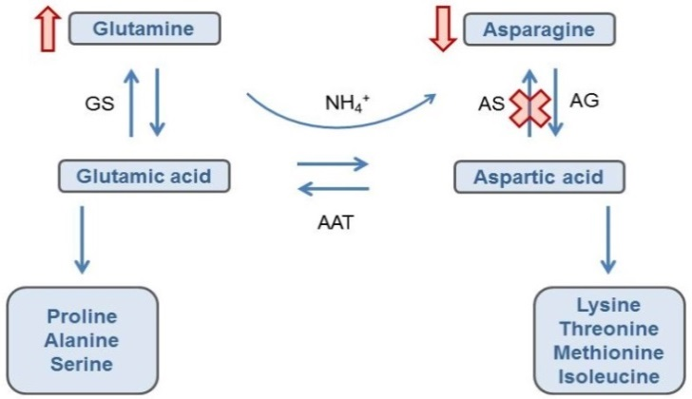
Figure 7: The interrelationship between asparagine and glutamine biosynthesis pathways.
This simplified diagram outlines the metabolic pathways linking the biosynthesis of asparagine and glutamine. The enzyme asparagine synthetase (AS) converts aspartic acid to asparagine. Aspartic acid can also be converted to glutamic acid and in turn, glutamine. By silencing the expression of AS, the expected result would be a decrease in asparagine and an increase in glutamic acid and glutamine. Other enzymes shown in this pathway include AG – asparaginase, AAT – aspartate aminotransferase, GS – glutamine synthetase.

5.2.3 Comparison of free amino acid levels
In addition to total amino acid levels, specific free amino acid levels were also measured as it is the unbound form of asparagine that contributes to the formation of acrylamide during cooking.

Analysis of the free amino acid levels (Table 13) showed there was a 3.9 and 3.8-fold reduction in asparagine levels for V11 and Z6 respectively, correlated with increased glutamine levels. Again, these results are expected because the biosynthesis of these amino acids is interdependent (Figure 7).

Although there are statistically significant differences in free asparagine and glutamine levels between the transformed lines (V11 and Z6) and their parental line, the values fall within the natural variation range seen in the reference varieties for the V11 study and the ranges in the published literature.

Table 13: Summary of free asparagine and glutamine results
Variable | Sample | Mean |  | Tolerance Interval  (min-max) | Combined Literature range  (min-max)
 |  | V11 | Z6
Asparagine | Control | 312 | 309 | 10.0-520 | 31.2-689
 | Transformant | 79.4 | 80.4
Aspartic Acid | Control | 51.5 | 44.2 | 4.20-71.4 | 6.4-197
 | Transformant | 53.7 | 45.1
Glutamine | Control | 125 | 162 | 10.0-298 | 33.6-539
 | Transformant | 222 | 259
Glutamic Acid | Control | 61.8 | 54.5 | 4.40-96.4 | 12.5-136
 | Transformant | 66.5 | 57.6
1. Bolded and underlined results indicate those data points that were statistically significant when comparing the control to the transformed line.
2. Tolerance intervals were calculated from reference varieties of potatoes grown in the V11 compositional analysis study.

5.2.4 Changes in sucrose and reducing sugars
To investigate the effect of silencing genes encoding enzymes involved in the hydrolysis of starch and sucrose, the levels of sucrose, glucose and fructose were analysed. As glucose and fructose contain an aldehyde group that can act as a reducing agent, these sugars are known as reducing sugars.

The data from freshly harvested tubers from V11 showed no differences in sucrose and a trend towards lower reducing sugar levels (Table 14). Although reducing sugar levels in the fresh Z6 tuber were lower than the parental control, they were within the variability determined for the parental control (12.7 mg/100 g) and the levels were not statistically significantly different (p>0.05). Instead, sucrose was statistically significantly higher in the fresh Z6 tuber compared to its parental control. However, the sucrose value falls within the published literature range (39.7-1390 mg/100 g) indicating the levels are still within the range typically found in potatoes.

The differences in Z6 sucrose levels correlates to increased total carbohydrate levels in Z6 (Table 10). When the plant has sufficient amounts of sucrose, it will produce more stored carbohydrates such as starch and cellulose, which make up the components of crude fibre. However, there was no increase in crude fibre levels in Z6, which possibly reflects the overall small increase in sucrose that was observed.

Glucose and fructose can accumulate in tubers during cold storage. Comparison of the carbohydrate levels in V11 tubers kept in cold storage (10˚C) did not reveal any statistically significant changes in the levels of sucrose or reducing sugars compared to the parental control (Table 14). The mean carbohydrate levels fluctuated over time within the control and transformed groups. In contrast, cold storage (7˚C) data for Z6 line showed statistically significantly lower levels of reducing sugars compared to the parental controls (Table 14). These data correlate well with the silencing of Vlnv (the gene encoding vacuolar invertase). Vacuolar invertase would normally facilitate the conversion of sucrose to fructose and glucose during cold storage. While the reported value is below the literature range (13-1,208 mg/100 g), it is not of biological relevance or concern.

Table 14: Summary of the sucrose and reducing sugar levels in freshly harvested and cold-stored potatoes
Temperature | Variable | Sample | Mean Sucrose (mg/100g) |  | Mean Reducing Sugars (mg/100g)
 |  |  | V11 | Z6 | V11 | Z6
 | Fresh | Control | 194 | 122 | 35.1 | 17.7
 |  | Transformant | 197 | 133 | 26.7 | 6.76
7 or 10˚C | 3 months | Control | 179 | – | 151 | –
 |  | Transformant | 147 | – | 53.5 | –
 | 6 months | Control | 74.2 | 134 | 14.7 | 27.2
 |  | Transformant | 98.0 | 137 | 39.4 | 6.32
 | 9 months | Control | 145 | – | 105 | –
 |  | Transformant | 171 | – | 92.3 | –
1. Bolded and underlined results indicate statistical significance when comparing the control to the transformed line.

In terms of the impact on the level of sucrose and reducing sugars, silencing of all three genes (PhL, R1 and Vlnv) in Z6 was more effective than silencing of the PhL and R1 genes only in V11.

5.3 Conclusions of the compositional analyses
Detailed compositional analyses were undertaken of transformed lines V11 and Z6 to characterise the intended compositional changes as well as identify any unintended compositional changes. This included analysis of proximates, fibre, vitamins, minerals, total amino acids, free amino acids, glycoalkaloids, sucrose and reducing sugars (fructose and glucose).

Only minor statistically significant differences were observed in the proximates, fibre, vitamins, minerals and total amino acid levels in the transformed potatoes. No differences in glycoalkaloid levels were observed in V11 and only a minor statistically significant difference was observed in Z6. The levels of these analytes fell within the natural variation found across the range of conventional potato lines used for human consumption.

In terms of the expected changes, statistically significant differences were observed in the levels of both total and free asparagine and glutamine. The reported levels however fell within the range of natural variation for potatoes, indicating these changes are not biologically significant. Similarly, there was a statistically significant increased level of sucrose in freshly harvested Z6 tubers and was accompanied by statistically significant lower levels of reducing sugars following cold storage. Minimal, or no differences in sucrose and reducing sugar levels were observed in the progenitor V11 line. The differences observed in sucrose and reducing sugar levels are not biologically significant.

In summary, the data indicate that tubers from V11 and Z6 are compositionally equivalent to tubers from conventional potato varieties.

6 Nutritional impact
In assessing the safety of a GM food, a key factor is the need to establish the food is nutritionally adequate and will support typical growth and well-being. In most cases, this can be achieved through an understanding of the genetic modification and its consequences, together with an extensive compositional analysis of the food.

If the compositional analysis indicates biologically significant changes to the levels of certain nutrients in the GM food, additional assessment should be undertaken to assess the consequences of the changes and determine whether nutrient intakes are likely to be altered by the introduction of such foods into the food supply. Where a GM food has been shown to be compositionally equivalent to conventional varieties, the evidence to date indicates that feeding studies will add little to the safety assessment and would not be warranted (Herman and Ekmay 2014; Bartholomaeus et al., 2013; OECD 2003).

Potato lines V11 and Z6 are the result of genetic modifications intended to reduce blackspot bruising as well as reduce the potential for acrylamide to be produced upon cooking. In addition, the Z6 line is also resistant to foliar late blight infection. The extensive compositional analyses of tubers that have been undertaken to demonstrate the nutritional adequacy of potato lines V11 and Z6 indicate they are equivalent in composition to tubers from conventional potato cultivars.

The introduction of food from V11 and Z6 into the food supply is therefore expected to have little nutritional impact and, as such, no additional studies, including animal feeding studies, are required.

7 References
Amrein TM, Bachmann S, Noti A, Biedermann M, Barbosa MF, Biedermann-Brem S, Grob K, Keiser A, Realini P, Escher F et al. (2003) Potential of Acrylamide Formation, Sugars, and Free Asparagine in Potatoes: A Comparison of Cultivars and Farming Systems. Journal of Agricultural and Food Chemistry 51:5556–5560
Anderson JE, Michno JM, Kono TJ, Stec AO, Campbell BW, Curtin SJ, Stupar RM (2016) Genomic variation and DNA repair associated with soybean transgenesis: A comparison to cultivars and mutagenized plants. BMC Biotechnology 16:41
Bartholomaeus A, Parrott W, Bondy G, Walker K (2013) The use of whole food animal studies in the safety assessment of genetically modified crops: Limitations and recommendations. Critical Reviews in Toxicology 43(S2):1–24
Bhaskar PB, Wu L, Busse JS, et al. (2010) Suppression of the vacuolar invertase gene prevents cold-induced sweetening in potato, Plant Physiol 154:939–948
Bushey DF, Bannon GA, Delaney BF, et al. (2014) Characteristics and safety assessment of intractable proteins in genetically modified crops. Regul Toxicol Pharmacol 69:154–170
CFIA (2016) Snowden. Canadian Food Inspection Agency, Ontario. https://www.inspection.gc.ca/plant-health/potatoes/potato-varieties/snowden/eng/1312587385900/1312587385901. Accessed March 2020
CFIA (2015) The biology of Solanum tuberosum (L.) (Potatoes). Canadian Food Inspection Agency, Ontario. https://www.inspection.gc.ca/plant-health/plants-with-novel-traits/applicants/directive-94-08/biology-documents/solanum-tuberosum-l-/eng/1330982063974/1330982145930 Accessed March 2020
Chawla R, Shakya R, Rommens CM (2012) Tuber-specific silencing of asparagine synthetase-1 reduces the acrylamide-forming potential of potatoes grown in the field without affecting tuber shape and yield. Plant Biotechnol J 10:913–924
Codex (2009) Foods derived from modern biotechnology, 2nd edition. Codex Alimentarius Commission, Joint FAO/WHO Food Standards Programme, Food and Agriculture Organization of the United Nations, Rome. http://www.fao.org/3/a1554e/a1554e00.htm. Accessed March 2020
Danies G, Small IM, Myers K, Childers R, Fry WE (2013) Phenotypic characterization of recent clonal lineages of Phytophthora infestans in the United States. Plant Disease 97:873–881
Davies AMC, Division CF, Lane C (1977) The Free Amino Acids of Tubers of Potato Varieties Grown in England and Ireland. Potato Res. 20:9–21
Delaney B, Astwood JD, Cunny H, et al. (2008) Evaluation of protein safety in the context of agricultural biotechnology, Food Chem Toxicol 46 (S2): S71-97
FAO (2016) FAOSTAT. Production: Crops. Food and Agriculture Organization of the United Nations, Rome. http://www.fao.org/faostat/en/#data/QC/visualize. Accessed March 2020
FDA (2003) Detection and quantitation of acrylamide in foods, US Food and Drug Administration, Maryland. https://www.fda.gov/food/chemicals/detection-and-quantitation-acrylamide-foods. Accessed April 2020.
FDA (2016) Guidance for industry: acrylamide in foods. US Food and Drug Administration. https://www.fda.gov/regulatory-information/search-fda-guidance-documents/guidance-industry-acrylamide-foods. Accessed April 2020
Forsyth A, Weeks T, Richael C, Duan H (2016) Transcription activator-like effector nucleases (TALEN)-mediated targeted DNA insertion in potato plants. Front Plant Sci 7:e1572
Foster SJ, Park T, Pel M, et al. (2009) Rpi-vnt1.1, a Tm-2(2) homolog from Solanum venturii, confers resistance to potato late blight. Mol Plant Microbe Interact 22:589–600
FSANZ (2013) Response to Heinemann et al on the regulation of GM crops and foods developed using gene silencing. Food Standards Australia New Zealand, Canberra. http://www.foodstandards.gov.au/consumer/gmfood/Pages/Response-to-Heinemann-et-al-on-the-regulation-of-GM-crops-and-foods-developed-using-gene-silencing.aspx. Accessed April 2020.
FSANZ (2016) A1128 – Food derived from reduced acrylamide potential & browning potato line E12. Food Standards Australia New Zealand. https://www.foodstandards.gov.au/code/applications/Pages/A1128GMPotatoE12.aspx. Accessed March 2020.
FSANZ (2017) A1139 – Food derived from Potato Lines F10, J3, W8, X17 & Y9. Food Standards Australia New Zealand. https://www.foodstandards.gov.au/code/applications/Pages/A1139.aspx. Accessed March 2020.
Gao L, Bradeen JM (2016) Contrasting potato foliage and tuber defence mechanisms against the late blight pathogen Phytophthora infestans. PLoS One 11:e0159969
Hawkes JG, Hjerting JP (1960) Some wild potato species from Argentina. Phyton 9:140-146
Hannon GJ (2002) RNA interference. Nature 418:244-251
Herman RA, Ekmay R (2014) Do whole-food animal feeding studies have any value in the safety assessment of GM crops? Regulatory Toxicology and Pharmacology 68:171–174
Horton DE, Anderson JL (1992). Potato Production in the Context of the World and Farm Economy. In The Potato Crop, Harris, P., ed. (Chapman & Hall) 794–815
Jones JD, Dangl JL (2006) The plant immune system. Nature 444:323–329
Jones JD, Witek K, Verweij W, et al. (2014) Elevating crop disease resistance with cloned genes. Philos Trans R Soc Lond B Biol Sci 369(1639):e20130087
Kozukue N, Yoon K-S, Byun G-I, Misoo S, Levin CE, Friedman M (2008) Distribution of Glycoalkaloids in Potato Tubers of 59 Accessions of Two Wild and Five Cultivated Solanum Species. Journal of Agricultural and Food Chemistry 56:11920–11928
Lisinska G, Leszczynsk W (1989) Potato Tubers as a Raw Material for Processing and Nutrition. Potato Science and Technology 11–128
Marone D, Russo MA, Laido G, Leonardis AM de, Mastrangelo AM (2013) Plant nucleotide binding site-leucine-rich repeat (NBS-LRR) genes: active guardians in host defence responses. Int J Mol Sci 14:7302–7326
McHale L, Tan X, Koehl P, Michelmore RW (2006) Plant NBS-LRR proteins: adaptable guards. Genome Biol 7:e212
Muller-Rober B, La Cognata U, Sonnewald U, Willmitzer L (1994) A truncated version of an ADP-glucose pyrophosphorylase promoter from potato specifies guard cell-selective expression in transgenic plants. Plant Cell 6:601–612
OECD (2015) Potato (Solanum tuberosum ssp. tuberosum) from Safety Assessment of Foods and Feeds Derived from Transgenic Crops, Vol 1, OECD Publishing, Paris, France.
OECD (2003) Considerations for the safety assessment of animal feedstuffs derived from genetically modified plants. Organisation for Economic Co-operation and Development, Paris. http://www.oecd.org/officialdocuments/displaydocumentpdf?cote=ENV/JM/MONO (2003)10&doclanguage=en. Accessed March 2020
OECD (2002) Consensus document on compositional considerations for new varieties of potatoes: key food and feed nutrients, anti-nutrients and toxicants. Organisation for Economic Co-operation and Development, Paris. https://www.oecd.org/env/ehs/biotrack/46815167.pdf. Accessed March 2020
OECD (1997) Consensus document on the biology of Solanum tuberosum subsp. tuberosum (Potato). Organisation for Economic Co-operation and Development, Paris. https://www.oecd.org/env/ehs/biotrack/46815598.pdf. Accessed March 2020
Pavek JJ, Corsini DL, Love SL, Hane DC, Holm DG, Iritani WM, James SR, Martin MW, Mosely AR, Ojala JC, Stanger CE, Thornton RW (1992) Ranger Russet: A long Russet potato variety for processing and fresh market with improved quality, disease resistance, and yield. American Potato Journal. 69:483–488
Richael CM, Kalyaeva M, Chretien RC, et al. (2008) Cytokinin vectors mediate marker-free and backbone-free plant transformation. Transgenic Res 17:905–917
Richael CM, Rommens CM (2012) Employment of cytokinin vectors for marker-free and backbone-free transformation. Methods Mol Biol 847:3–10
Rogan GJ, Bookout JT, Duncan DR, Fuchs RL, Lavrik PB, Love SL, Mueth M, Olson T, Owens ED, Raymond PJ et al. (2000) Compositional Analysis of Tubers from Insect and Virus Resistant Potato Plants. Journal of Agricultural and Food Chemistry 48:5936–5945
Rommens CM, Yan H, Swords K, Richael C, Ye J (2008) Low-acrylamide French fries and potato chips. Plant Biotechnol J 6:843–853
Rydberg P, Eriksson S, Tareke E, Karlsson P, Ehrenberg L, Tornqvist M (2005) Factors that influence the acrylamide content of heated foods. Adv Exp Med Biol 561:317–328
Saville AC, Martin MD, Ristaino JB (2016) Historic Late Blight Outbreaks Caused by a Widespread Dominant Lineage of Phytophthora infestans (Mont.) de Bary. PLoS One. 28;11(12):e0168381
Sharma SK, Bolser D, de Boer J, Sønderkær M, et al. (2013) Construction of Reference Chromosome-Scale Pseudomolecules for Potato: Integrating the Potato Genome with Genetic and Physical Maps. Genes Genomes Genetics 3:2031–2047
Shepherd LVTVT, Bradshaw JEE, Dale, MFBFB., McNicol, JWW, Pont, SD, Mottram, DSS, Davies, HVV (2010) Variation in Acrylamide Producing Potential in Potato: Segregation of the Trait in a Breeding Population. Food Chemistry 123:568–573
Sowokinos JR (2001) Biochemical and molecular control of cold-induced sweetening in potatoes. Am. J. Pot Res 78:221–236
Stadler RH, Blank I, Varga N, et al. (2002) Food chemistry: acrylamide from Maillard reaction products. Nature 419:449–450
Talburt WF, Schwimmer S, Burr HK (1987) Sturcture and Chemical Composition of the Potato Tuber. In Potato Processing, Talburt WF and Smith O, eds. (Van Nostrand Reinhold Compnay) 11–46
Tareke E, Rydberg P, Karlsson P, Eriksson S, Tornqvist M (2002) Analysis of acrylamide, a carcinogen formed in heated foodstuffs. J Agric Food Chem 50:4998–5006
Ugent D, Peterson LW (1988) Archaeological remains of potato and sweet potato in Peru. CIP Circular 16:1–40
van Haaren MJ, Sedee NJ, Boer HA de, Schilperoort RA, Hooykaas PJ (1989) Mutational analysis of the conserved domains of a T-region border repeat of Agrobacterium tumefaciens. Plant Mol Biol 13:523–531
Visser RG, Stolte A, Jacobsen E (1991) Expression of a chimaeric granule-bound starch synthase-GUS gene in transgenic potato plants. Plant Mol Biol 17:691–699
Vivanti V, Finotti E, Friedman M (2006) Level of Acrylamide Precursors Asparagine, Frutose, Glucose, and Sucrose in Potatoes Sold at Retail in Italy in the United States. Journal of Food Science 71:C81–C85
Wesley SV, Helliwell CA, Smith NA, et al. (2001) Construct design for efficient, effective and high-throughput gene silencing in plants. Plant J 27:581–590
Xu X, Pan S, Cheng S, et al. (2011) Genome sequence and analysis of the tuber crop potato. Nature 475:189–195
Zhu X, Richael C, Chamberlain P, et al. (2014) Vacuolar invertase gene silencing in potato (Solanum tuberosum L.) improves processing quality by decreasing the frequency of sugar-end defects. PLoS One 9:e93381

8 Appendix 1

Flowchart showing the development and selection methodology for the creation of the V11 line.
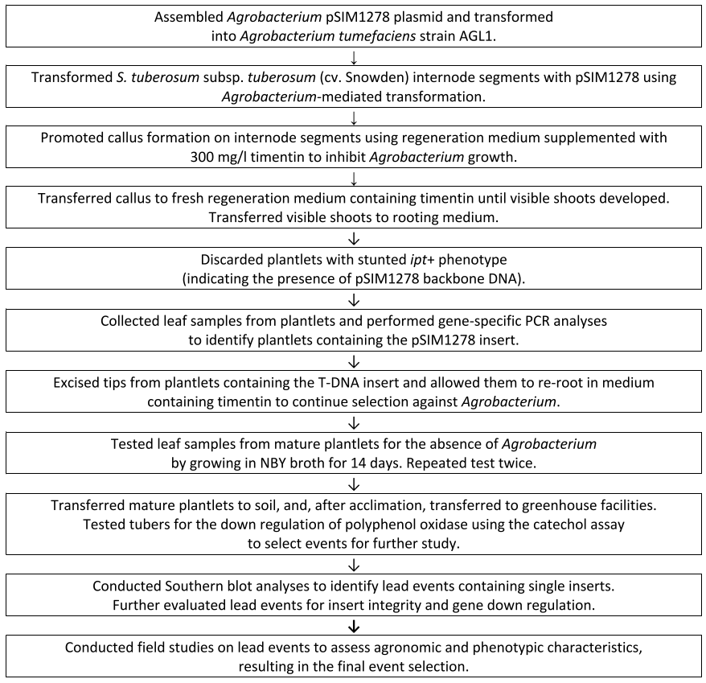

Flowchart showing the development and selection methodology for the creation of the Z6 line.
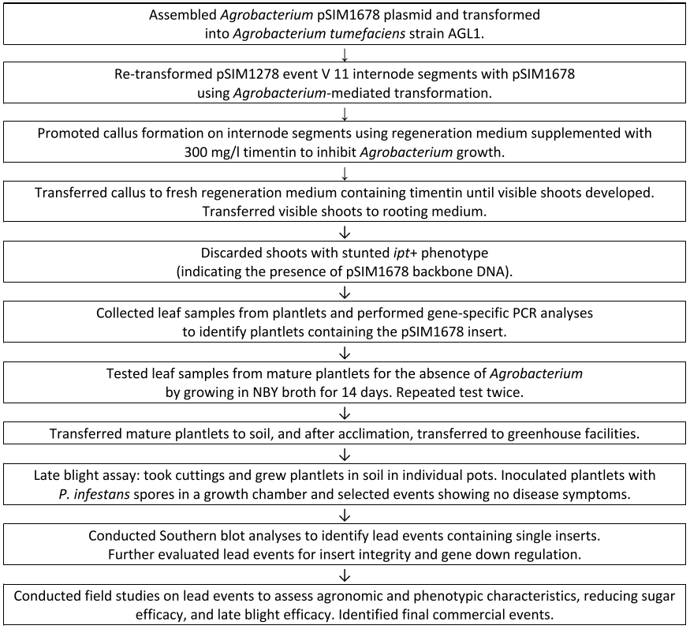

http://www.innatepotatoes.com/
https://www.foodstandards.gov.au/consumer/chemicals/acrylamide/Pages/default.aspx
https://www.europotato.org/varieties/view/Snowden-E
www.ncbi.nlm.nih.gov/nuccore/AF234297.1
http://solanaceae.plantbiology.msu.edu/pgsc_download.shtml
www.allergenonline.org
www.ncbi.nlm.nih.gov/protein/18542113
www.ncbi.nlm.nih.gov/protein/AAL75450
Intractable proteins are those that are extremely difficult to isolate and purify. Without the ability to obtain a high amount of purified product, protein characterisation studies cannot be performed.
Spreader plants are pathogen susceptible plants that are used to inoculate and allow the movement of a pathogen throughout the field trial area
https://www.cropcomposition.org

