Supporting document 1

Guidance on the application of microbiological criteria for Listeria monocytogenes in RTE food – Proposal P1017

Criteria for Listeria monocytogenes – Microbiological Limits for Foods

USING THIS GUIDE
Food Standards in Australia and New Zealand

The Australian and New Zealand food standards system is governed by legislation in the states, territories, New Zealand, and the Commonwealth of Australia; including the Food Standards Australia New Zealand Act 1991 (the FSANZ Act).

The FSANZ Act sets out how food regulatory measures are developed. It created FSANZ as the agency responsible for developing and maintaining the Australia New Zealand Food Standards Code (the Code).

Responsibility for enforcing the Code in Australia rests with authorities in the states and territories; the Commonwealth Department of Agriculture, Fisheries and Forestry for imported food; and with the Ministry for Primary Industries in New Zealand.

Responsibility of food businesses

This Guidance document is not a legally binding document. It is designed to provide an overview of requirements in the Code relating to microbiological limits for food.

This Guidance document reflects the views of FSANZ. However, the Guidance document cannot be relied upon as stating the law. FSANZ is not responsible for enforcement of the Code or for providing advice on food compliance issues. In Australia, state or territory government agencies are responsible for enforcing and interpreting the Code. In New Zealand this is the responsibility of the NZ for Primary Industries public health units or local governments. Legal requirements may also change, for example, as government regulations are made or changed and as courts determine cases on food law in Australia and New Zealand.

Food businesses should obtain legal advice to ensure they are aware of developments in the law and any implications of such developments.

As well as complying with food standards requirements, food businesses must also continue to comply with other legislation.

In Australia, this legislation includes the Competition and Consumer Act 2010; the Imported Food Control Act 1992; and state and territory fair trading Acts and food Acts.

In New Zealand, this legislation includes the Food Act 1981 and Fair Trading Act 1986.

Disclaimer

FSANZ disclaims any liability for any loss or injury directly or indirectly sustained by any person as a result of any reliance upon (including reading or using) this Guidance document. Any person relying on this Guidance document should seek independent legal advice in relation to any queries they may have regarding obligations imposed under the standards in the Australia New Zealand Food Standards Code.

Purpose

The purpose of this Guidance document is to provide an overview to authorities and producers of ready-to-eat (RTE) food of microbiological criteria for Listeria monocytogenes (L. monocytogenes) in RTE foods as specified in Standard 1.6.1 and when evidence (validation) may be necessary for its application.

Background

The ability of a food to support the growth of L. monocytogenes increases the risk that the food will contribute to listeriosis. Many factors need to be considered in determining whether growth is supported to any significant degree before the food is consumed. A consideration of these factors, including the physical and chemical characteristics of the product, shelf life and processing treatments allows RTE foods to be assessed on the basis of whether growth of L. monocytogenes can occur in the food or not. This approach is reflected in Standard 1.6.1 where two limits for L. monocytogenes are specified depending on whether growth can occur.

The limits in Standard 1.6.1 are end point limits, applicable to food for sale or intended for sale. These should be met through a preventative approach to food safety which relies on food businesses implementing through-chain control measures and verifying that these measures are in place and working effectively. While limits for L. monocytogenes in Standard 1.6.1 may allow up to 100 cfu per gram in particular RTE foods, it would be expected that businesses should be implementing controls to prevent Listeria contamination to the extent possible for their particular food product. The establishment of two limits in Standard 1.6.1 recognises that for certain RTE foods and processes, occasional low level contamination may be unavoidable.

For some RTE foods, the application of L. monocytogenes limits is not relevant. The Codex Guidelines on the application of general principles of food hygiene to the control of Listeria monocytogenes in foods (Codex, 2007) states that testing against microbiological criteria for L. monocytogenes may not be useful for:

- products that receive a listericidal treatment after being sealed in final packaging that ensures prevention of recontamination until opened by the consumer or otherwise compromised,
- foods that are aseptically processed and packaged, and
- products that contain a listericidal component that ensures rapid inactivation of the pathogen if re-contaminated (e.g. products that contain >5% ethanol)

As such, RTE foods such as commercially sterile foods (ie: canned foods), foods cooked in their retail container/package (ie: cook-chill pouched food) etc. may not need to be subjected to Listeria testing.

Standard 1.6.1

The Schedule to Standard 1.6.1– Microbiological Limits in Food specifies end point microbiological criteria for L. monocytogenes in RTE foods based on whether growth of the microorganism can occur:

SCHEDULE

Column  1 | Column  2 |  | Column  3 |  | Column  4 | Column  5 | Column  6
Food | Microorganism/test/toxin |  | n |  | c | m | M
Ready-to-eat food in which the growth of Listeria monocytogenes will not occur | Listeria monocytogenes | 5 |  | 0 |  | 100 cfu/g
Ready-to-eat food in which the growth of Listeria monocytogenes can occur | Listeria monocytogenes | 5 |  | 0 |  | not detected in 25 g

These criteria are based on the food product being produced under general principles of food hygiene to control L. monocytogenes in RTE foods with appropriate evaluation of the production environment and process control.

“Ready-to-eat” is defined in Standard 1.1.1 of the Food Standards Code:
Ready-to-eat – in relation to food means food that is ordinarily consumed in the same state as that in which it is sold, and –

(a) does not require further processing (such as cooking), but may be defrosted, reheated or portioned before consumption; and
(b) does not include nuts in the shell and whole, raw fruits and vegetables that are intended for hulling, peeling or washing by the consumer.
In relation to limits for L. monocytogenes, the definition for RTE foods may cover such foods as:

- Pre-packed raw vegetable and salad mixes (with shelf life greater than 5 days), but not whole fruits or vegetables. For example, punnets of strawberries or whole rockmelons are not RTE foods but packaged fruit salad mixes containing cut melon and strawberries would be.

- Refrigerated meals (such as quiches, soups, curries) that are intended to be heated before serving but do not require cooking. Any meals, refrigerated or frozen, that are sold with clear cooking instructions would not be considered RTE.

- Processed dairy products (e.g. milk, cream, cheese, yoghurt, dairy desserts).

- Processed meat products (e.g. refrigerated ham, salami, roast meats, pâté).

- Processed seafood products (e.g. refrigerated hot and cold smoked salmon/trout).

- Refrigerated dips.

Clause 6 of Standard 1.6.1 sets out criteria that must be met for the growth of Listeria monocytogenes to not occur in a RTE food. These criteria relate to the food’s chemical and physical characteristics, shelf life, and processing factors.

Food not supporting the growth of Listeria monocytogenes

For the purposes of the Schedule to this Standard, the growth of Listeria monocytogenes will not occur in a RTE food if:

- the food has a pH < 4.4 regardless of water activity; or
- the food has a water activity < 0.92 regardless of pH; or
- the food has a pH < 5.0 in combination with a water activity of < 0.94; or
- the food has a refrigerated shelf life ≤ 5 days; or
- the food is frozen (including foods consumed frozen and those intended to be thawed before consumption); or
- it can be validated that the level of L. monocytogenes will not increase by > 0.5 log over the food’s stated shelf life; or
- the food has not had a listericidal treatment and it can be validated that the level of Listeria monocytogenes will not exceed 100 cfu/g throughout the food’s stated shelf life.
These criteria capture the elements of growth through specifying a maximum log increase within the stated shelf life.

For the purposes of this guidance document only, the following explanations are provided in relation to “growth” and “shelf life”:

Growth – Greater than an average of 0.5 log cfu/g increase in L. monocytogenes levels for at least the stated shelf life of the product.
[Note that 0.5 log is two times the estimated standard deviation associated with the experimental enumeration method (viable counting/plate counts)]

Stated shelf life – The period of time, established under intended conditions of distribution, storage, retail and use, that the food would remain safe and suitable.

The criteria in Standard 1.6.1 for when L. monocytogenes will not occur in ready-to-eat food also include consideration of whether a listericidal treatment has been applied to the food. This criterion acknowledges that, for some RTE foods, processing does not include a listericidal treatment and product safety depends on the through-chain steps taken to minimise or reduce contamination. Occasional low level contamination in such products may be unavoidable and so a limit of 100 cfu/g would apply throughout its shelf life providing there is evidence that this limit will not be exceeded.

A definition for listericidal treatment is included in the Standard:

Listericidal treatment means a process that can eliminate Listeria monocytogenes.

Such a process may include a physical treatment, such as a heat treatment or high-pressure processing.

Decision framework

A decision framework (Figure 1) has been developed to assist food businesses and enforcement agencies to determine the appropriate microbiological criteria, if any, that are applicable to a RTE food product and when validation is required to support that determination.

In deciding what end-point microbiological criterion applies to a RTE food, the initial step of the framework identifies types of RTE foods for which testing for L. monocytogenes is considered unnecessary. Products include those that are commercially sterile and/or not subject to post-process contamination following a listericidal treatment.

The framework then considers the chemical and physical characteristics of the food, its shelf life, and processing factors. Where insufficient, inadequate or no information exists to demonstrate that growth of L. monocytogenes will not occur in a RTE food, it may be prudent to consider that the food can support growth and therefore a limit of ‘not detected’ would apply.

Food characteristics and shelf life
Knowledge of the chemical and physical characteristics of a product provides an initial delineation between whether an RTE food supports the growth of L. monocytogenes.

Default criteria have been agreed internationally (Codex) for RTE foods where the physico-chemical characteristics fall into one of three ranges throughout the food’s stated shelf life. These default criteria are:

- pH < 4.4, regardless of water activity;
- a_{w} < 0.92, regardless of pH; and
- combination of pH < 5.0 and water activity < 0.94.

In addition, foods which are frozen are also included in that list and include foods consumed frozen and those intended to be thawed before consumption (to be eaten cold or re-heated). Final use of the frozen product must be considered, for example, is the product intended to be thawed for retail sale at which stage it would not be a frozen product.

The potential for L. monocytogenes to grow to high levels in foods with a short refrigerated shelf life (≤ 5 days) is restricted (Health Canada, 2011; Ross 2011). Studies support the conclusion that, providing Good Manufacturing Practices (GHP)/Good Handling Practices (GHP) have been followed to minimise initial contamination levels, short shelf life foods pose a lower risk with respect to causing to listeriosis.

For the purposes of Standard 1.6.1, foods meeting these criteria are considered to not support the growth of L. monocytogenes.

Production processes and additional validation

1. Has the RTE food received a listericidal treatment?

The next consideration for determining the appropriate microbiological limit is whether a RTE food receives a listericidal treatment during production. The presence of L. monocytogenes in RTE foods that have received a listericidal treatment indicates re-contamination following the listericidal processing step. Whether growth can then occur may depend upon product characteristics, use of inhibitory substances, production/packaging practices, and/or the specified shelf life.

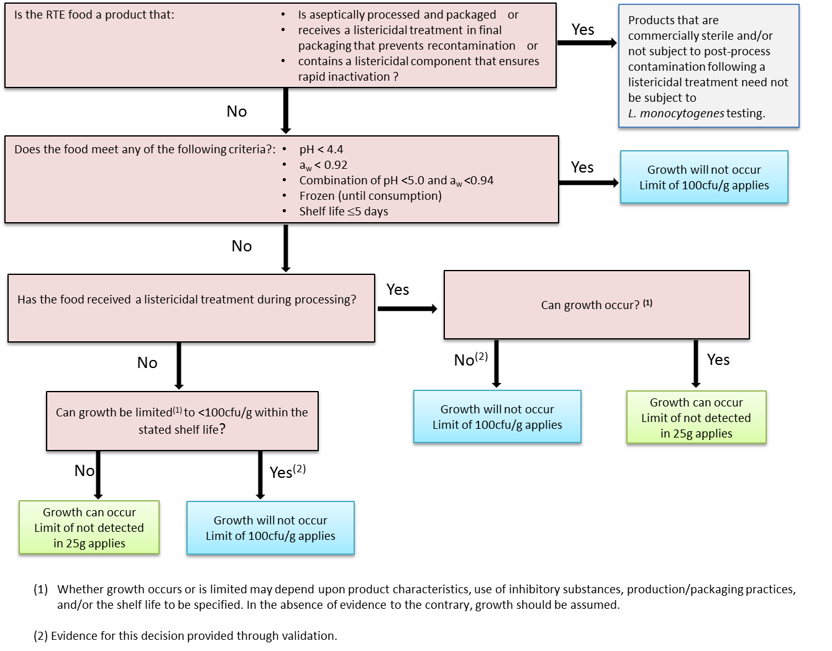
Figure 1 Recommended framework for applying limits for L. monocytogenes in RTE foods for the purpose of Standard 1.6.1 and need for validation

Recognising the potential for post-process contamination, foods receiving a listericidal treatment may have been formulated or undergone additional mitigation treatments to inhibit growth of L. monocytogenes should it become present.

In the absence of any other information, a limit of ‘not detected’ in 25 g would apply to these RTE foods throughout their shelf life. This is the default criterion should a business not have specific information available about their RTE food (e.g. unable to validate whether growth of L. monocytogenes can occur or not during the stated shelf life).

If evidence can be provided that the RTE food does not support growth, then a limit of 100 cfu/g throughout the stated shelf life would be applied for the purposes of Standard 1.6.1.

2. RTE foods not receiving a listericidal treatment

Some foods do not receive a listericidal treatment during processing (e.g. cold smoked finfish; fresh cuts) and ensuring product safety relies on minimising or reducing contamination during primary production, processing and distribution, and limiting growth through maintaining the cold chain and restricting shelf life. Occasional low level contamination of such products by L. monocytogenes may be unavoidable but may not present a risk if growth cannot occur or is limited within the stated shelf life.

If evidence can be provided that the level of L. monocytogenes is limited (<100 cfu/g) within the shelf life of these foods, then a limit of <100 cfu/g applies for the purpose of Standard 1.6.1.

Validation

Evidence that L. monocytogenes will not grow in a RTE food may be based upon:

- the physico-chemical characteristics of the food
- historical information on similar or related products
- information from the scientific literature and risk assessments
- challenge studies
- predictive modelling
- a combination of these approaches.

Validation documentation should provide the objective evidence that shows that the product does not support the growth of L. monocytogenes or that growth is limited (<100 cfu/g) under reasonably foreseeable conditions of distribution, storage, retail and use.

1. Key process parameters

It is recommended that process and production parameters are clearly identified and that evidence as to how these parameters are controlled and verified is provided. Information about the product that should be documented includes:

- Specifications for physico-chemical characteristics of the product, such as pH, a_{w}, salt content, concentration of preservatives.
- The key process parameters at each stage of production
  - concentration of L. monocytogenes at the beginning of the shelf-life of the RTE product, pH, a_{w}, washing conditions, cold smoking conditions etc.
- The control measures in place to ensure product and process parameters are met and how these are verified.
- Identification of each ingredient including its effective concentration.
  - permitted antibacterial agents, water activity depressants (sugar, salt, etc), pH reducing agents (vinegar, organic acids, etc).
- The type of packaging system used taking into account the storage and processing conditions and the possibilities for contamination.

2. Scientific literature

A review of the scientific literature is useful to provide information on the possible level of
L. monocytogenes contamination that could be expected and its growth profile in the food product being considered as well as similar products. Reference to published challenge studies may be useful in providing evidence on the factors that inhibit growth of
L. monocytogenes.

3. Challenge studies

Challenge studies provide information on the response of pathogens (growth and inactivation) to changes in the intrinsic physio-chemical parameters and impact of production and processing factors. The design of a challenge study must adequately reflect the processes used to make the RTE food product.

There are a number of existing resources available to assist in the conduct of challenge and shelf life studies for L. monocytogenes in RTE foods, including:

- Listeria monocytogenes Challenge Testing of Ready-to-Eat Refrigerated Foods (Health Canada, 2012)

- Guidance document on Listeria monocytogenes shelf-life studies for ready-to-eat foods, under Regulation (EC) No 2073/2005 of 15 November 2005 on microbiological criteria for foodstuffs (Commission of the European Communities, 2008)

- Shelf life of ready-to-eat food in relation to L. monocytogenes – Guidance for food business operators (Chilled Food Association, 2010)

In addition, the NSW Food Authority has produced a guidance document on shelf life testing with respect the establishment of ‘use-by’ dates that provides useful information: Shelf life testing, ‘Use-by’ dates for food safety (NSW Food Authority, 2010).

4. Predictive microbiological models

Predictive models that are validated, robust and built upon scientifically sound data can play an important role, along with other supporting information, in determining if a given product formulation or process will reduce the likelihood of Listeria presence or growth.

A number of predictive microbiological models are freely available on the internet, including:

- Meljholm and Dalgaard (2009) developed a growth rate and growth boundary model for L. monocytogenes in RTE shrimp (Seafood Spoilage and Safety Predictor). The model includes 12 factors and their interactive effects of relevance to the prediction of the probability of growth: temperature, salt, pH, six acids (acetic acid, benzoic acid, citric acid, diacetate, lactic acid and sorbic acid), smoke components (phenol), CO₂ in head space gas at equilibrium and nitrite. This model has been validated for meat products, seafood products, poultry products and non-fermented dairy foods (e.g. milk, cream and ice cream) (Mejlholm et al, 2010).

- Augustin et al. (2005) evaluated the performance of eight growth rate and probability of growth/no growth models using a combination of temperature, pH, the main acid present in the medium, water activity, nitrite, phenol and the proportion of CO₂ in the modified atmosphere as factors.

- ComBase (2012) is a freely available database of observed microbial responses to a variety of food-related environments and a collection of relevant predictive models. Separate models are available to predict the response of L. monocytogenes to key factors such as temperature, pH and salt concentration in combination with organic acids, nitrite and carbon monoxide. The models are based on outputs from laboratory experiments observed in culture media under well controlled laboratory conditions.

- The USDA Pathogen Modelling Program (USDA, 2013) is a package of models that can be used to predict the growth and inactivation of foodborne bacteria, primarily pathogens, under various environmental conditions. The predictions are specific to certain bacterial strains and specific environments (e.g., culture media, food, etc.) that were used to generate the models.

Use of these models requires specialised technical skills and knowledge for correct utilisation and interpretation of results. Additionally, each model has inherent limitations which must be known and understood by the user. For example, modelling programs may not extend to the impact of certain preservatives and specialised technical expertise may be required to evaluate preservative efficacy.

Predictions from models are based on observations largely made in artificial growth medium and available studies. To understand how L. monocytogenes will behave in a specific product may require a challenge test.

Further information

Further information regarding validating food safety measures can be found in the Codex document Guidelines for the Validation of Food Safety Control Measures (Codex, 2008).

Sampling and analysis

Standard 1.6.1 stipulates two 2 class sampling plans for L. monocytogenes in RTE foods based on whether the food supports the growth or does not support the growth according to the methods prescribed by Australian Standard AS 5013:

- L. monocytogenes not detected (5 x 25 g analytical units) with reference method AS5013.24.1-2009 Food microbiology – Microbiology of food and animal feeding stuffs – Horizontal method for the detection and enumeration of Listeria monocytogenes – Detection method (ISO 11290-1: 1996, MOD).

- L. monocytogenes not exceeding 100 cfu/g (5 x 10 g analytical units) with reference method (under the AS 5013 series) AS 5013.24.2-2009 Food Microbiology – Microbiology of food and animal feeding stuffs – Horizontal method for the detection and enumeration of Listeria monocytogenes – Enumeration method (ISO 11290-2: 1998, MOD).

When sampling for the purposes of complying with Standard 1.6.1, it is recommended that five sample units of at least 100 g or mL be taken at random and be representative of the lot or production conditions.

Prior to submitting samples for analysis, consideration needs to be given as to what limit should apply and, therefore, whether enrichment (detection) and/or a plating method is to be used; as well as the time taken for testing (which may have implications for when a lot is released to the market). It is recommended that food businesses develop procedures for sampling and analysis, including details on any hold and test procedures and corrective actions.

References

Augustin J-C, Zuliani V, Cornu M, Guillier L (2005) Growth rate and growth probability of Listeria monocytogenes in dairy, meat and seafood products in suboptimal conditions. Journal of Applied Microbiology 99:1019-1042

Chilled Food Association (2010) Shelf life of ready-to-eat food in relation to L. monocytogenes – Guidance for food business operators v 1.1.1. Chilled Food Association, Kettering, United Kingdom. http://www.chilledfood.org
Codex (2007) Guidelines on the Application of General Principals of Food Hygiene on the Control of Listeria monocytogenes in Foods (CAC/GL 61 - 2007). Codex Alimentarius Commission, Geneva, Switzerland. http://www.codexalimentarius.org/standards/list-of-standards/
Codex (2008) Guidelines for the Validation of Food Safety Control Measures (CAC/GL 69-2008). Codex Alimentarius Commission, Geneva, Switzerland. http://www.codexalimentarius.org/standards/list-of-standards/

ComBase (2012) Web-based resource for Quantitative and Predictive Food Microbiology http://www.combase.cc/index.php/en/
EC Commission Staff Working Document (2008) Guidance document on Listeria monocytogenes shelf-life studies for ready-to-eat foods, under Regulation (EC) No 2073/2005 of 15 November 2005 on microbiological criteria for foodstuffs. Brussels. http://ec.europa.eu/food/
Health Canada (2011) Policy on Listeria monocytogenes in ready-to-eat foods. Health Canada, Ottowa, Canada.
http://www.hc-sc.gc.ca
Health Canada (2012) Listeria monocytogenes Challenge Testing of Refrigerated Ready-to-Eat Foods. Health Canada, Ottowa, Canada. http://www.hc-sc.gc.ca

Mejlholm O, Dalgaard P (2010) Development and validation of an extensive growth and growth boundary model for Listeria monocytogenes in lightly preserved and ready-to-eat shrimp. Journal of Food Protection 72:2132-2143
Mejlholm O, Gunvig A, Borggaard C, Blom-Hanssen J, Mellefont L, Ross T, Leroi F, Else T, Visser D, Dalgaard P (2010) Predicting growth rates and growth boundary of Listeria monocytogenes — An international validation study with focus on processed and ready-to-eat meat and seafood. International Journal of Food Microbiology 141:137-150

NSW Food Authority (2010) Shelf life testing, ‘Use-by” dates for food safety. http://www.foodauthority.nsw.gov.au

Ross T (2010) Defining "Short Shelf Life" foods with respect to risk from Listeria monocytogenes. Ministry of Agriculture and Forestry, Wellington, New Zealand. http://www.foodsafety.govt.nz

USDA (2013) Pathogen Modelling Program (PMP) online: http://pmp.arserrc.gov/PMPOnline.aspx

